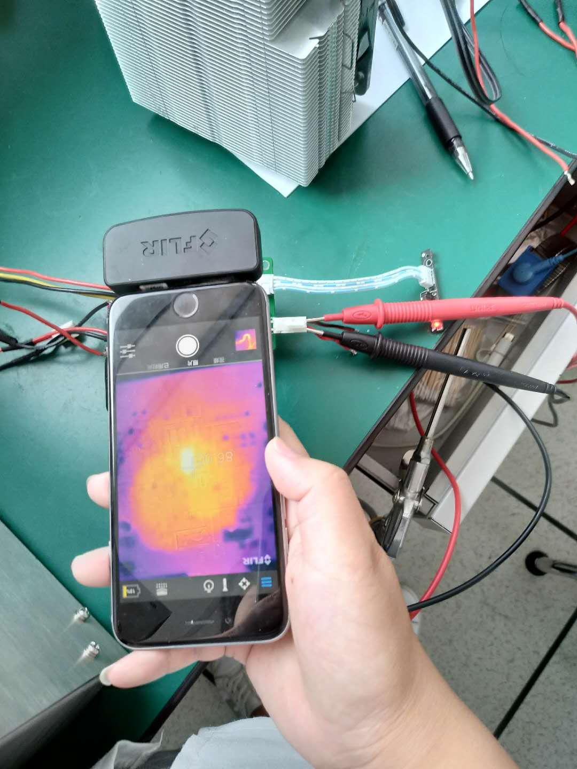

The chip temperature，86°C

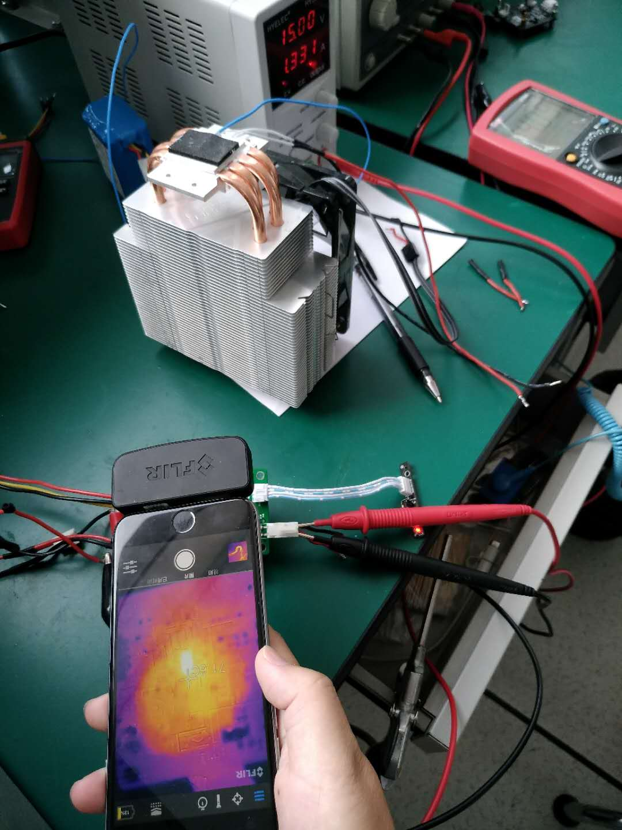

* Total current of input circuit,1,331A,15V，Temperature around the chip，71.6°C

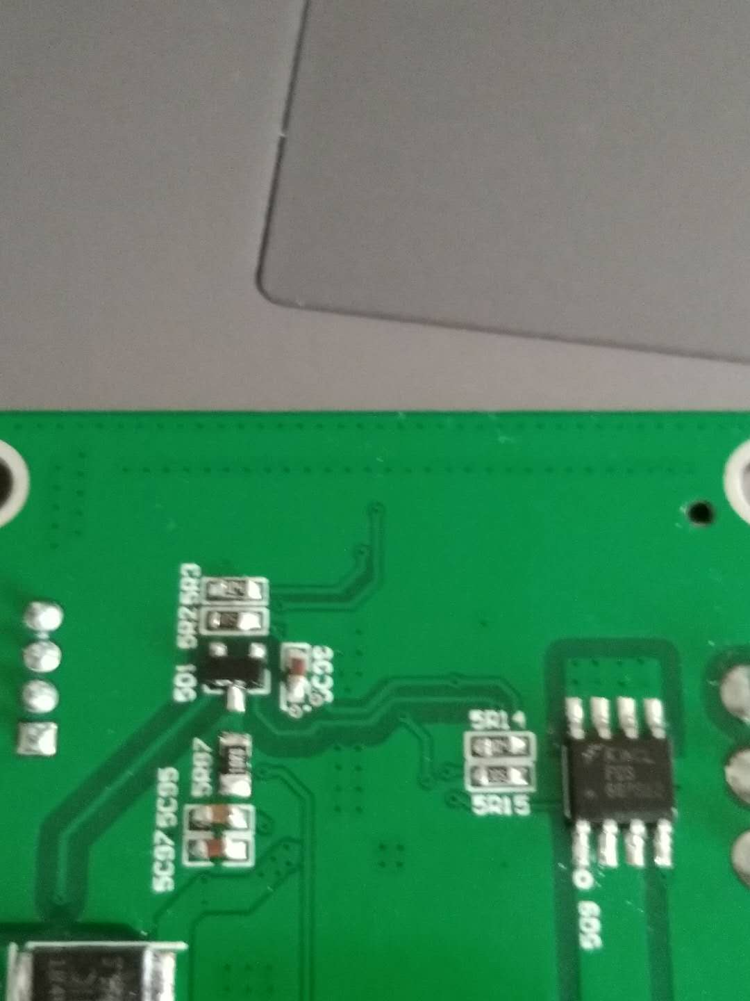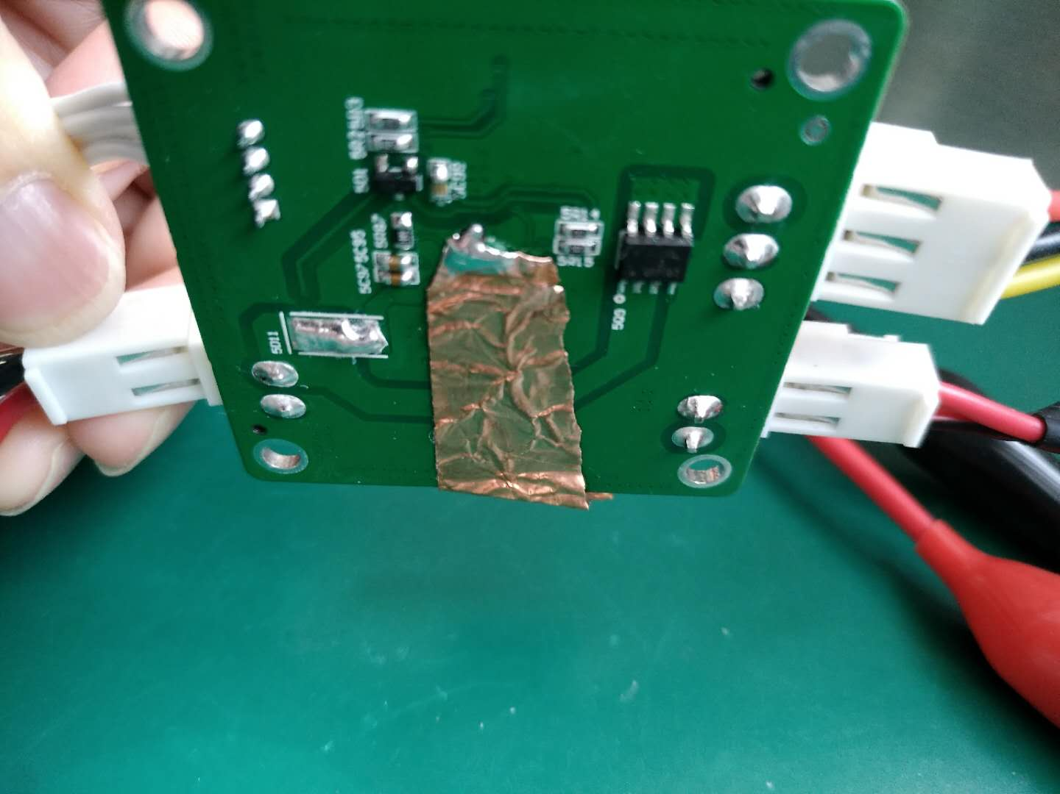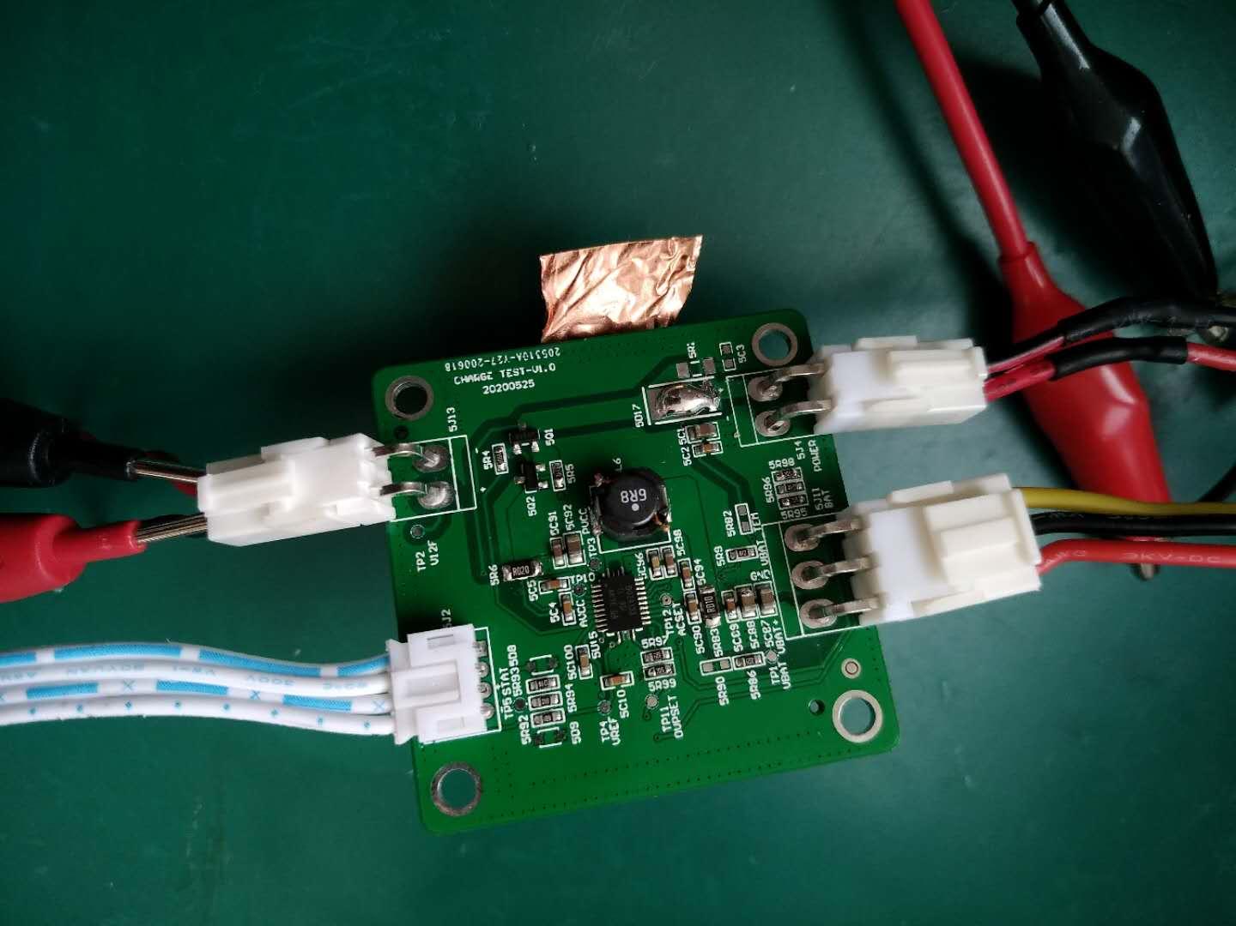

* Through hole of chip bottom soldering plate

Experiments help to dissipate heat with copper skin

Experiments help to dissipate heat with copper skin