**Issue. the display will be dimmed black during power up. after some seconds, will be normal.**

* **EN is Hight, PWM is 1KHz. Input is 12V battery(9V~16V). EN and PWM is ok.**
* **FSET is 160kohm, current limit is 80mA, duty-cycle is 50%.**
* **FAULT is pull up to high, not found low during power up.**
* **Not use TEMP sensor.**

**LED_A1/A2/A3 connect to LED_VOUT;**

**LED_K1/K2/K3 connect to OUT1/OUT2/OUT3**

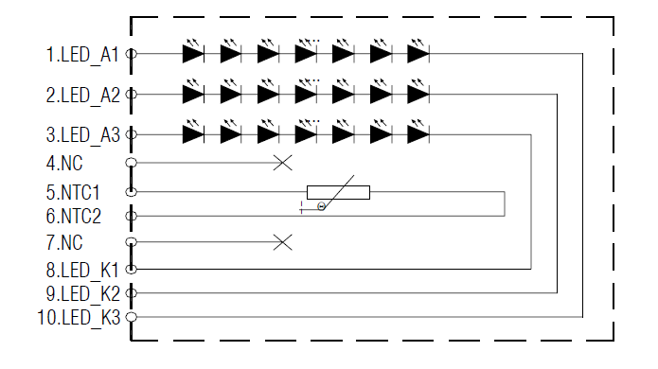

**Schematic as below:**

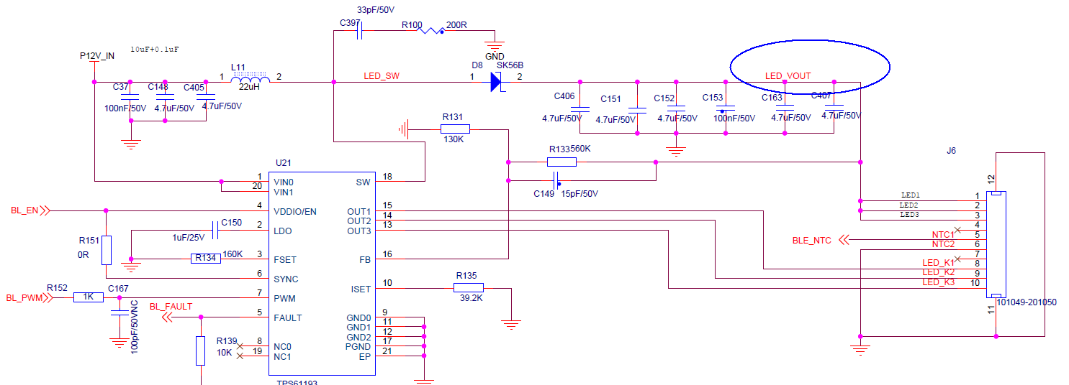

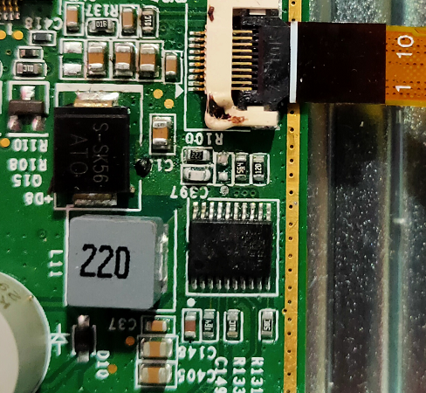

背光驱动IC的型号如下为TPS61193Q:

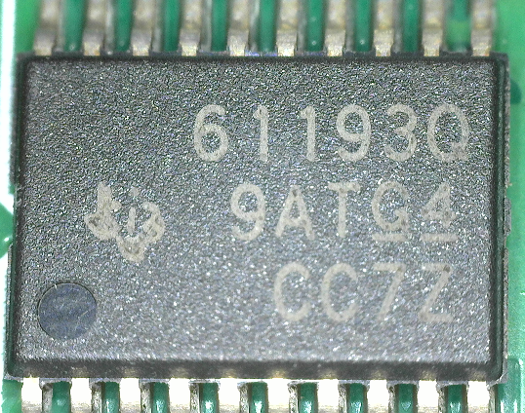

**Issue:**

The LED_OUT voltage is lower than normal (22V)。

1、yellow is LED_VOUT voltage when power up/. only have 19V；

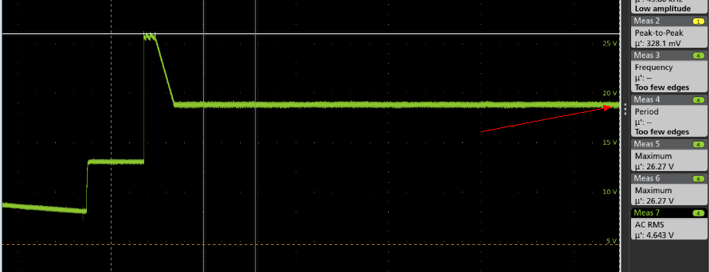

After about 2.5s, voltage up to 22V, the light of display become to normal level. As below picture show:

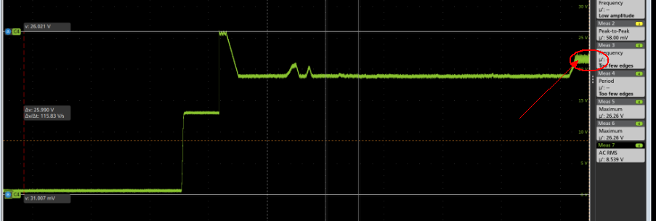

2、The OUT*N output waveform in abnormal condition, the voltage level will be 6.8V and amplitude is difference with different channel.

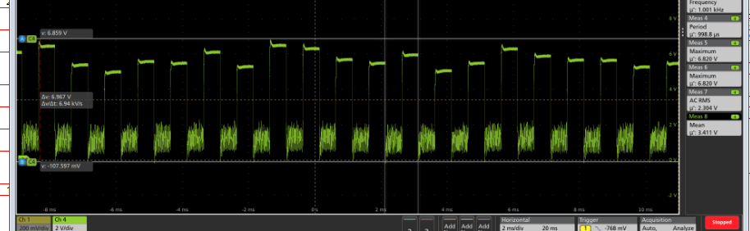

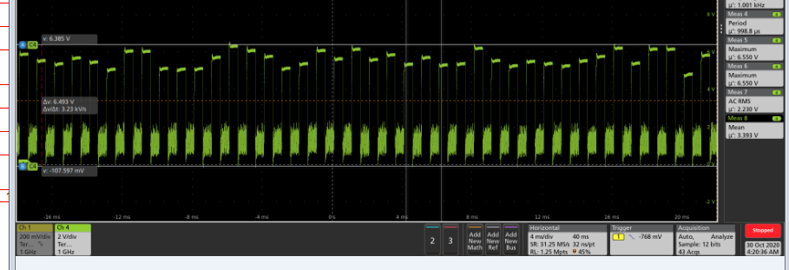

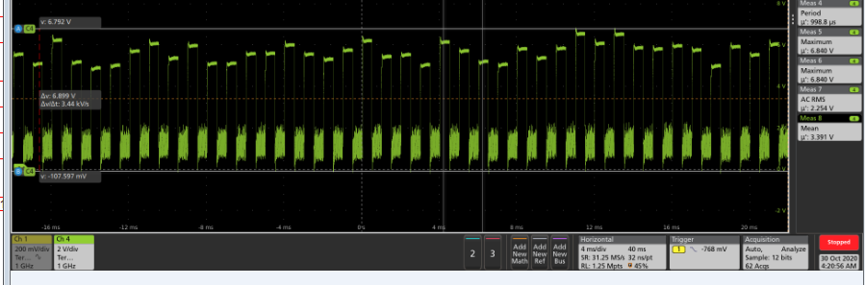

3. in normal condition, below are OUT* waveform:

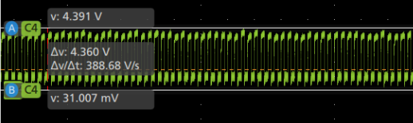

4. OUT* waveform during power up in abnormal condition:

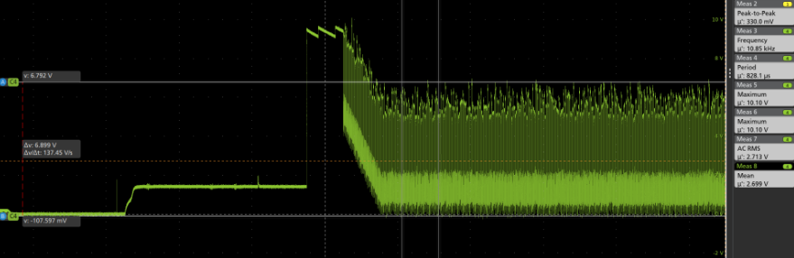

5. OUT* waveform during power up in normal condition:

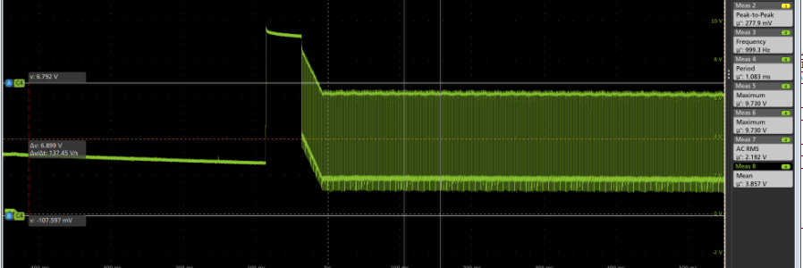

The amplitude is 5.5V and the same with others channel.

