Measure the lower right MOS VDS of the full bridge in burst mode
Sometimes there will be abnormal waveforms, as shown below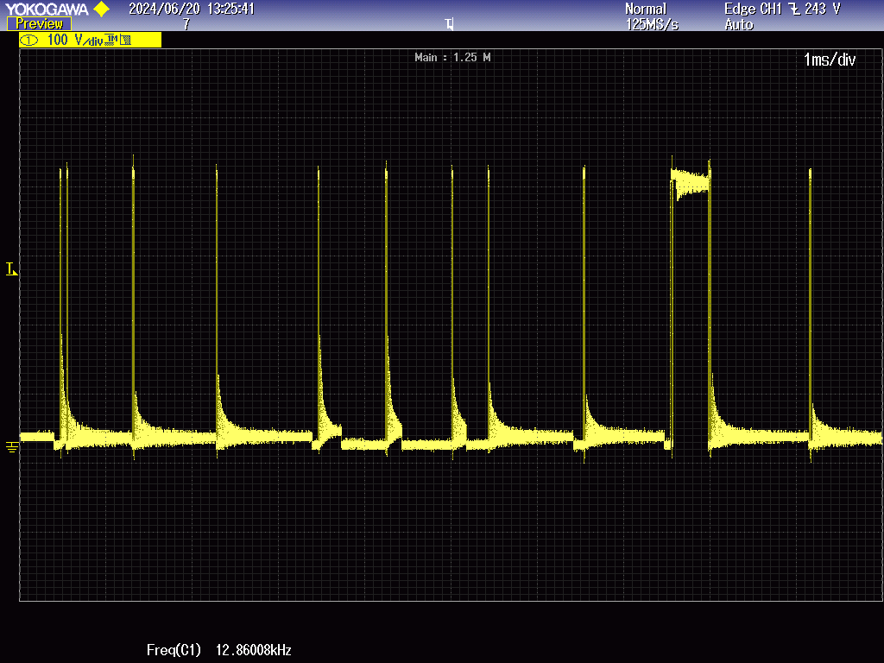
圖一
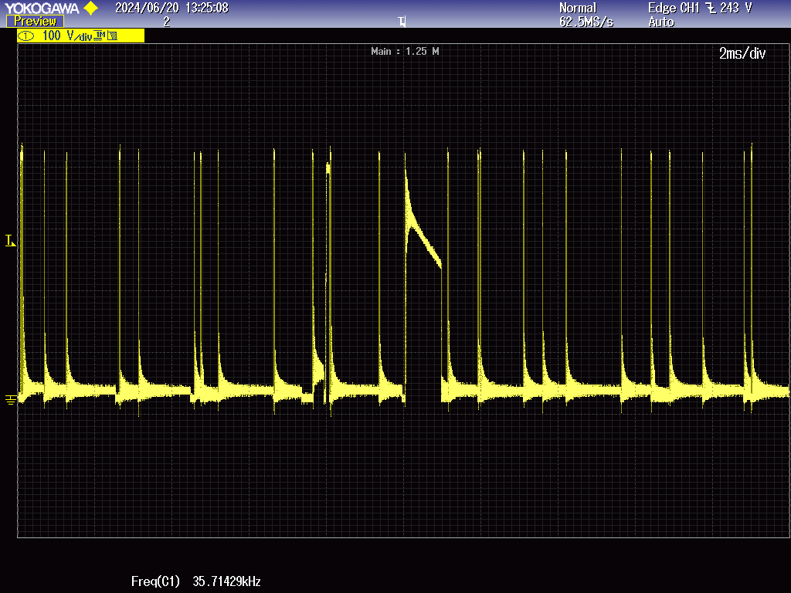
圖二

TI's demo board does not have this problem
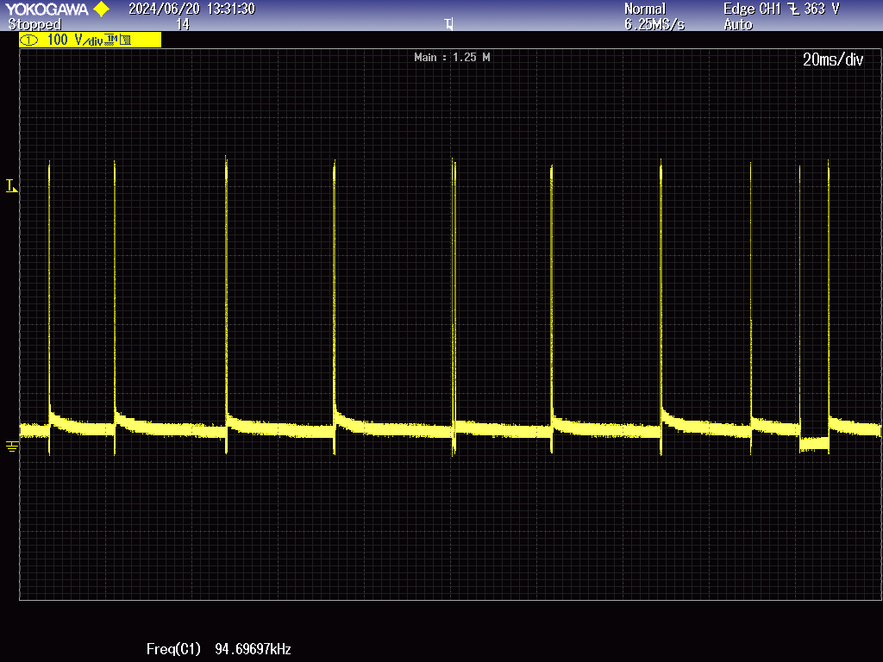
Demo board waveform

