I ran my test one more time and I attached a doc of the results I’m getting. Im using a MIIC-204 iport/usb device to communication to the chip.

Reading data using F082 I get:

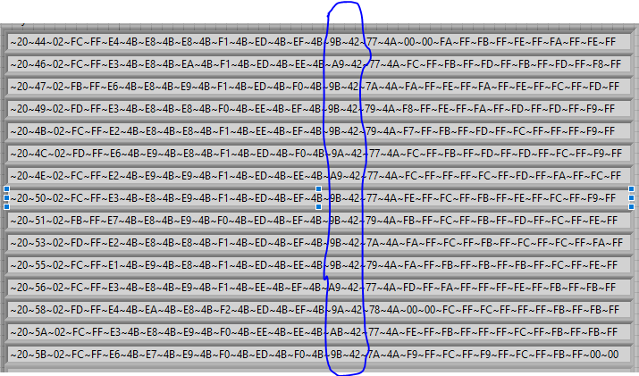

For the 15 reads I do in order to get the avg ADCPack: ignoring the first bye(~20) which just tells me the length of the data. The areas circled above would be all the ADCpack’s = HHhh

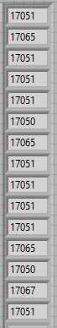Which translates to : in decimal. The average would be:

my applied voltage is 22546.6mv

Pack gain = (22546.6/17054.733) X 65536 = 86639.52 this value seems too large to me.

My second question would be how does a value of say 0x4BE4 = 19428 translate to roughly 3599mv for cell 1 voltage.

0x4BE4 = 19428 comes from the first line of picture 1 representing cell voltage 1

And the ~3599mv is what I can read from the Battery management Studio

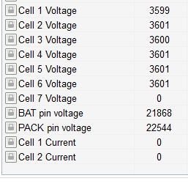

Or are they completely unrelated