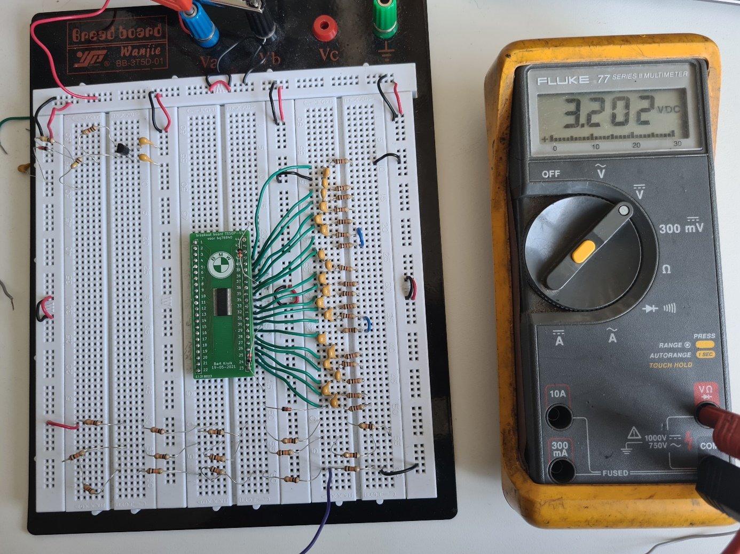
No connections has been made to the IC. The voltage is measured on the lowest resistor (I use this one to test my unit instead off real cells. The measure cable is the purple one below the breadboard.
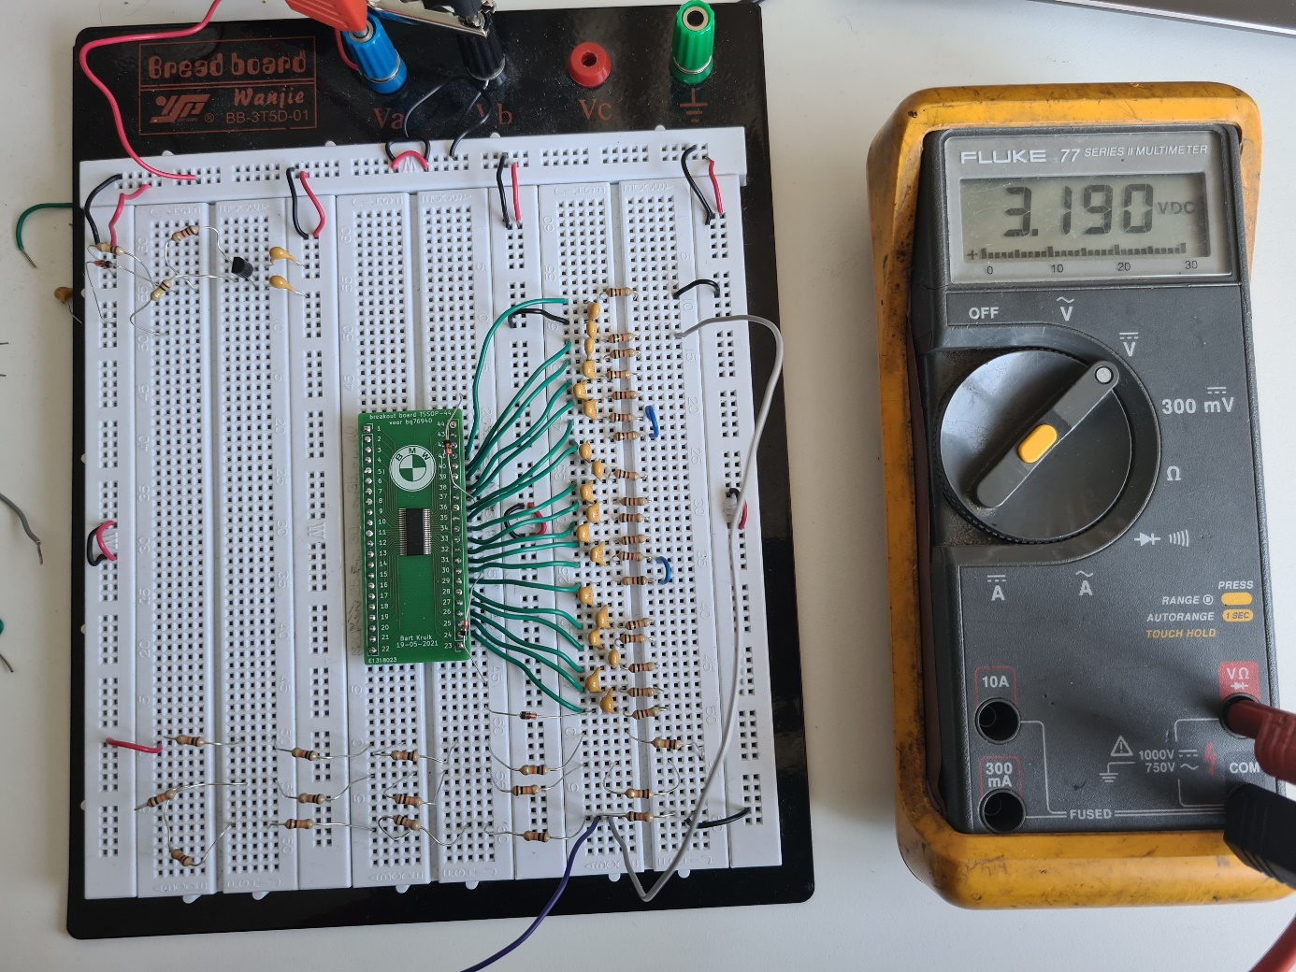
After I connect the + off the lowest resistor on pin VC1 the voltage will drop already. The voltage has been measured at the same place.
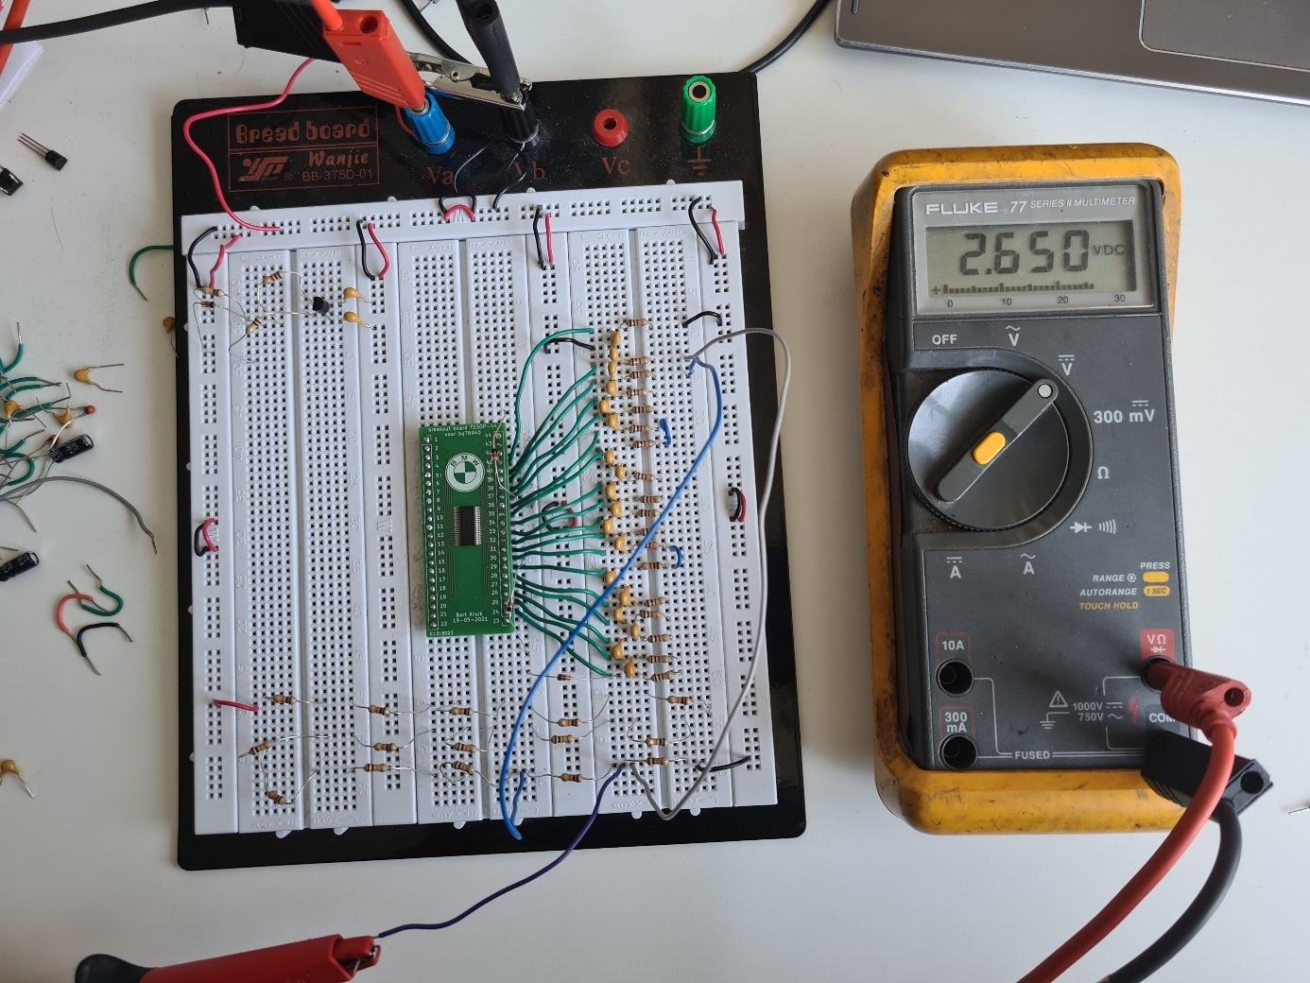

After connection the second + the voltage will drop to 2.65V.

