Blu=battery voltage; Magenta: battery current

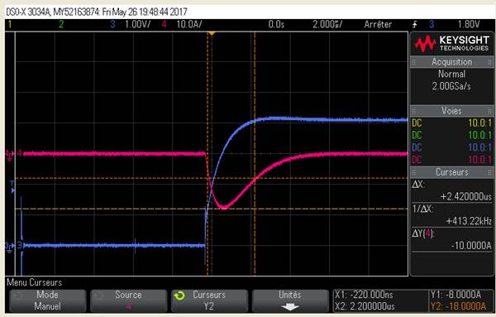

Blu: Batt pin

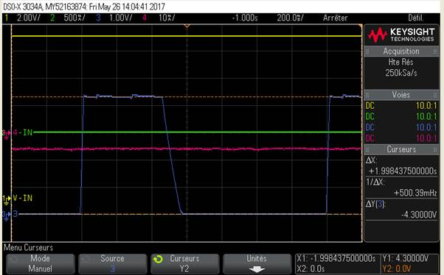

Input current when adapter plugged in (battery not connectec for this test)

