Battery 25.6V 54.4Ah

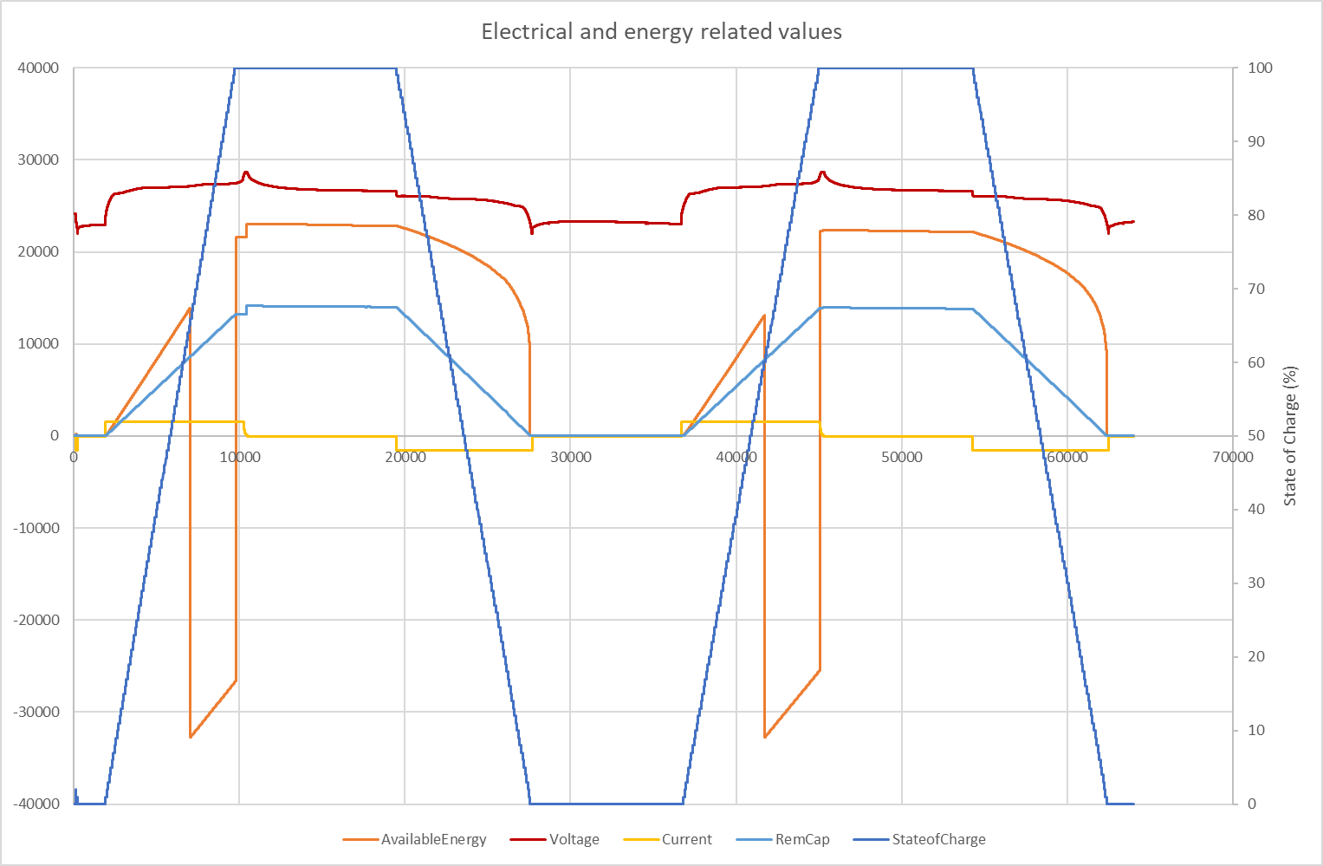

Battery 12.8V 54.4Ah

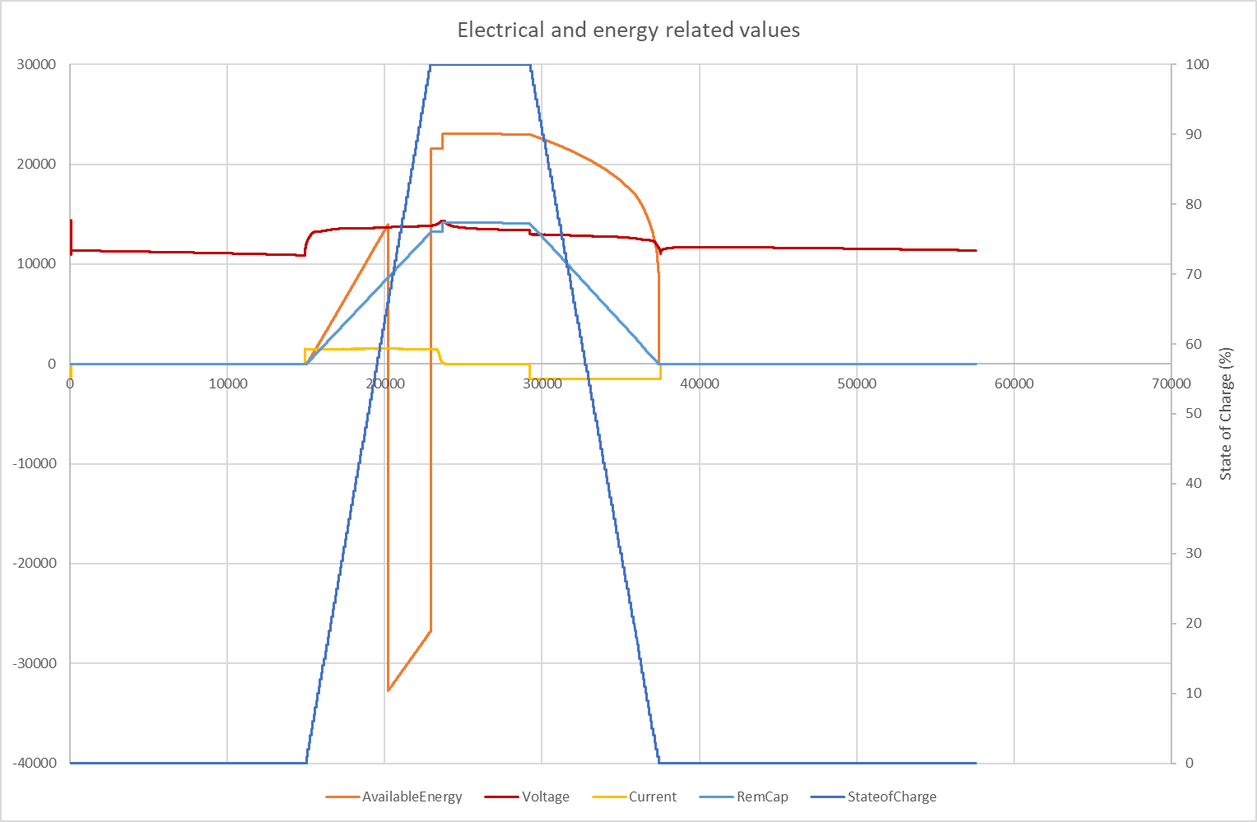

Battery 25.6V 41.6Ah

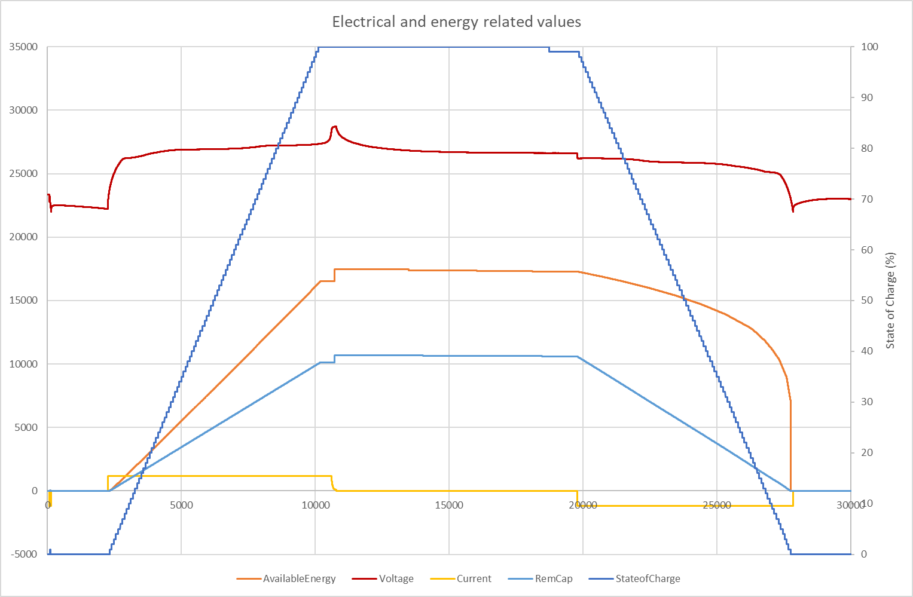

Battery 12.8V 27Ah

