I hope you are well. I am just starting to do some tests with the LM74700 Eval boards.

I noticed that when trying to disable the output of the eval module by connecting the Enable pin to ground (after removing R2 pull-up resistor), that the output is still present on Vout (due to the internal body diode of the FET as also detailed in the data sheet)

“ When the LM74700-Q1 is in shutdown mode, forward current flow through the external MOSFET is not interrupted but is conducted through the MOSFET's body diode.”

My question is –
If I am using the LM74700 as an oring device, won’t there be the potential of the internal body diode trying to supply the load current of the FET that is turned off?
The DMT6007LFG-13 FET data sheet (as fitted to the EVM) says in the that the internal body diode has the following characteristics -
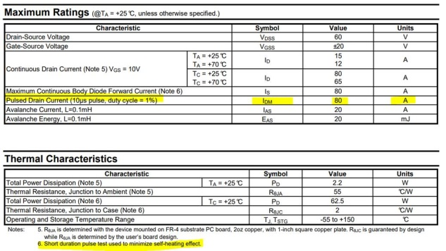
I am guessing that it still won’t be able to do any decent continuous load (Amps) due to the forward voltage drop of the diode (which under normal operation wouldn’t come into effect when the FET is active).

So am I correct in thinking for a true ideal diode oring switch over I would need two back to back FETs driven by the VN74700 ?

