Project: 12V/3A

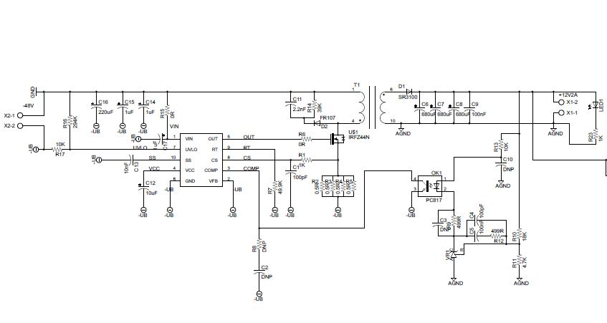

Transformer details for Input:-48V, Output: 12V/3A

**Core: EE25/13/7**

|  |  |  |
| --- | --- | --- |
| Winding | No. of turns | Wire Gauge |
| Primary, W1 | 15 | 28AWG*3 |
| Secondary, W2 | 6 | 22AWG*3 |

**Primary Inductance: 35uH**

Component Used:

* MOSFET=> TOSHIBA TK6A60D, 6A, 600V
* RCZ Snubber: 39K2W and 2.2nF
* R11 50K
* R15 4.7K and R9 18K
* Output Diode NXP BYQ28E200, 3A, 100V
* Current Sense resistor 6 paralell 0.5 ohm 0.25W resistor

Switching frequency: 123KHz

Result:

* Out put voltage 12.07V @ Io=1.25A [Voltage going down on increasing load]
* Maximum Switching Voltage=135V
* MOSFET Heatup
* Current sense resistor heatup
* After 5 min of  running Device on Io=1.25A, MOSFET, Device[LM5020]and Current sense resistor Damage
* Input current is very high