Original behavior  No additional circuit on the soft start pin except SS cap | 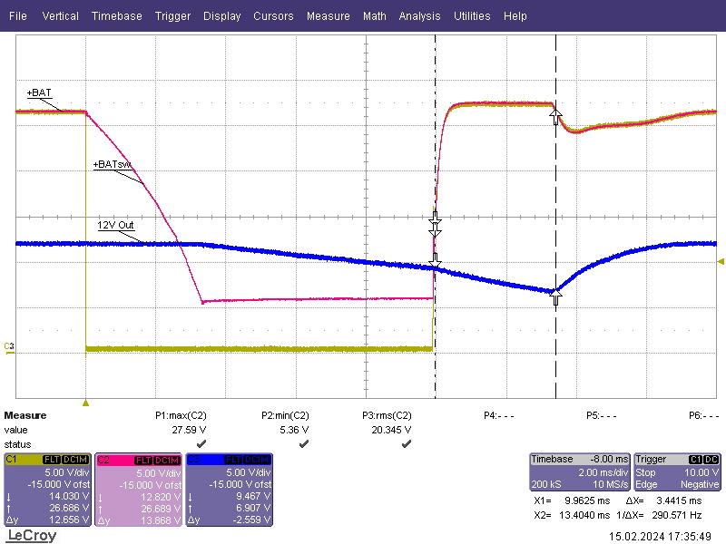
With diode from FB to SS  Refer to schematics screenshot for the details | 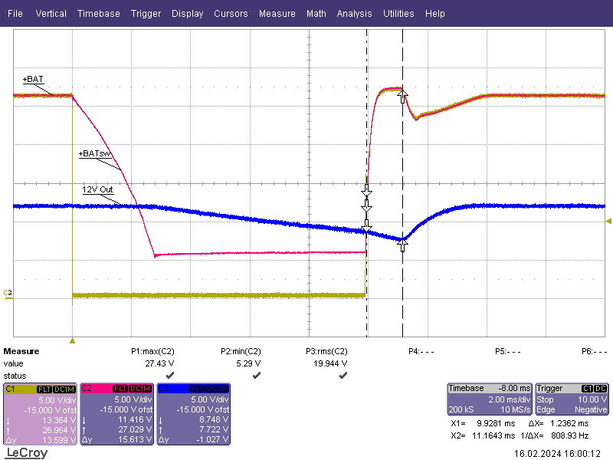
+BAT is Input to application board connector
+BATsw is Hotswap controller output
12 Out is Buck boost regulator output

Red arrow shows modified Soft start circuit for quick restart time after power interruption

