we run the Fusion Digital Power Studio, (Fusion Digital Power Studio(sldc011K.zip) is download from https://www.ti.com/tool/UCD3138FW-BIDI#technicaldocuments )
When we do as below:
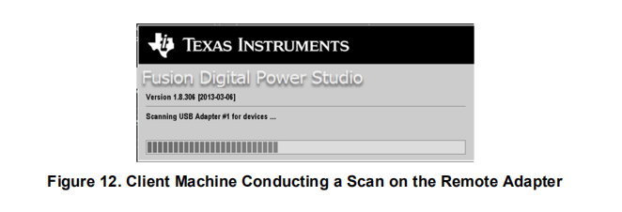
But when we connected the external devices ,we want to find as below,but we can not.
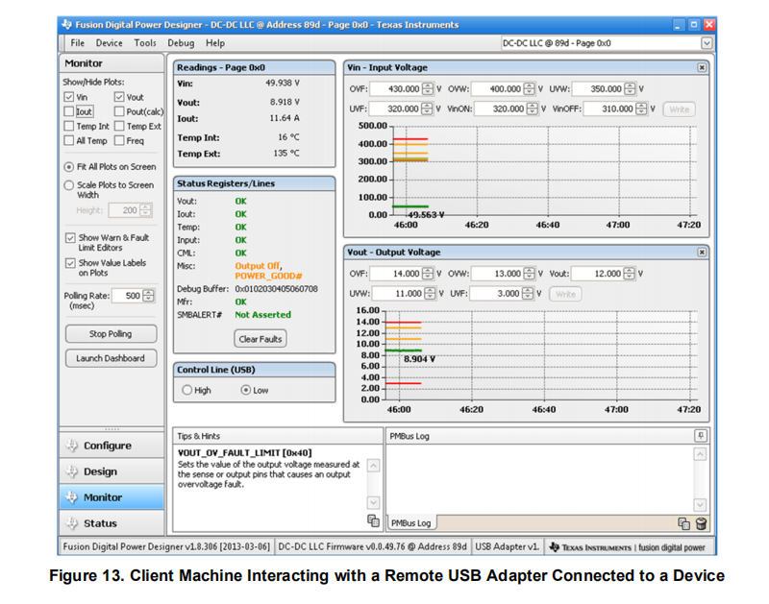
We meet the error as below:
there was an error bootstrapping the Fusion GUI for the DC-DC @ Address 88d:
The following PMBus commands could not be read from the DC-DC @ Address 88d:
VOUT_MODE
These commands are required for Fusion Digital Power Studio to run.
Please verify firmware and power and try again or contact customer support if you continue to have difficulties. 在 TIDP.PMBus.PMBusUIUtils.Verify_Parameters_Readable(PMBusDevice device, IEnumerable`1 command_ids) 在 TIDP.PMBus.PMBusUIUtils.Verify_Required_Parameters_Readable(PMBusDevice device) 在 TIDP.WinForms.Apps.DPGUI.DeviceControl.t() 在 TIDP.WinForms.Apps.DPGUI.DeviceControl.z()
The Fusion GUI can not continue due to this error.

