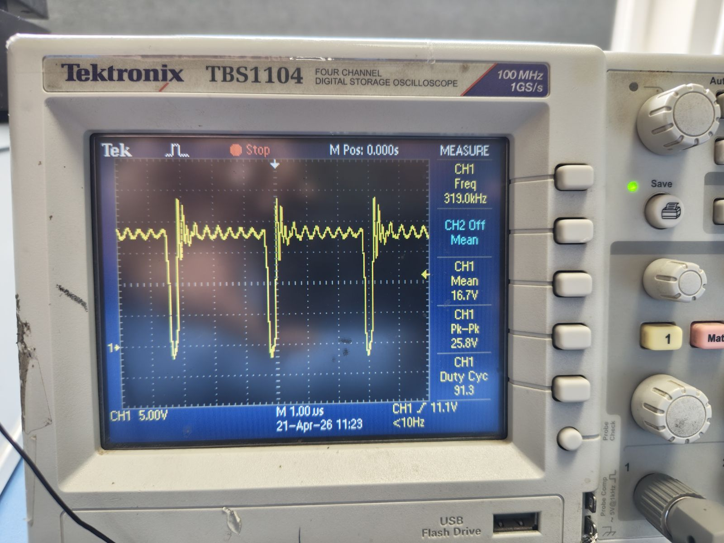
Gate Signal on Q6 Mosfet

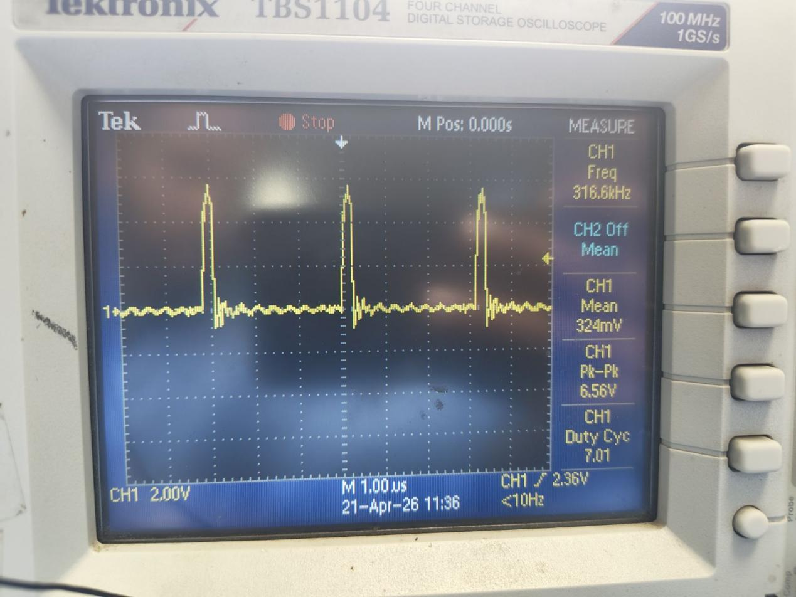
Gate Signal on Q8 Mosfet

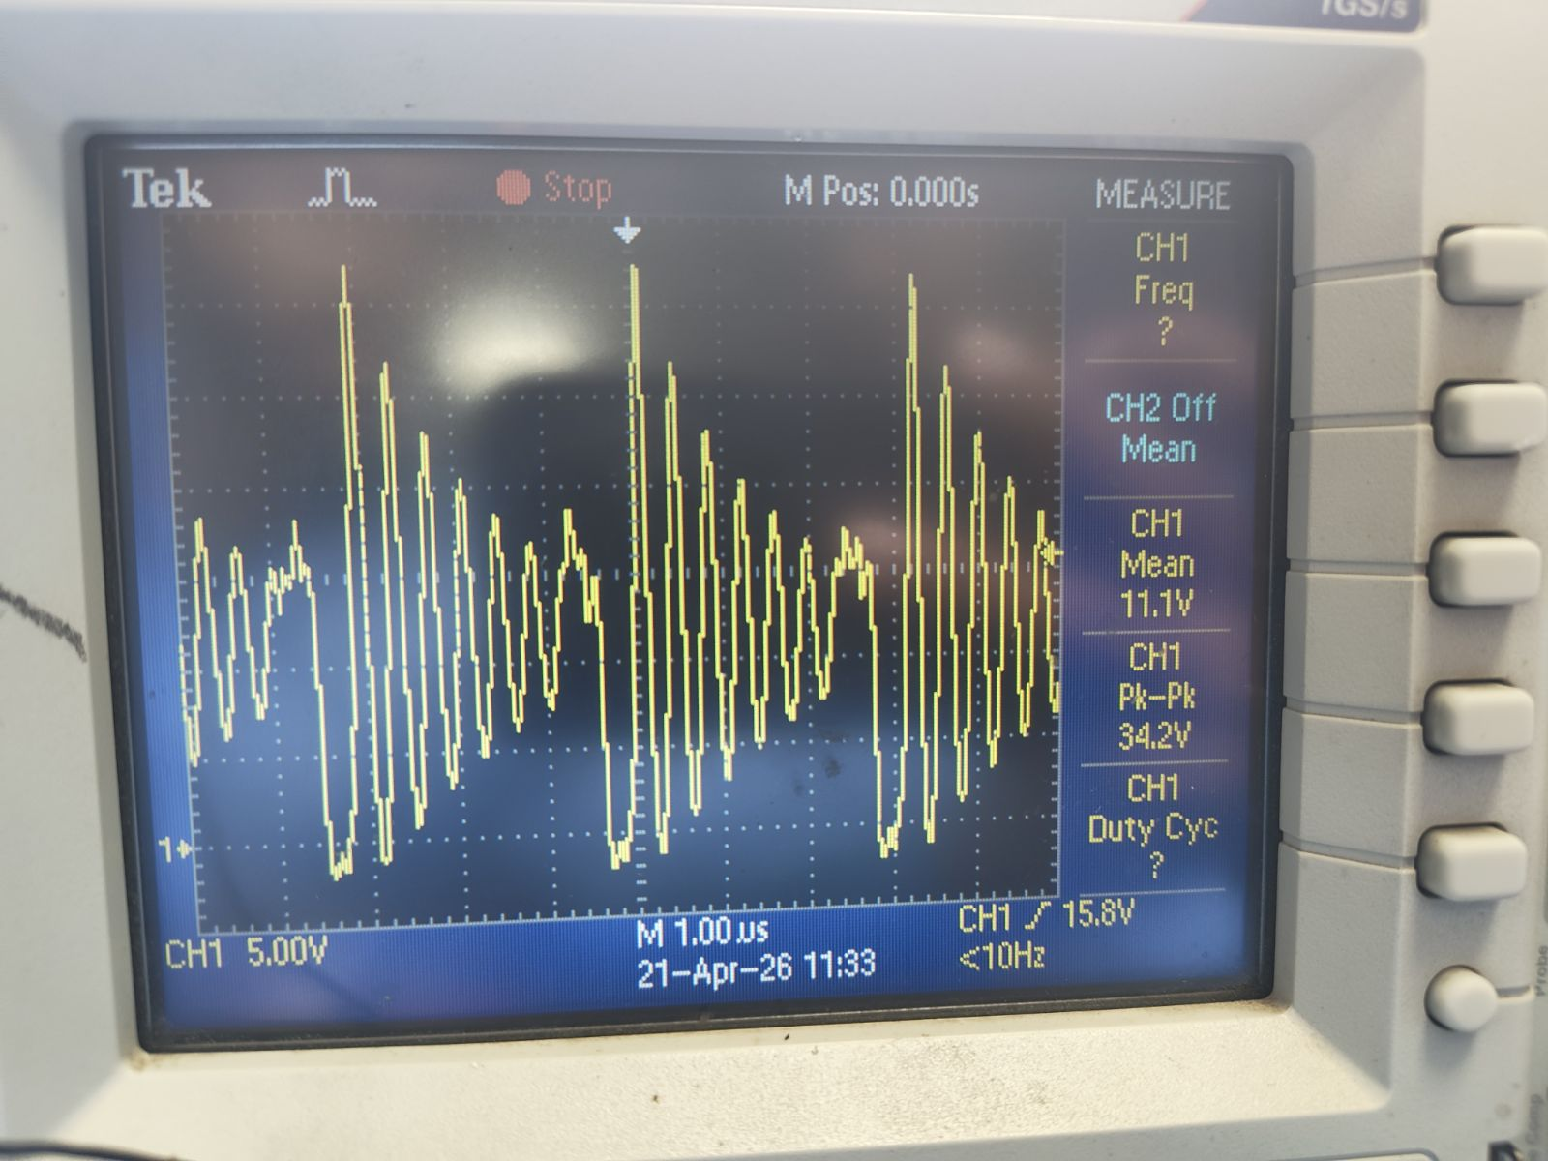
Gate Signal on Q5 Mosfet

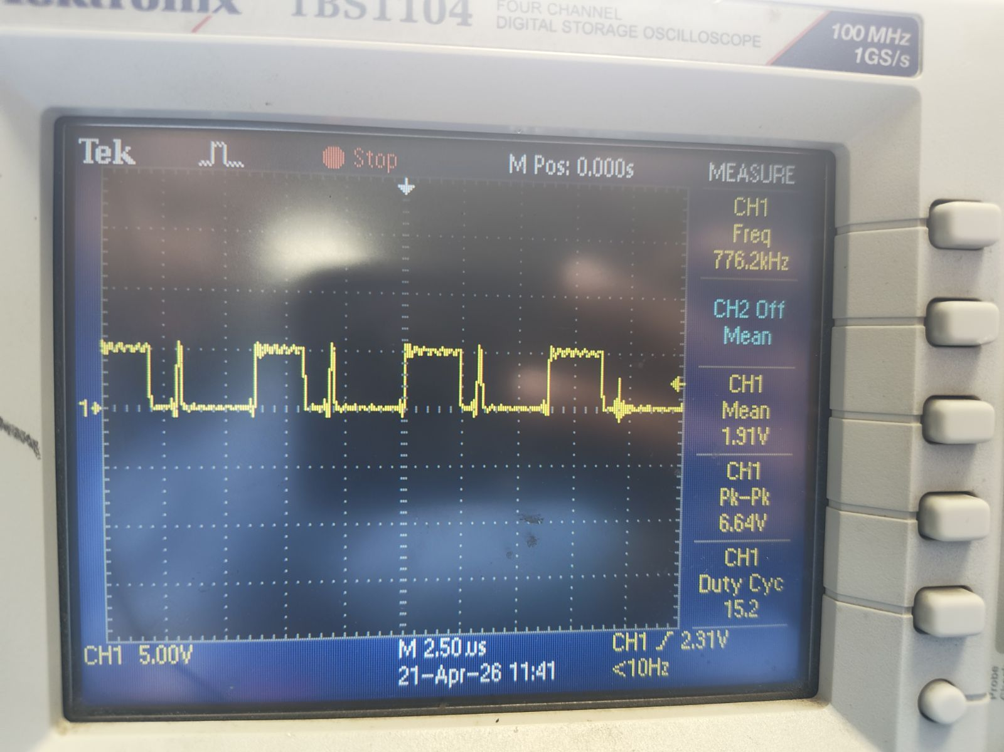
Gate Signal on Q7 Mosfet

