Input Filter Oscillations
Most power supplies present a constant power load to their inputs and therefore have a negative incremental input resistance. This means that the input current will decrease as the input voltage increases. In an off-line PFC stage the current control loop forces the system to emulate a positive resistance at line frequencies so that the input current follows the sinusoidal shape of the input voltage. But the negative input resistance behaviour is present at frequencies beyond the control loop crossover. DC/DC and off-line AC/DC converters will normally have some form of input filter, Figure 1. This filter can oscillate under some circumstances if not designed correctly and this is discussed widely in the literature but the summary rule is simple enough: the output impedance of the filter must be less than the input impedance of the converter at all frequencies.

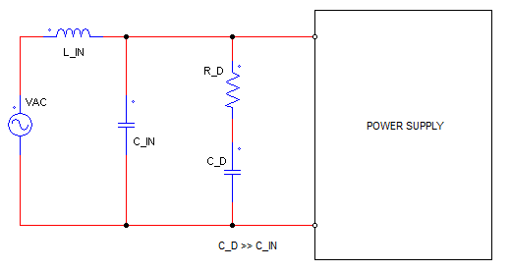 | 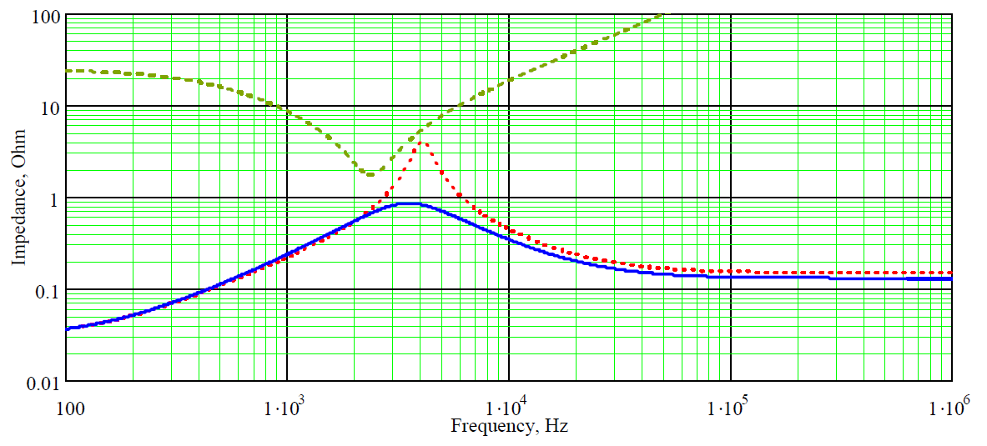
Figure 1 Typical AC/DC converter input filter. PSU input impedance in green. Undamped filter output impedance in red. Damped filter output impedance in blue.

Diagnosis and solution
The simplest way to identify an input filter oscillation is to remove the input filter or at least short out the input filter inductors. These oscillations will normally be at one or other of the resonances of the filter – normally in the range between about 1 kHz to 10 kHz depending on the filter design. Curing input filter oscillations requires modifying the input filter to reduce its output impedance, while maintaining its effectiveness.
- Change the L and C values to reduce the impedance.
- Add damping resistors to reduce filter impedance at its resonant frequencies (also called the Q factor). You can compare the red and blue traces in Figure 1.

