LM3940 regulator Feedback resistors LM2576 regulator Ground plane

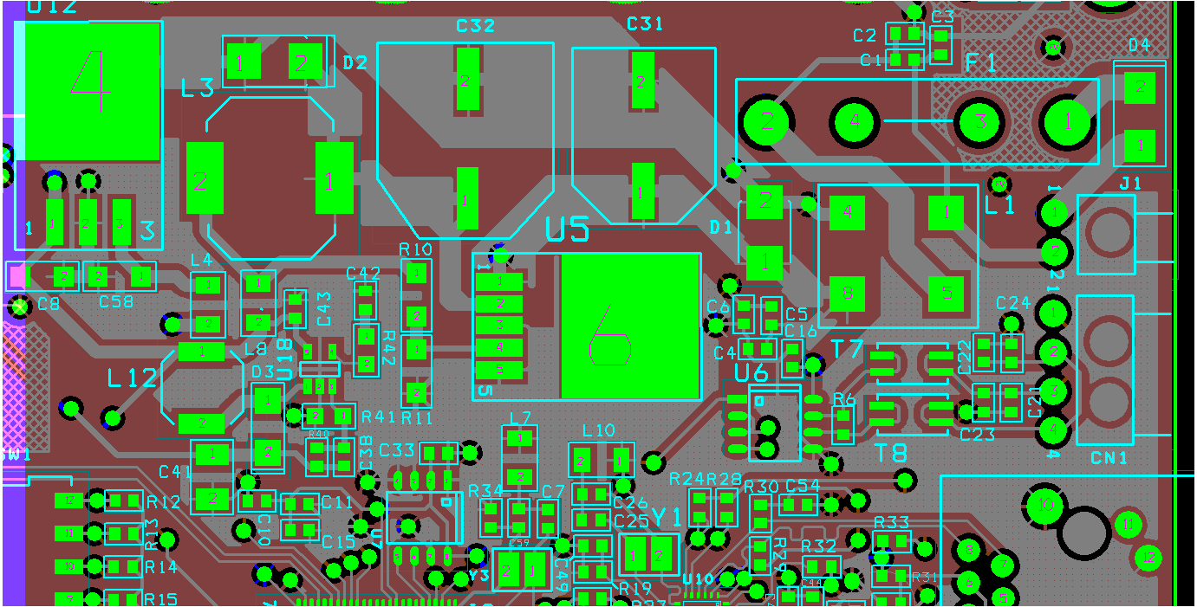

2nd layer –ground plane

3rd layer-power plane

**Regulator LM2576 and LM3940 placed on the top side of PCB**