1. Device GUI -> Utilities [Tab] -> Firmware Migration Tool
   1. 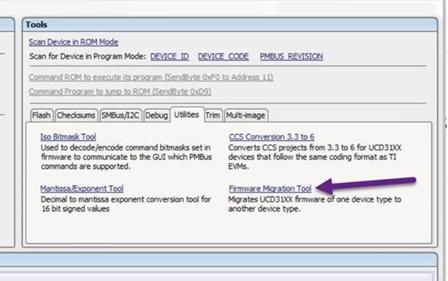
2. Browse to the following folders of the original project:
   1. Source folder
      1. Note: After browsing to the source – green text may appear showing which device id this project is using, example above “UCD310064V1 (UCD3138064)”.  The GUI scans pmbus.h to find this.
   2. Linker folder
   3. Header folder
   4. 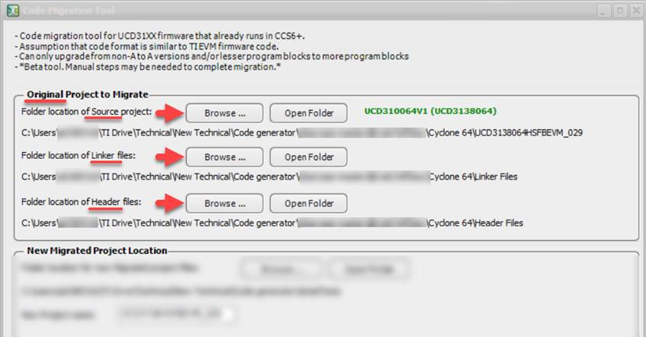
3. Specify the following for migration:
   1. Where you would like to place the newly created migrated project.
   2. Specify the new project name.
   3. Specify the original project type and the type you wish to migrate too.
   4. Click “Migrate”
   5. Note: The original project will remain unaffected.
   6. 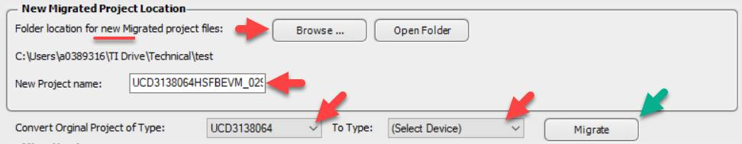
4. See Log for status of migration. Full details of changes are in the log.  At the end of the log a summary of the migration steps used to convert will be displayed along with warnings (see below for example).
   1. By clicking “Open Log” it will open in a web browser for easier viewing.
   2. 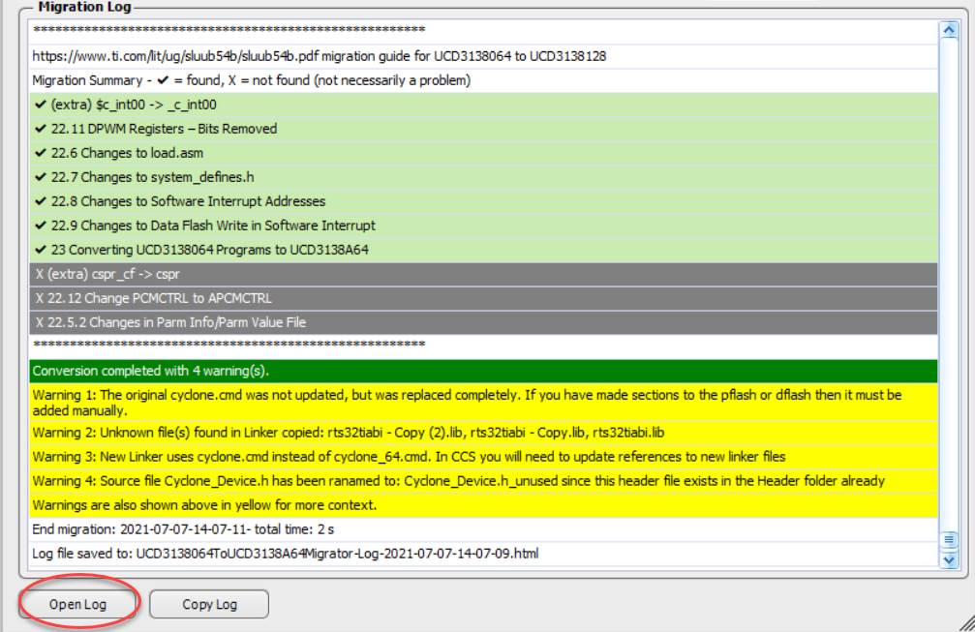
5. Access the newly created migrated project by clicking “Open Folder” in the “New Migrated Project Location” section. Each migration will include a timestamp on the folder name.
   1. 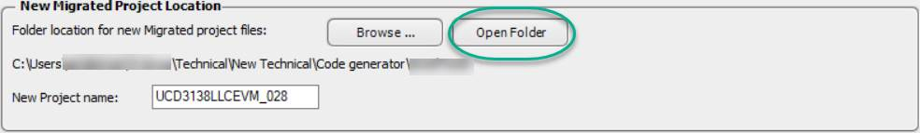
6. Migration guides followed for migration:
   1. UCD3138 -> UCD3138064 migration guide: <https://www.ti.com/lit/ug/sluuad8b/sluuad8b.pdf>
   2. UCD3138064 -> UCD3138A64/128 <https://www.ti.com/lit/ug/sluub54b/sluub54b.pdf>