I use tps2121 according to the typical circuit connection method. In Figure 1, the front stages of in1 and in2 are respectively connected with 12V input. Due to the voltage, the current tps2121 selects in2 (the out pin of tps2121 is currently loaded with 1.65A). At this time, my two 12V inputs are turned off (at the same time), and the output of out pin vibrates.



Figure 1

The waveform of out during shutdown is shown in the figure. (PS: the output voltage is 12V because the equipotential surface is - 12V)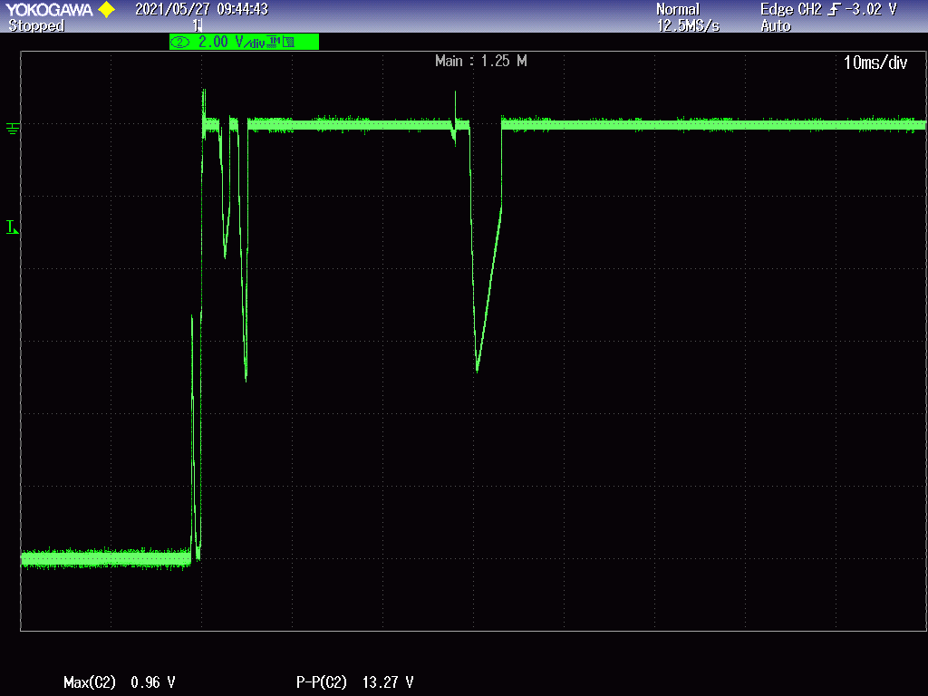

Figure 2 out Foot concussion

After the load of out pin 1.65A is turned off, turn off - 12V at the same time, and the waveform is shown in Figure 3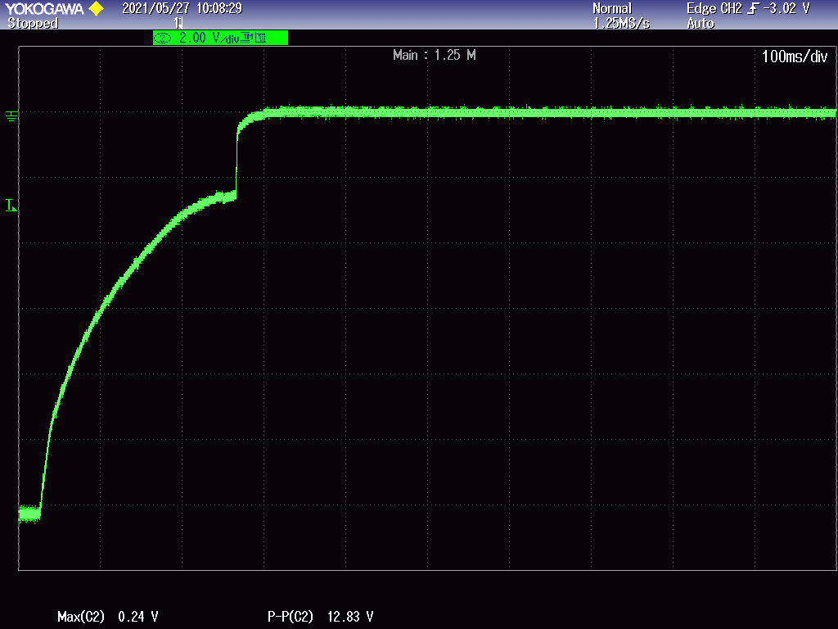

Figure 3 out The feet descend slowly

My preliminary judgment is that the switching between the two channels of tps2121 is relatively slow. If the switching is fast, the voltage should be reduced in the slow switching rather than low oscillation.

According to the TSW time and tfsw time in the tps2121 manual, tps2121 can switch as fast as 5us, but according to the typical solution, this time is not 5us. So please give an answer to the fast switching between tps2121 channels.