6.7v track,trace width=1mm I/p cap 10uf

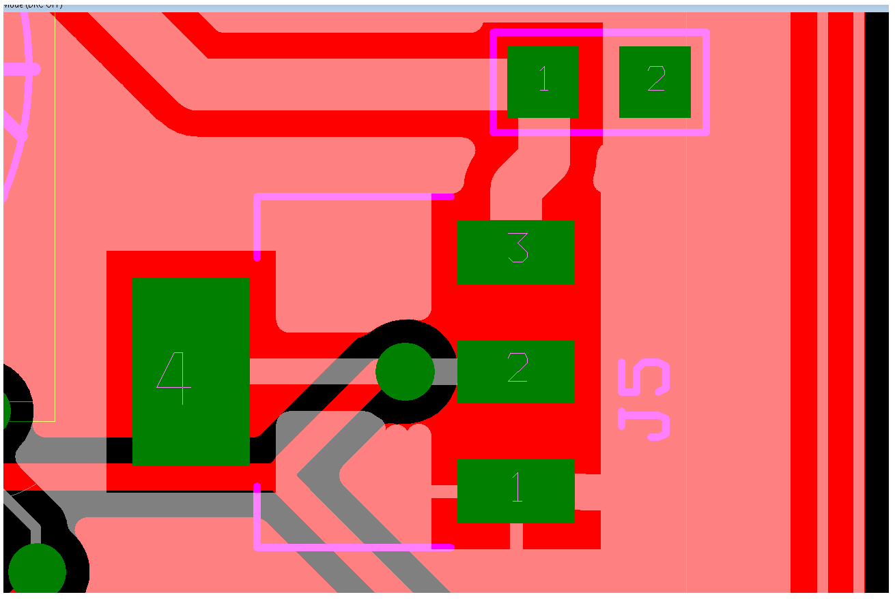

3.3v O/P track,trace width=0.5mm Ground plane at top layer Ground plane at bottom layer

IC LM1117MP-3.3/NOPB on the top side of PCB