* 1:The capacitor C11 is not very close tho the gauge. There are 2 vias between the gauge and the cap. Place the cap closer to the gauge and less vias is better. We can use separate capacitors for REGIN and VCC is possible to realize that each cap is close to gauge.
  + Hope you suggested capacitor addition on REG25. So added a CAP of 0.47uF on REG25.

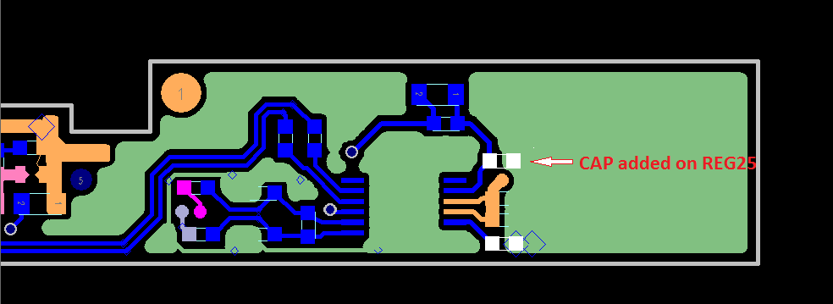

* 2:

[](http://e2e.ti.com/cfs-file/__key/communityserver-discussions-components-files/180/4747.e2e.JPG)

* I am not sure why the layout is like this, that a triangle in the yellow area.
  + Because of two layer enabled (layer 3 and 4)
* 3: Make sure to use kelvin connect in the BAT sense line.
  + Highlighted portion is sense line. It is routed in Layer 3 and Layer 4.Hope this meets the Kelvin connect requirement

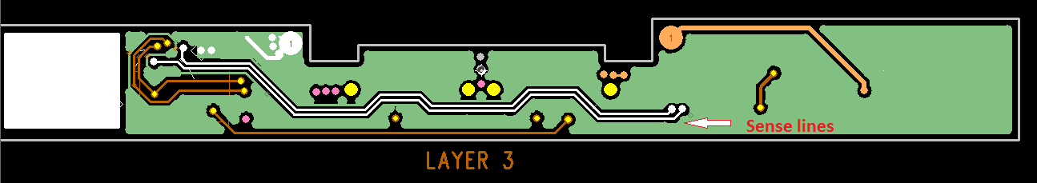

* 4: If possible, make the ground plane a complete plane.
  + Layer 2 is ground plane. Hope this is good enough.

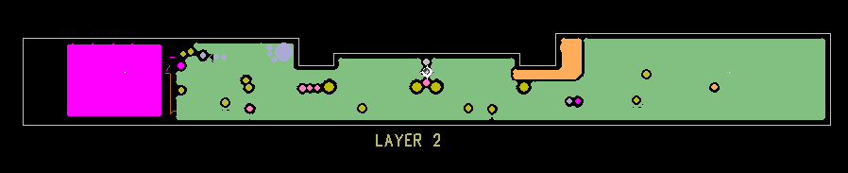

5: Make sure that the ground pin of U5 (pin 3) is close to the PACKN

* U5 placed near to PACKN

