**Load current changed from 0.02A to 0.08A, the waveform of SW point are as follows：**

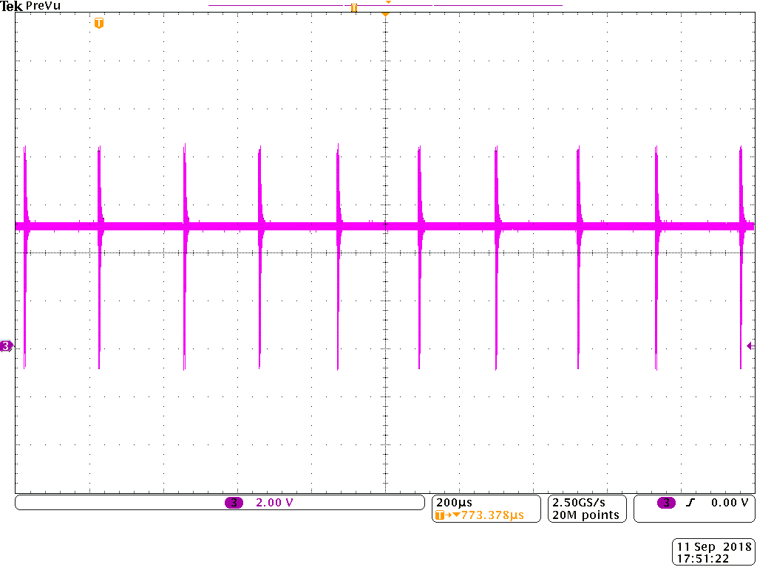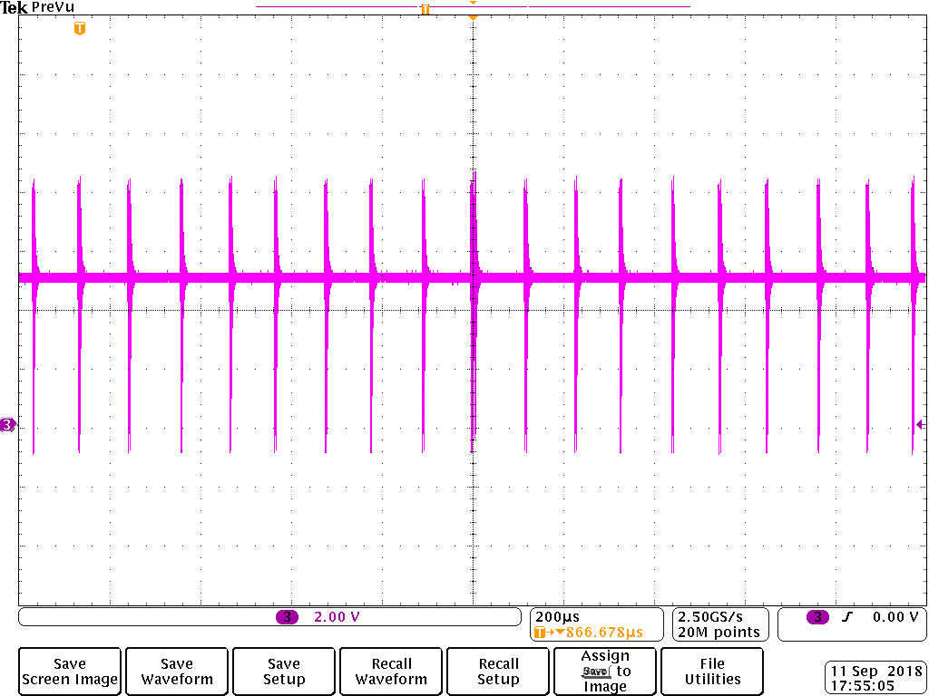

**0.02A 0.04A**

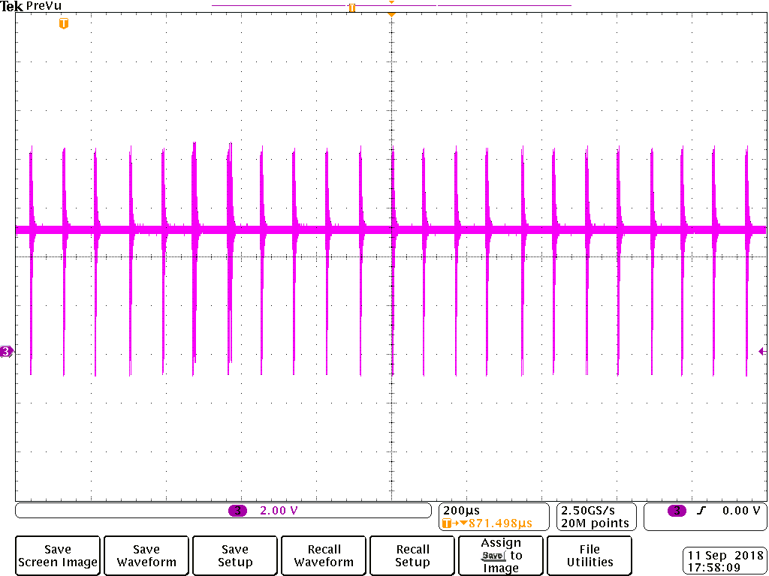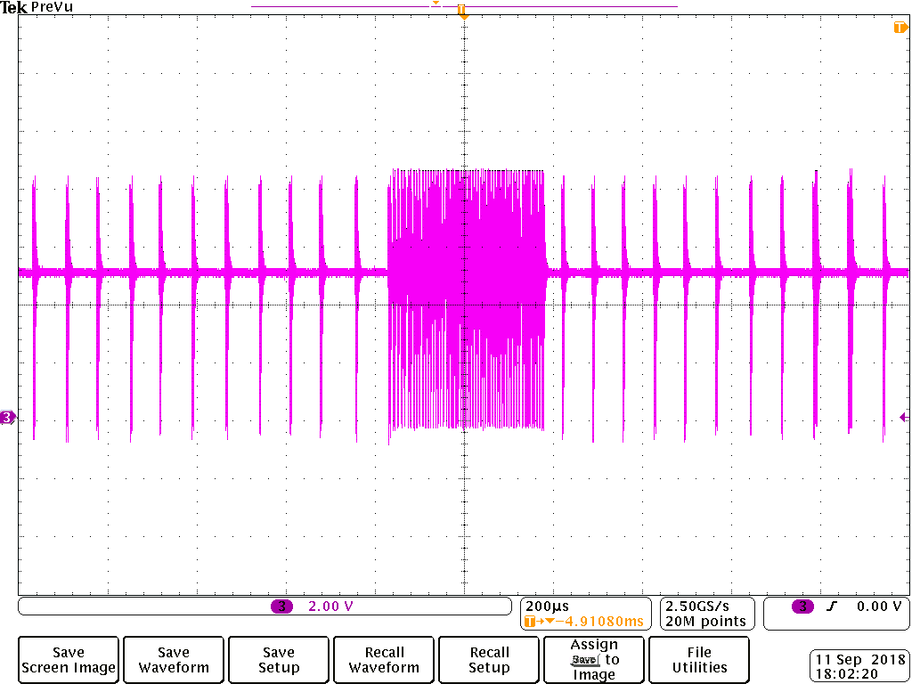

**0.05A 0.06A**

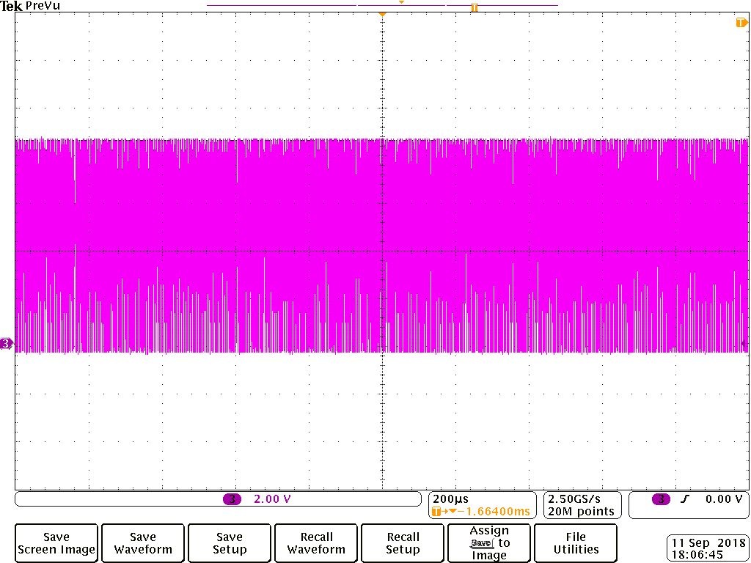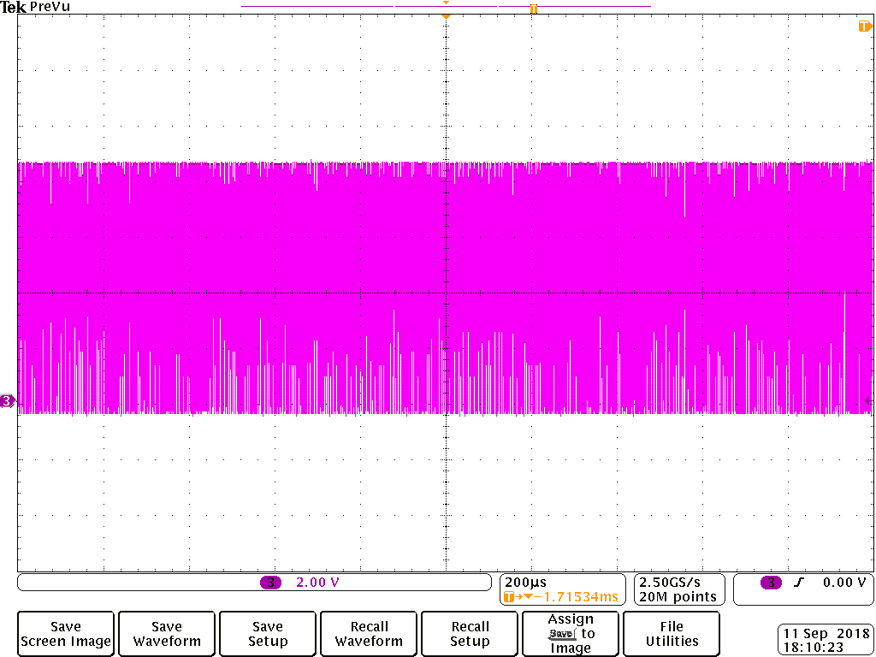

**0.07A 0.08A**

**Load current changed from 0.13A to 0.18A ：**

**Because the waveform in 200us looks same, so when the current changed in this range, I use a smaller spectrum.**

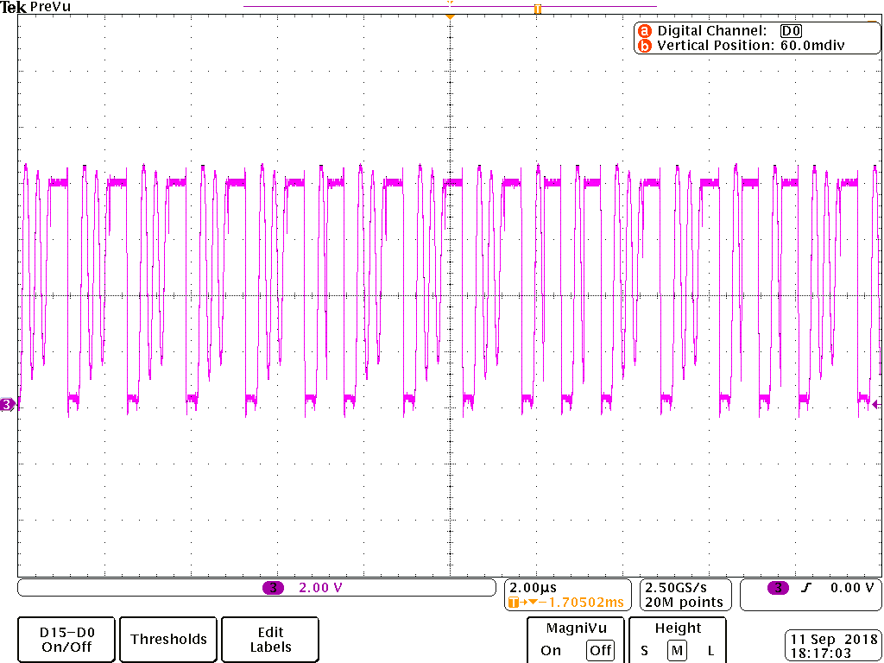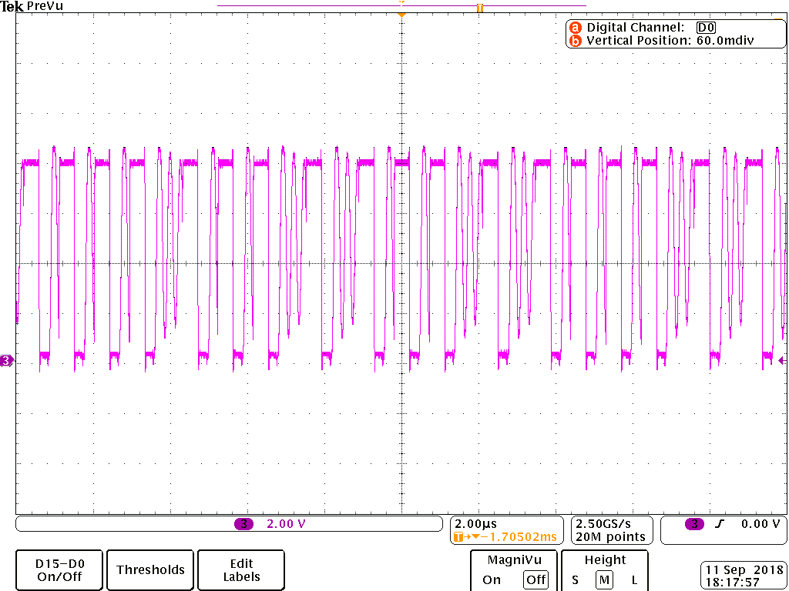

**0.13A (16 times switching） 0.14A（18）**

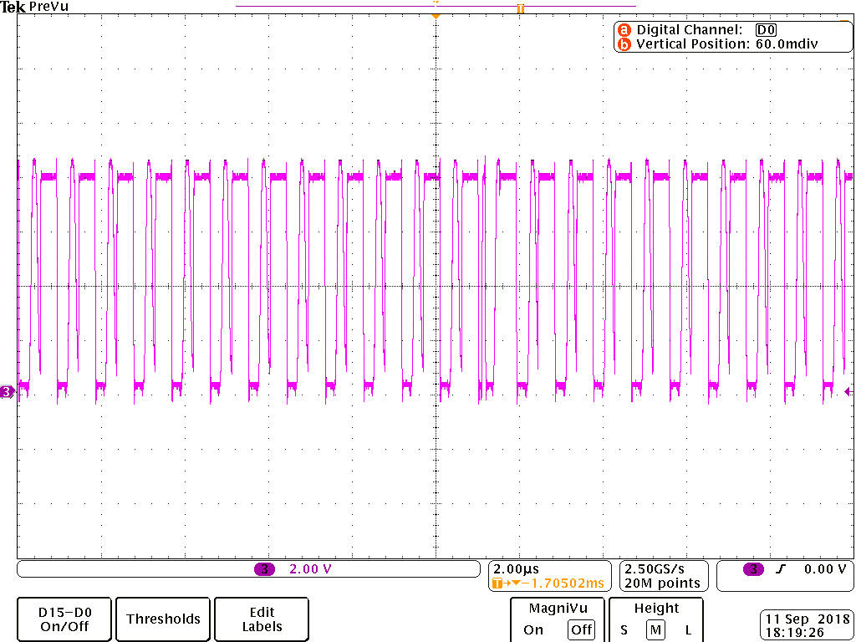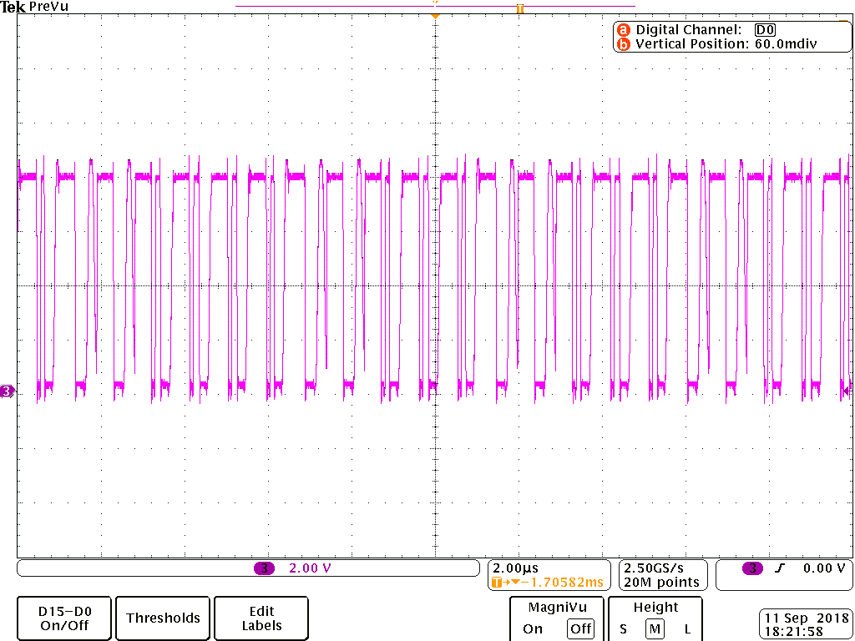

**0.15A （22） 0.16A（22+13）**

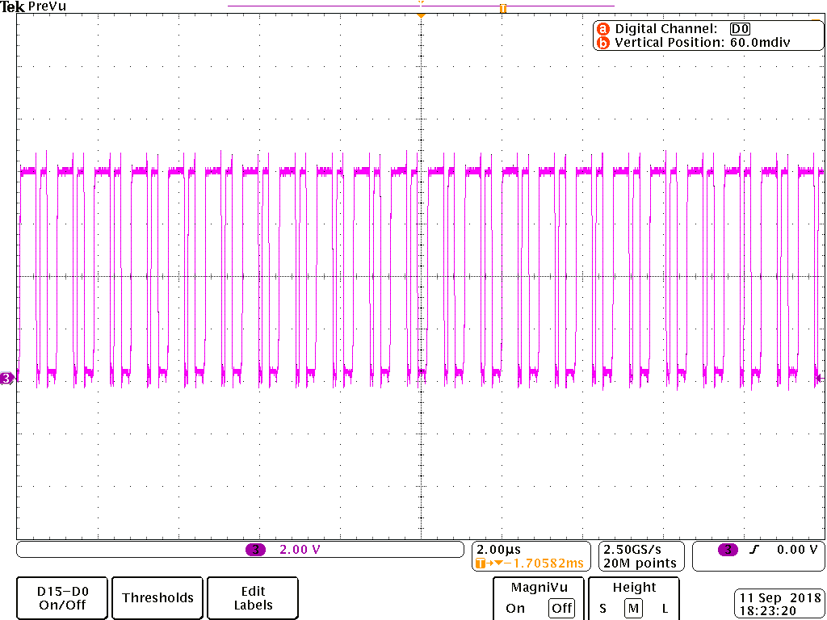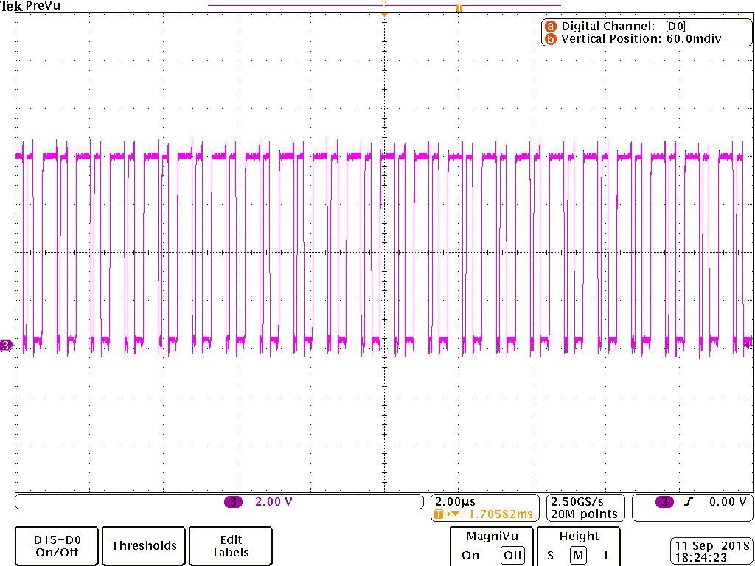

**0.18A（22+22） 0.23A（22+22）**

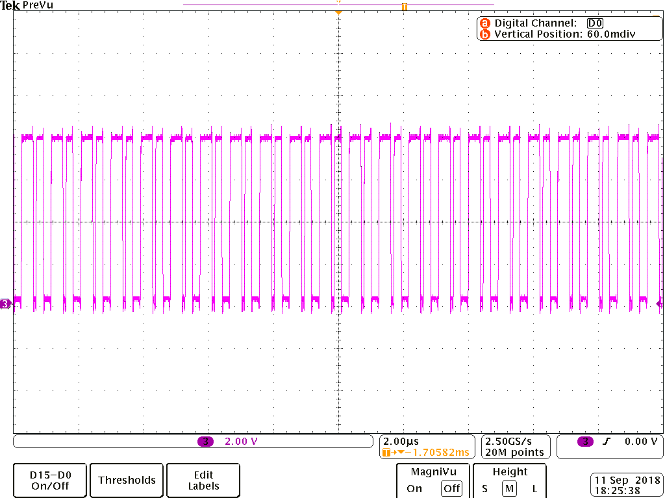

**0.3A（22+22）**

**This subharmonic will disappear when load current to 1.6A**