This is qiangjin of BYD.
I have a project use TPS23750 and found some issues. . Attached is the schematic diagram. I use 23750 to generate 5V voltage for my system. But now the output is only about 2V.
I tested vbia, 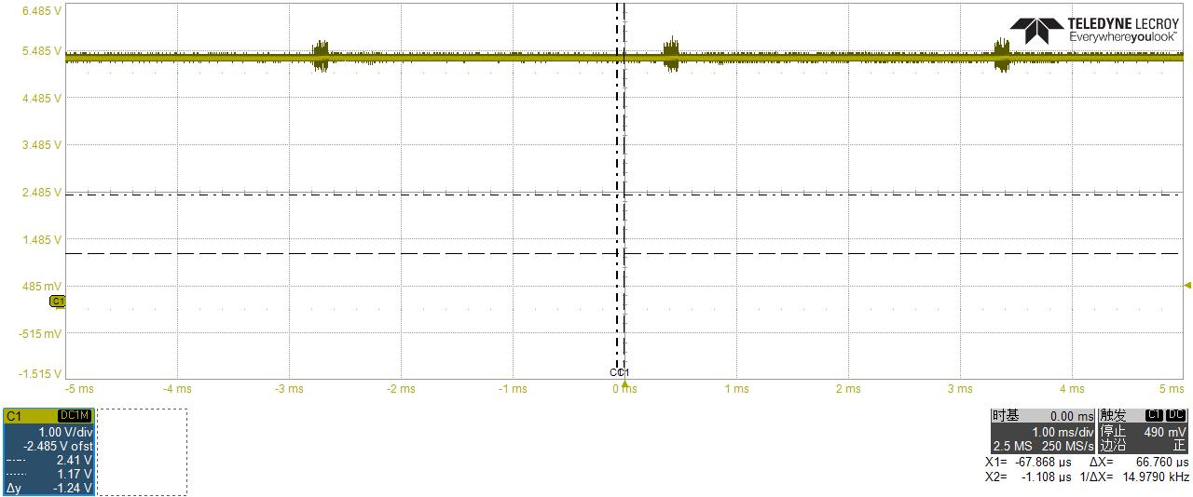
VTMR
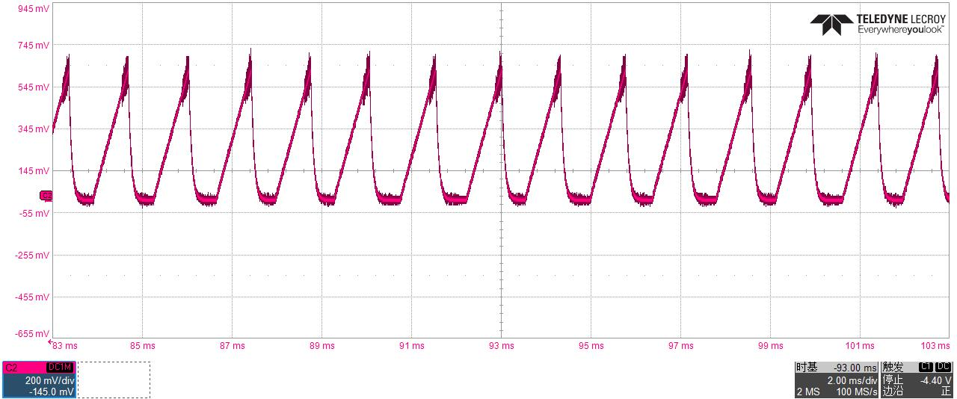
Vaux,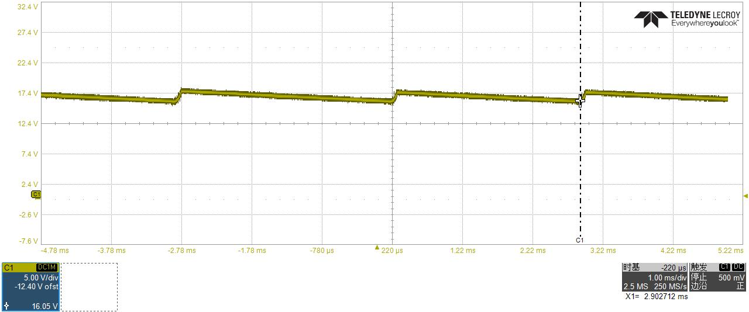
vgate,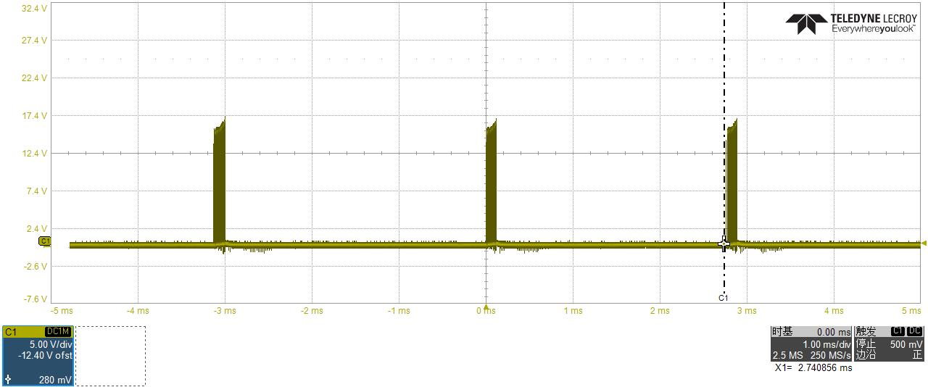 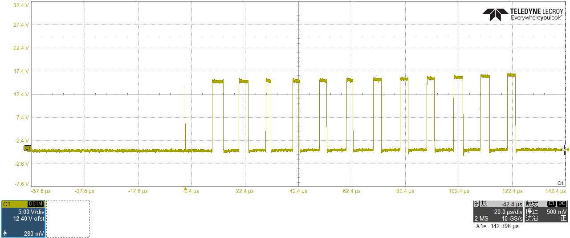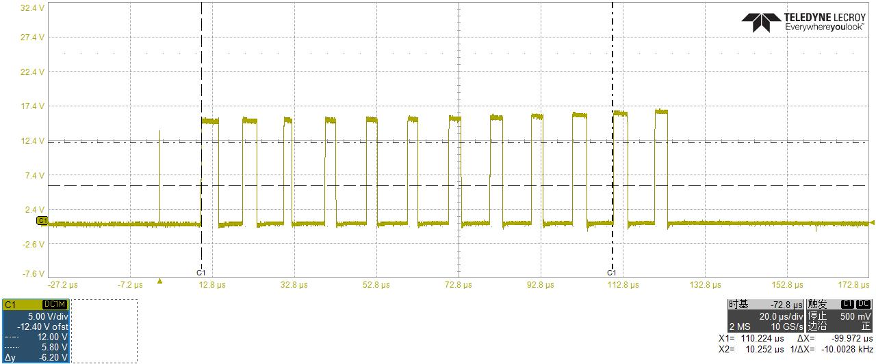

About MOS6. Yellow is vgate and red is Vdrain.
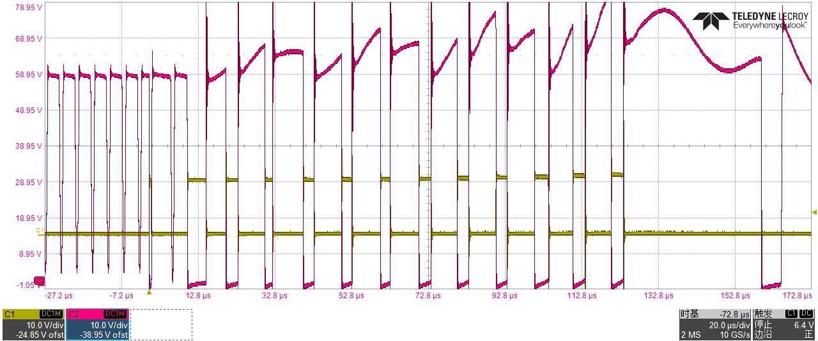
5pin and 1pin of T3
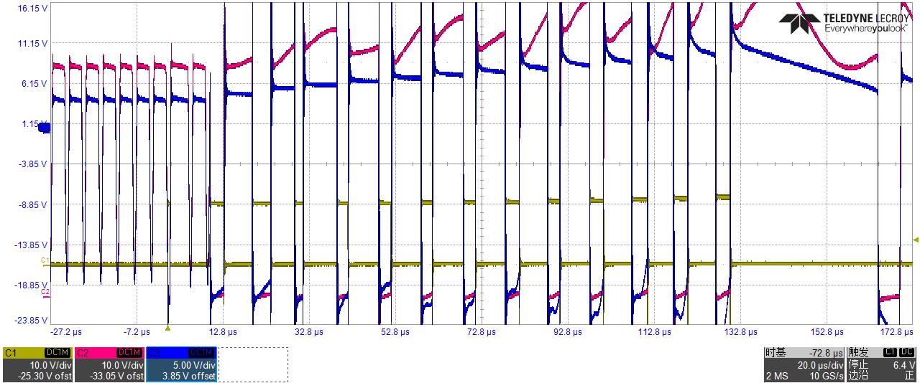
I found that T3 input voltage exceeded 57V. Is this a problem? (Please see the attached waveform) And T3's 9, 10 and 11, 12 pin voltage is about 2V to - 10V. So the output is 2V.

T3.9.10pin
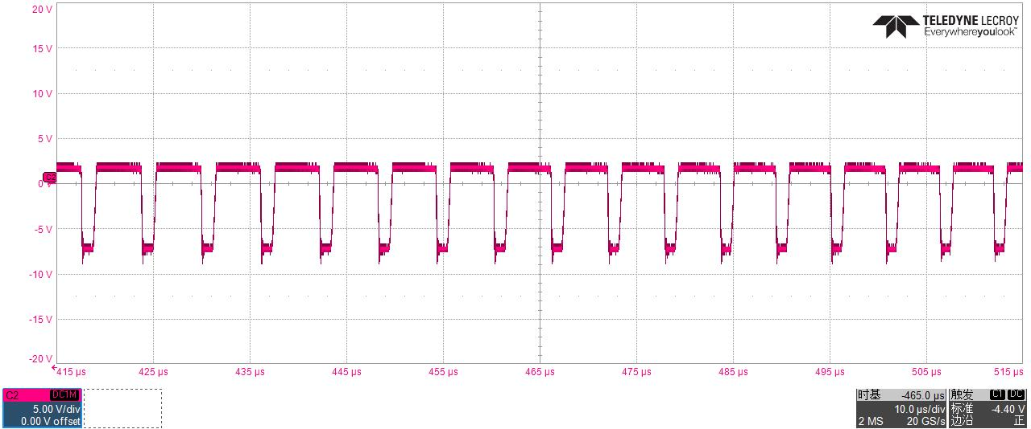
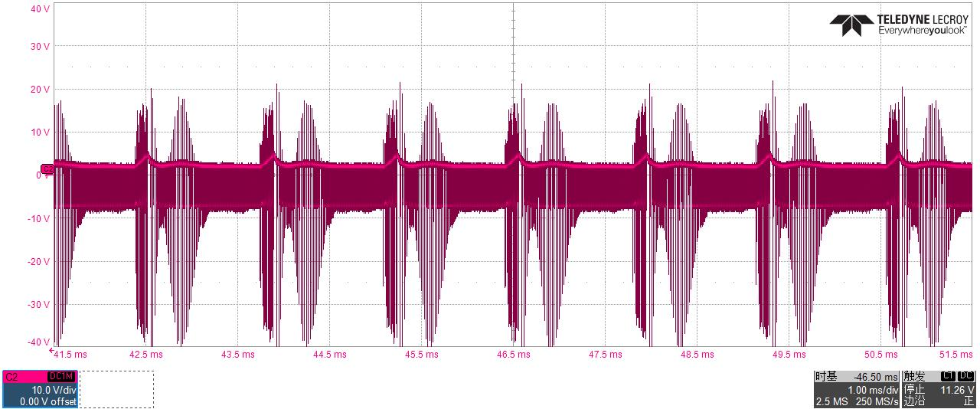
Vcomp VS Vgate
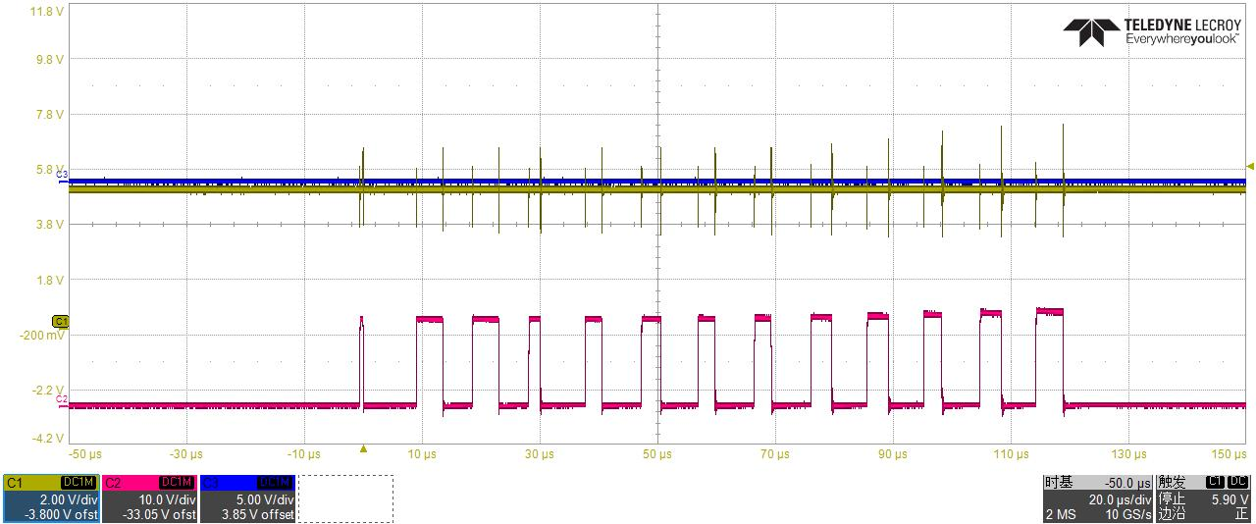
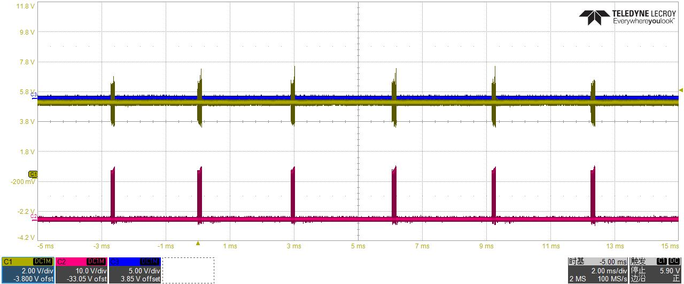
Vcomp is over 4V and I cannot find the reason.
Hope to give me some guidance on how to modify the circuit or what kind of test I should do.

