12V to 3.3V Layout
Device pins 10 to 14 are not connected on top layer to the pad under device.
It is better to connect via pcb pour than the vias.
Input capacitors should be close4 to the VIN(15-17) and GND(10 to 14) pins.
What is the pour (circled) on pins 10 to 14 connected to.
How is connected to the gnd on the rest of board.

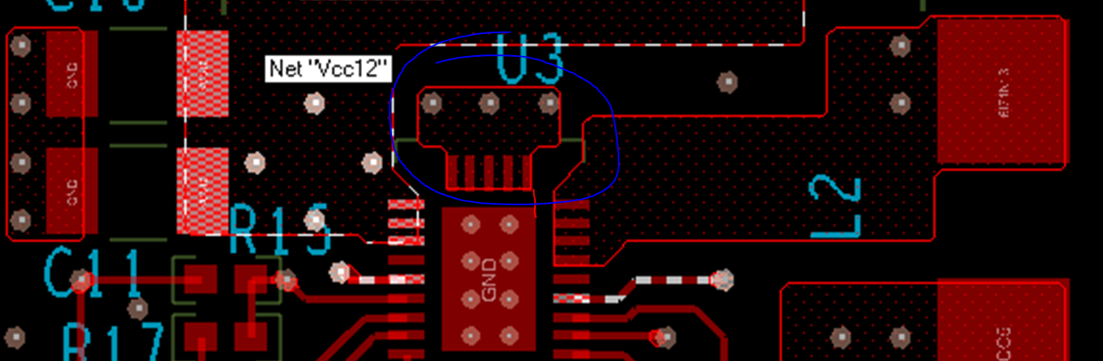

See figure 65 in https://www.ti.com/lit/ds/symlink/tps53915.pdf for layout recommendation.

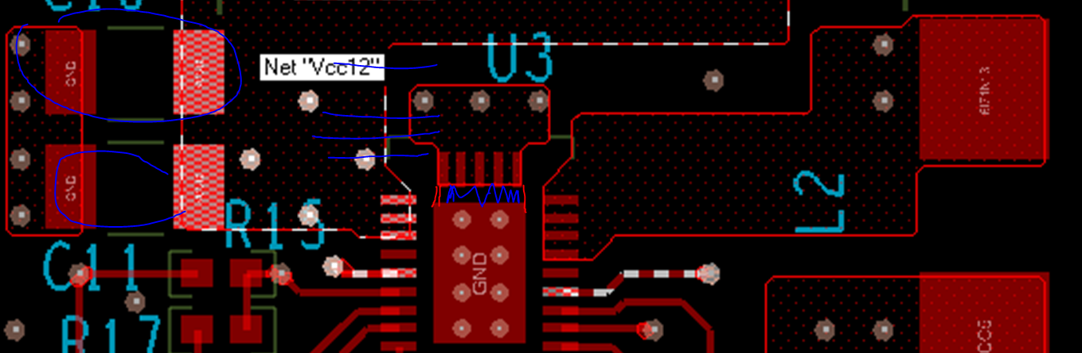

The SW pour area is large.
The inductor, boot capacitor and RC snubber are very far away from device.
The boot capacitor can be connected on the same side as device.
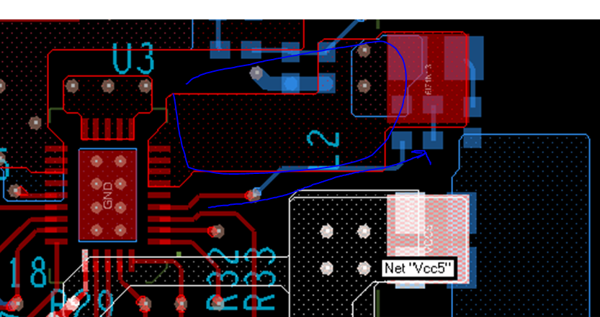

Replace the IC
And make the modifications to the board, before powering up.
