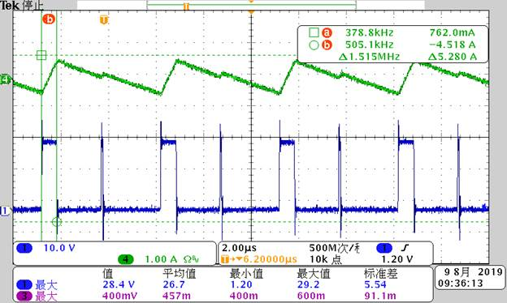

Vin=21.2V, Vo=3.068V,Io=0,Rboot=4.7R

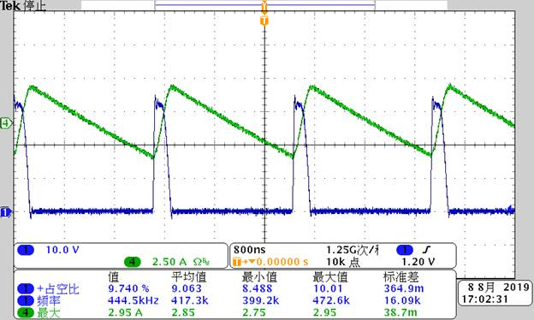

Vin=31.2V, Vo=3.07V, Io=0, Rboot=11R

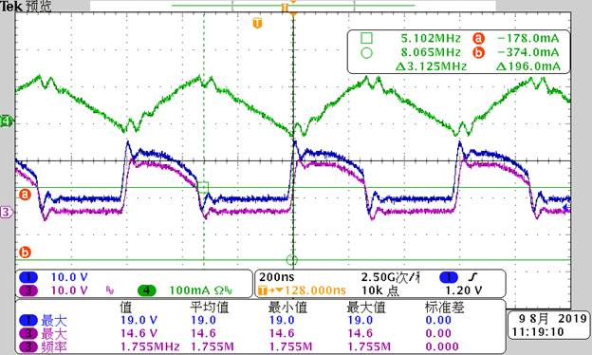

Vin=12V, Vo=5.079V,Io=0,Rboot=11R(1-Vcboot;3-SW;4-IL)

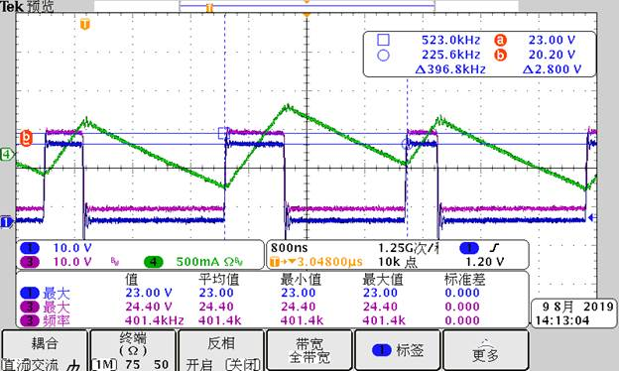

Vin=20V,Vo=5.06V,Io=0, Rboot=4.7R(1-SW;3- Vcboot;4-IL)