Schemetic：
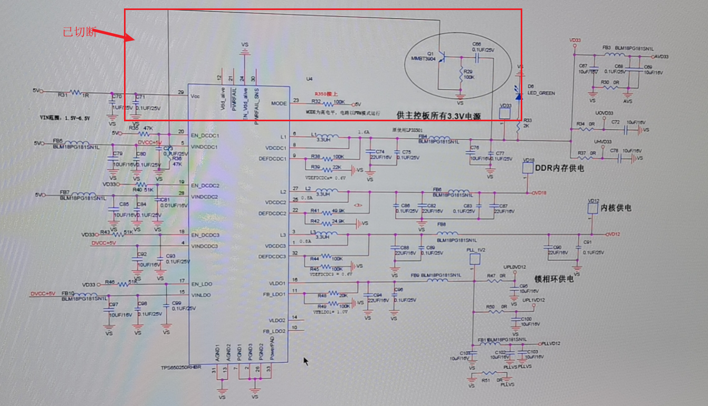
Bule：EN Pin Yellow VDCDC1 out put
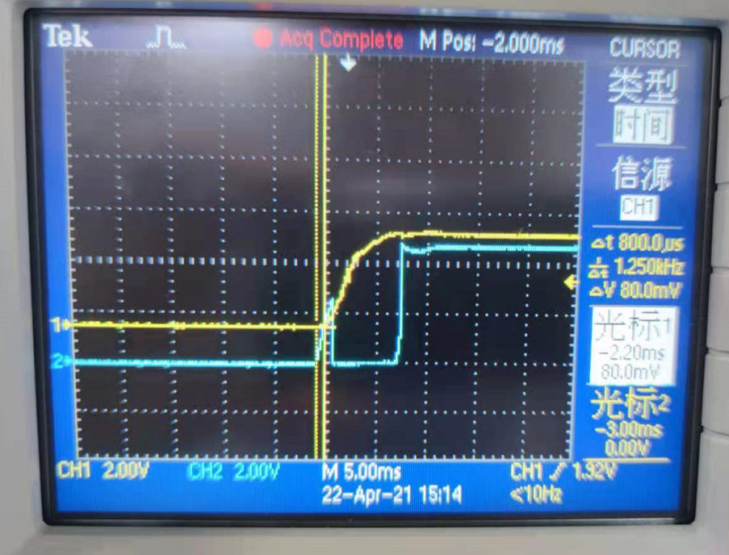

Pull Down EN_DCDC1 VDCDC1 3.3V still have output
