We have a test with below requirement :

* Input 14.5V ,and dropout every 500mS ,dropout lasting 0.5mS

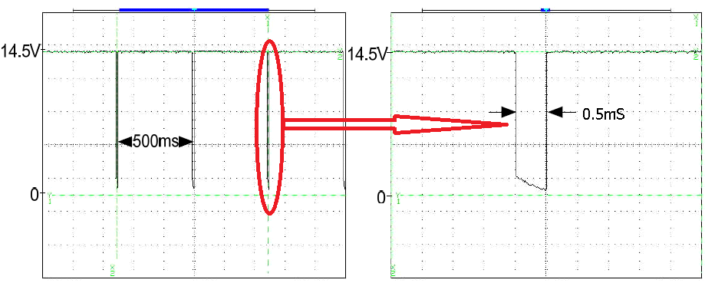

The schematic as below :

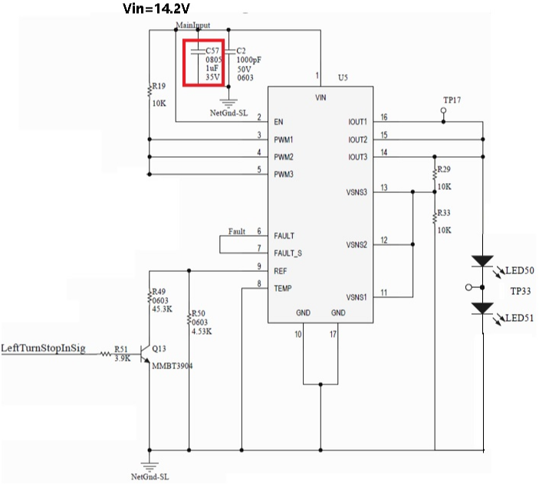

The failure of waveform as below :the fault pin will be pulled down for a cycle ,the fault pin of some samples will recover to high level and work normally, but the fault pin of some samples couldn’t recover and keep low level.

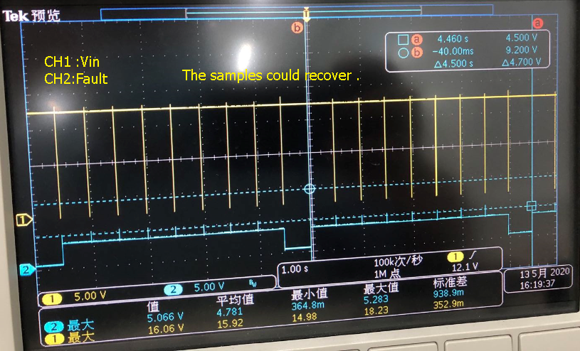

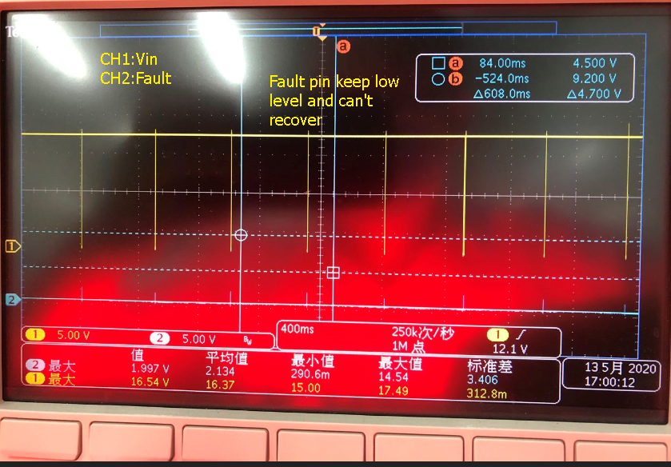

I have no idea what the root cause is that cause the fault pin dropdown and can’t recover ,even the input voltage and PWM pin recover to 14.5V .

After I debug the value of C57 to 10uF ,the circuit could work normally,the fault pin could keep high level as below.

It looks like the power inadequate ,but I am not sure about it .Could you tell me how to verify it ?Where I could find the related information in specification about the power supply requirement ?

