Could you help to check our updating steps with system?

Unseal FG;

Enter ROM mode;

Machine generated alternative text:
SP 
55 
55 
55 
55 
55 
55 
55 
55 
55 
55 
55 
55 
55 
55 
55 
55 
55 
55 
55 
55 
Wre Transatbcn 
Wre Transattjcn 
Read Transaction 
Transactjcn 
Read Transaction 
Transactjcn 
Read Transaction 
Transaction 
e Read Transaction 
Transaction 
e Read Trangttjon 
Transattjcn 
e Read Transaction 
Transaction 
Read 
Q. Transaction 
Read T rarettion 
o. Transaction 
Read Transaction 
Transattjcn 
Read Transaction 
Transattjcn 
00 00 00 
00 04 
00 72 
00 00 00 
00 
00 
00 00 00 
00 co 0? 

Transform Data one or two bytes once;

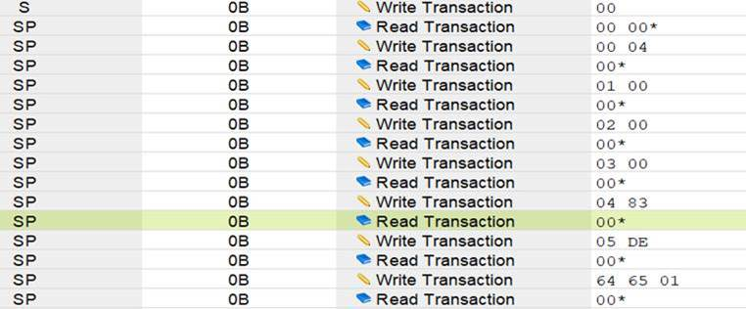

Execute flash code;

