Can you capture the waveform at Vout only 2--2.4V cycle?
1. Vin - Yellow Trace
2. Inductor current (see below)
3. SW - Purple Trace (I did not measure Vout after the inductor)
4. VCC - Blue Trace

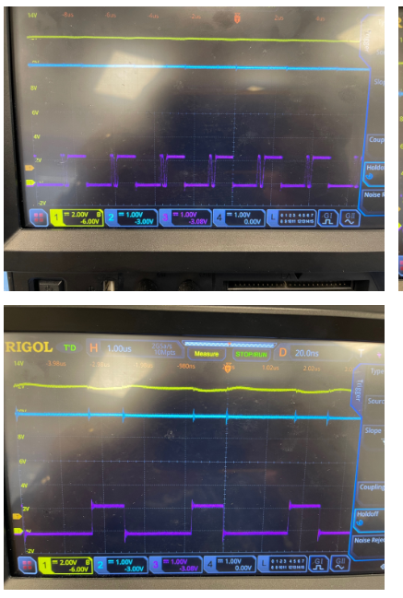
Searching for frequency. I out ~ 450mA Regulating. I out ~1.5A ERROR - I out < 100mA
