1. Make sure SYSREF is running continuously before enabling the SYSREF monitoring.
2. Set SYSR_CAPTURE register 0x24 to 0x1800 to enable the alignment monitoring and have the SYSRF_ALIGN_DLY set to the default position.
3. After enabling, write 0x1802 to address 0x24 to clear the statistics.

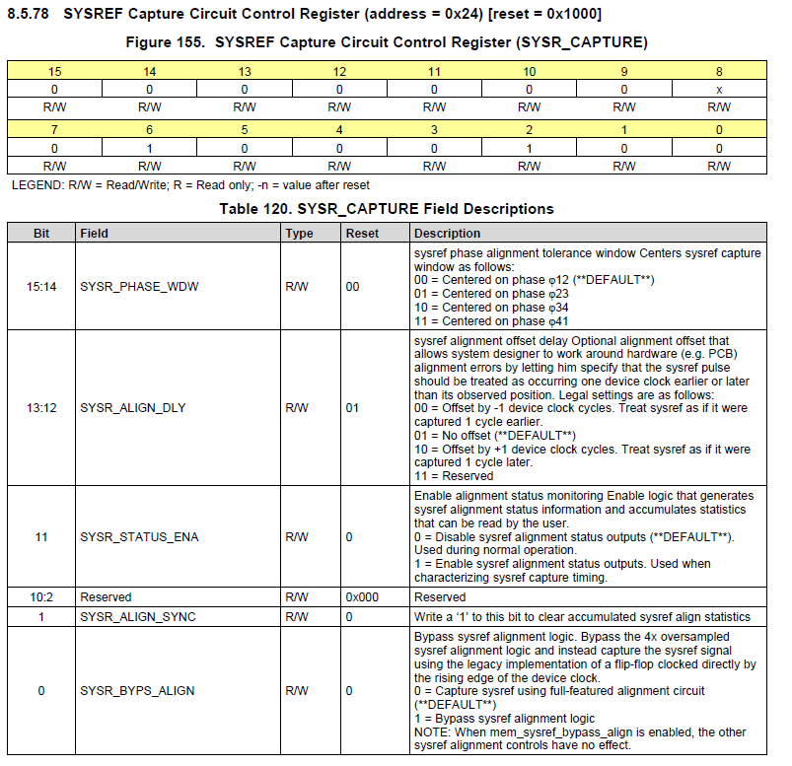

1. Read register SYSREF_ALIGN_R, address 0x78.

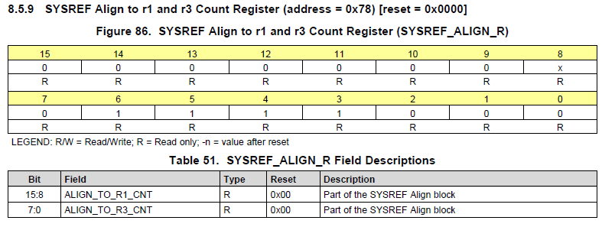

1. Read register SYSREF12_CNT, address 0x79. This will give the number of times SYSREF transition was located in phase 1 and phase 2.

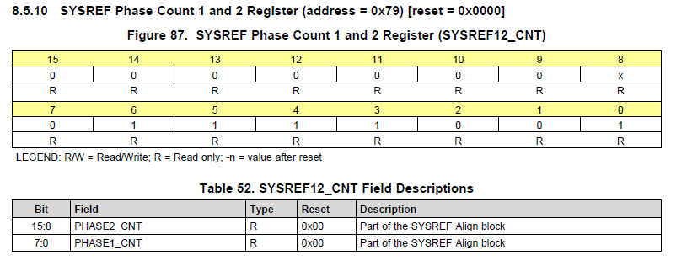

1. Read register SYSREF34_CNT , address 0x7A. This will give the number of times SYSREF transition was located in phase 3 and phase 4.

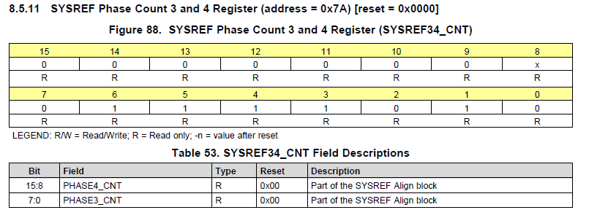

Record the values for address 0x78, 0x79, and 0x7A. Address 0x79 and 0x7A will show how often the SYSREF is captured in a particular region.

Repeat this test at room temp, and -30 C and in 10 degree increments between these two if possible. Ideally, the data should look like what is shown for DAC2 below.

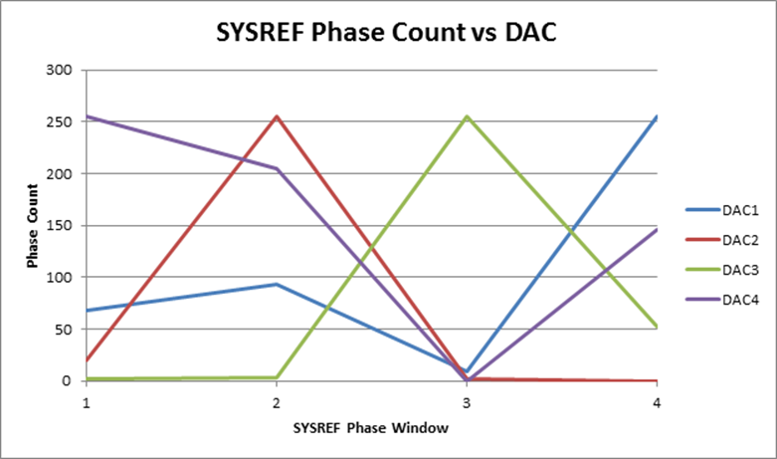

Adjust bits 15:14 of register 0x24 to capture SYSREF on the phase indicated by the data captured from address 0x79 and 0x7A.