1. To check for SYSREF, run the DAC in NCO only mode and synchronize the NCO blocks to SYSREF. Make sure SYSREF is not an integer divided of the NCO frequency used. If SYSREF is present, the NCO will be unstable. Set address 0x27 in page 1 and 2 to 0x2828 to use SYSREF as the SYNC source. If SYSREF is present, the DAC output will now be many tones as the NCO will be constantly reset by the SYSREF signal. If SYSREF is disabled, the DAC output will be a stable NCO tone.

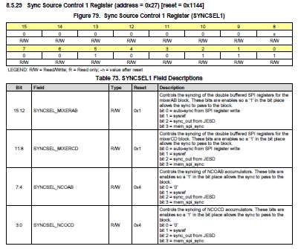

1. If SYSREF is DC coupled, it must have a CM voltage of 0.5V and at least a 100mV swing.
2. The following register determines which error will cause SYNC to de-assert (go low):

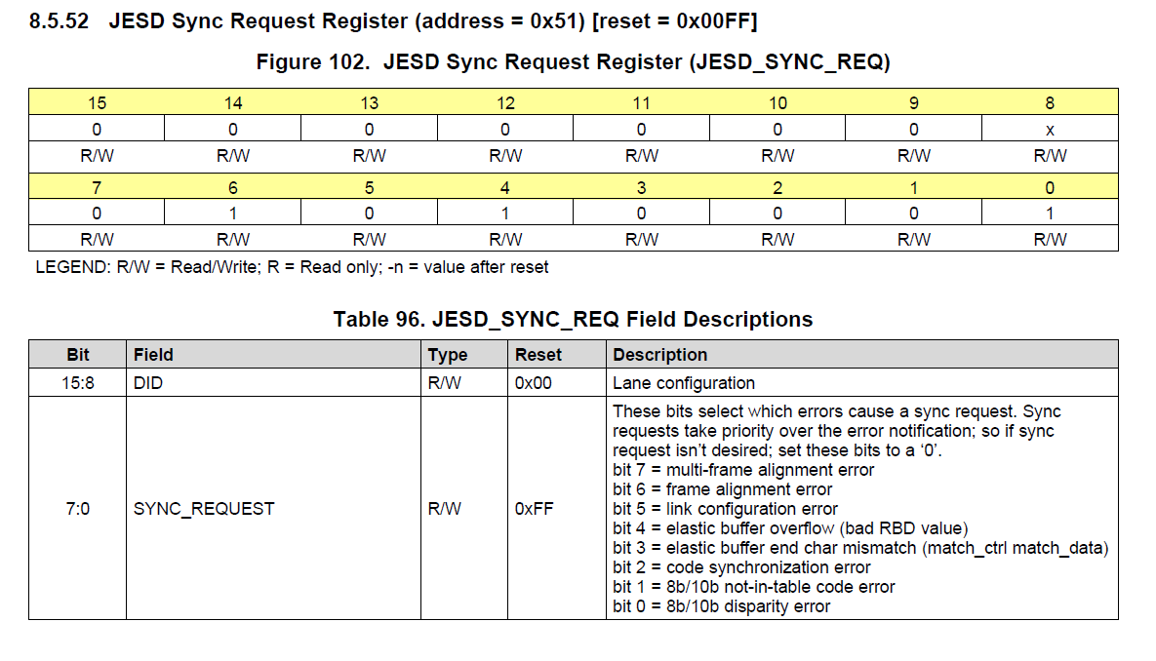

The default value used by TI is 0x001F.

1. This register reports JESD errors. GUI default is 0xFF. If bit 9 is set to 0, if any of the errors occur, a short SYNC pulse will occur.

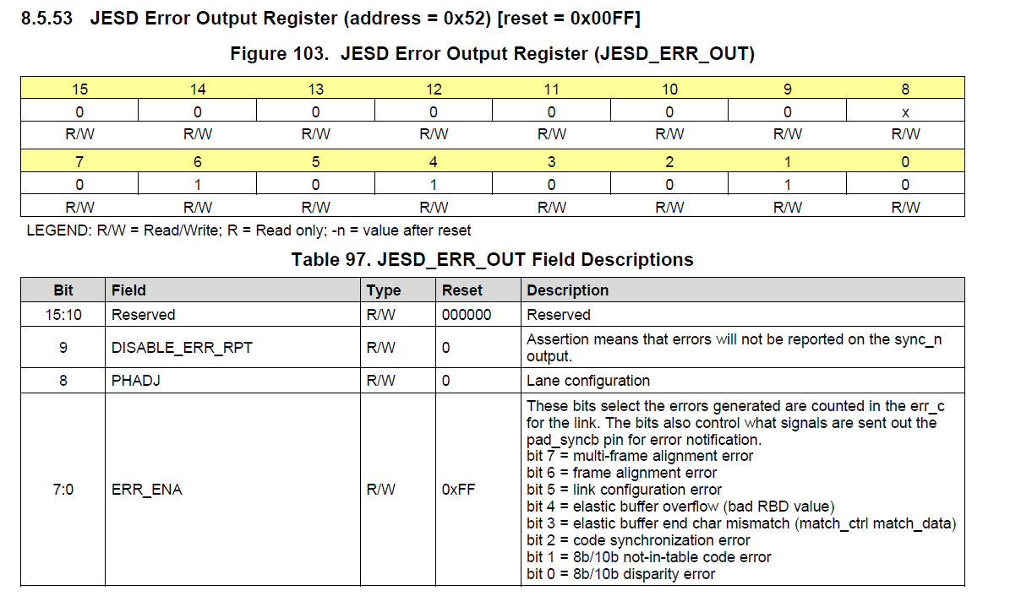

Sdafsdf

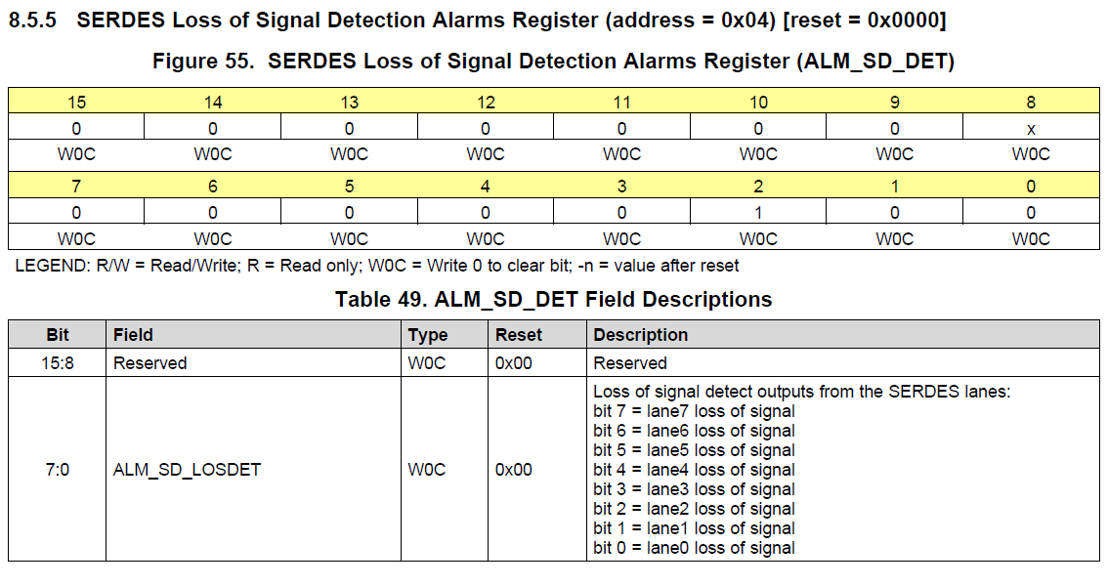

If any lane reports a loss of signal, the device will pull SYNC low. These map directly to the input pins.

If JTAG is not used, TRSTN must be tied low.