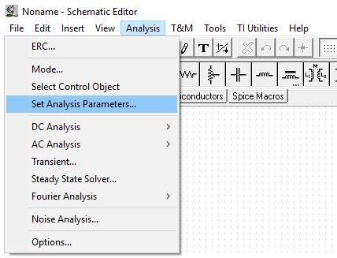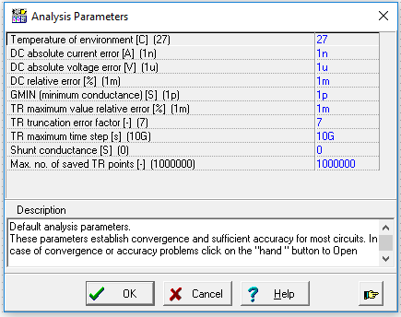
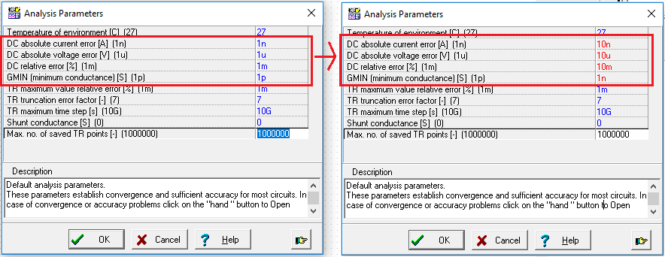

This is convergence related challenge. Relax the convergence parameter by going to Analysis -> Set Analysis Parameters.
Increase “DC absolute current error, DC absolute voltage error, DC Relative error, GMIN” from 1n, 1u, 1m, 1p respectively to 10n, 10u, 10m, 1n. From there keep increasing it slowly. For instance, increase it again to 20n, 20u, 2n respectively. Keep doing this until it reaches an optimum point where the simulation runs, and the simulation result is still accurate.

