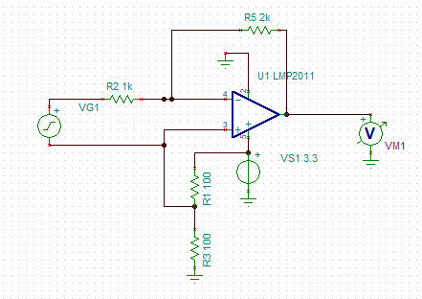

FIGURE 1. Test circuit



FIGURE 2. Improper output with VS1=3.3V



FIGURE 3. Normal Output with VS1=5V