Hi Howard,
It is super that Webench enable designs with opposite output voltages, thank you.
Here is the schematic:
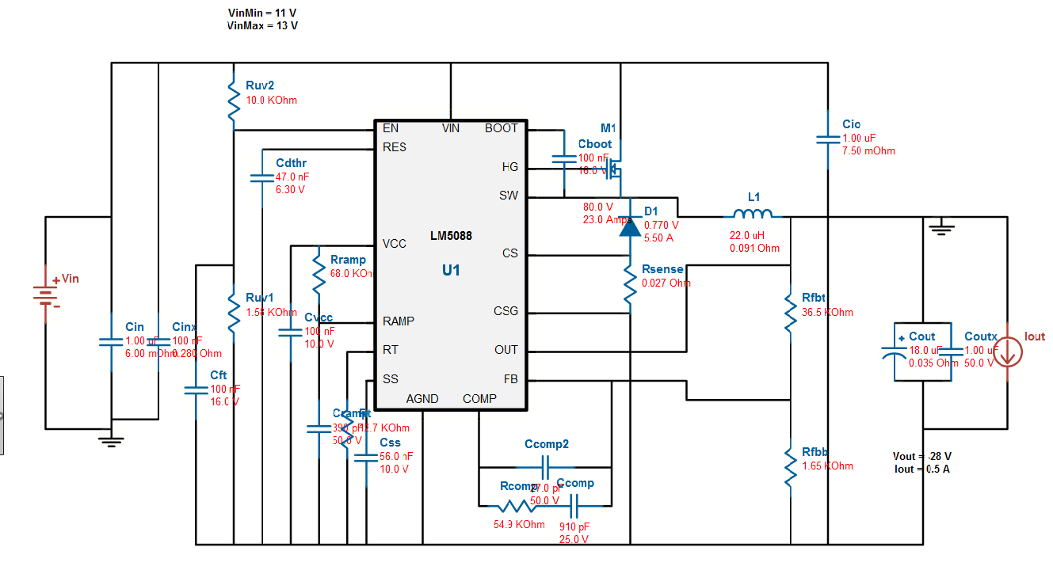

For the Loop components and L1 it is not possible to create custom parts or to chose components outside the upper and lover limit.
This is a problem as this limit simulation of the Bode plot with the actual component used in the design.

Please advise how to owercome this, thank you.
Regards
Jørgen

