Migrating from EasyPLL to Clock Architect

Summary
An existing design in EasyPLL can be created in Clock Architect in a few steps. You will need to enter your desired frequencies in Clock Architect, set a part filter, and open one of the recommended designs. Once a design has been created, override any loop filter components or parameters to match that of EasyPLL.

Open your existing EasyPLL design
This can be done from the MyDesigns page (http://webench.ti.com/appinfo/webench/scripts/my_designs.cgi) or in the email you received containing each of your EasyPLL designs in the last two years.
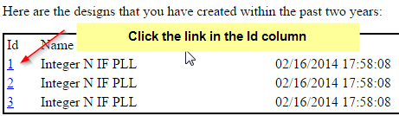

Open the product folder for your EasyPLL device
In EasyPLL, you can click the device name to get to the product folder for that device.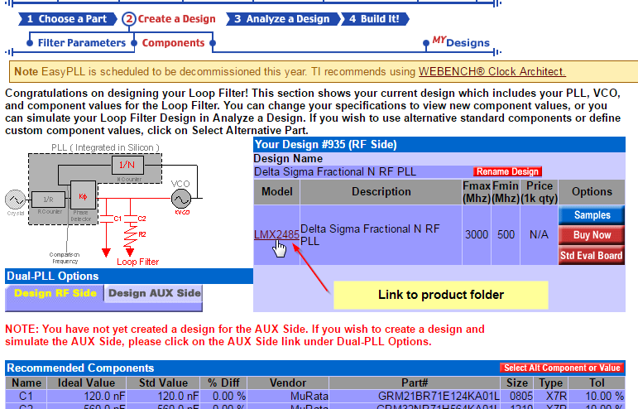

Find a solution with Clock Architect
On the product folder page, there is a panel to launch Clock Architect for a device on the right hand side. Enter your desired frequencies and click Open Design.
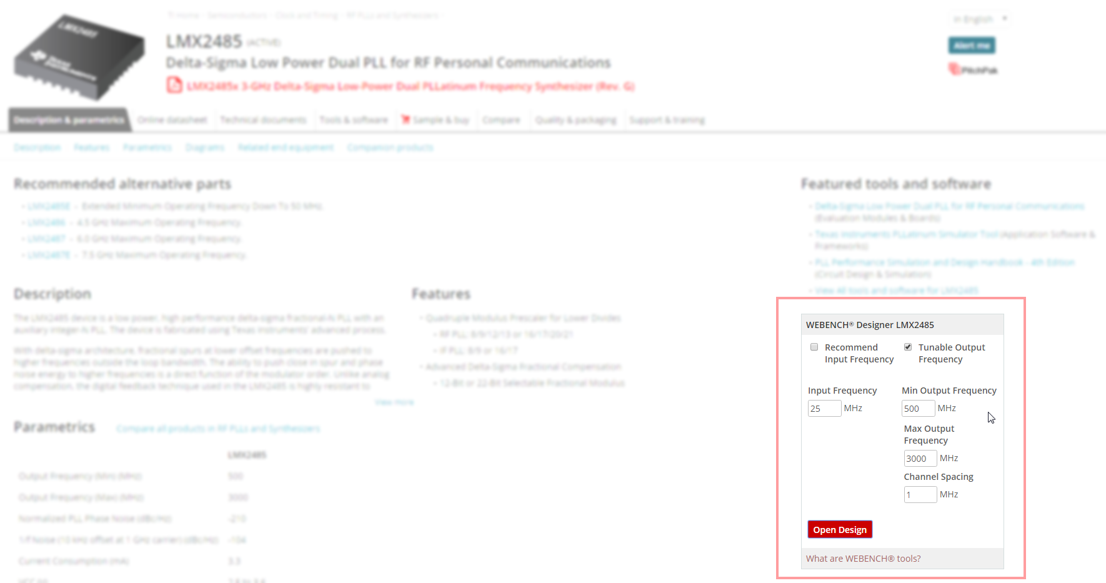
Clock Architect will come up with a solution for that device, which you can then simulate by clicking Open Design.
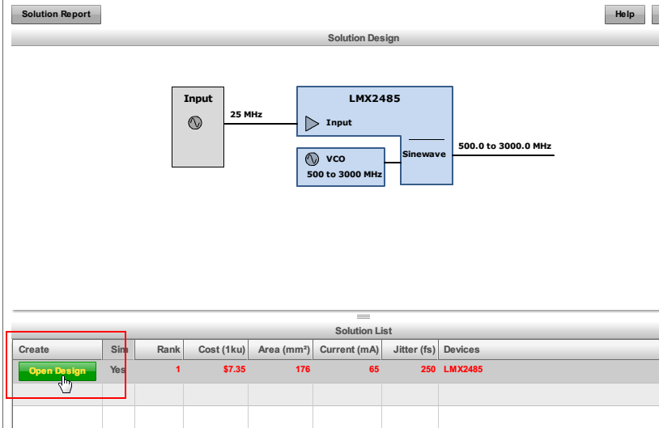

Simulate and set loop filter components + parameters
Once you open a design, you can see phase noise for a given output or modify loop filter settings in the LoopFilter tab.
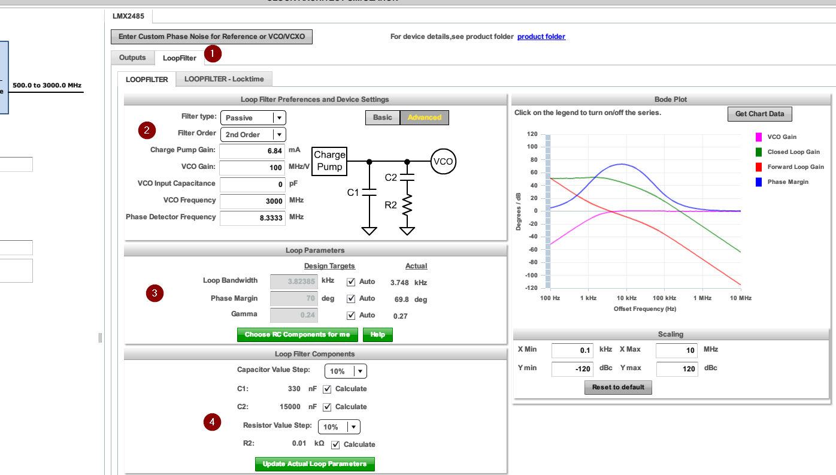
- Click the Loop Filter tab
- Here you can change the filter type and some parameters such as VCO Frequency or Phase detector frequency. Click “Choose RC components for me” or “Update actual loop parameters” to apply your changes.
- Here you can enter a designed loop bandwidth and have Clock Architect design a loop filter for you
- You can override the loop filter components with your own values. Uncheck “Calculate” to do this.
Below you can see how I copied values from EasyPLL to Clock Architect
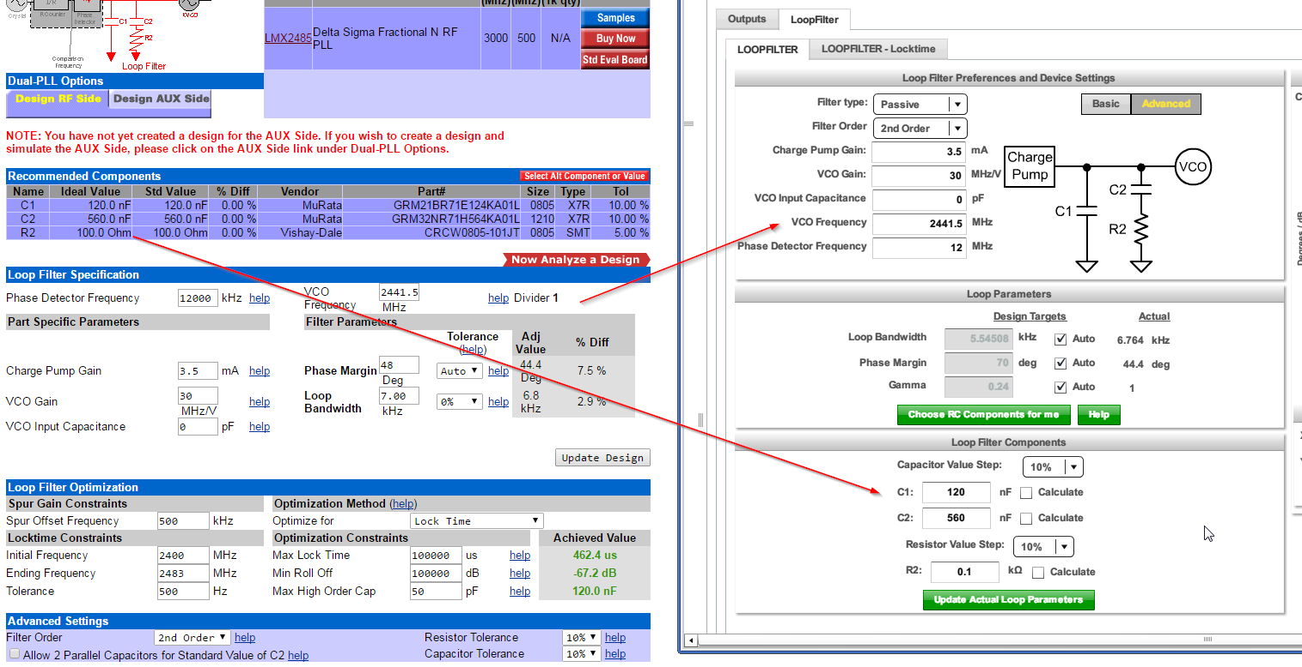

Additional Resources
For more information on using Clock Architect, see the following resources:
- Help page: http://webench.ti.com/help/#t=ClockArchitect%2FOverview.htm
- Video tutorial: http://ti.com/clockarchitect
- E2E Forum: https://e2e.ti.com/support/development_tools/webench_design_center/

