All measurements taken with a 24V input, 360mA load, and 20MHz bandwidth unless otherwise noted.

Efficiency

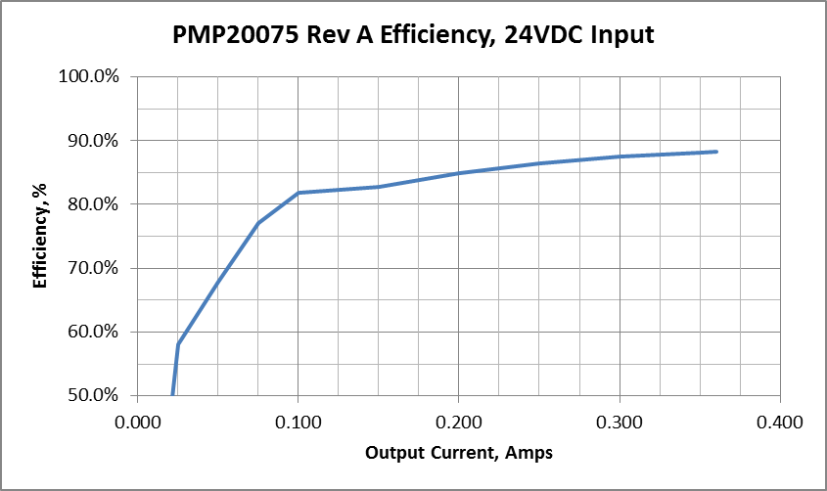

Iout | Vout | Iin | Vin | Eff
0.000 | 47.88 | 0.039 | 24.00 | 0.0%
0.025 | 47.88 | 0.086 | 24.00 | 58.0%
0.050 | 47.88 | 0.147 | 24.00 | 67.9%
0.075 | 47.88 | 0.194 | 24.00 | 77.1%
0.100 | 47.89 | 0.244 | 24.00 | 81.8%
0.150 | 47.89 | 0.362 | 24.00 | 82.7%
0.200 | 47.89 | 0.470 | 24.00 | 84.9%
0.250 | 47.89 | 0.577 | 24.00 | 86.5%
0.300 | 47.89 | 0.684 | 24.00 | 87.5%
0.350 | 47.89 | 0.793 | 24.00 | 88.1%
0.360 | 47.88 | 0.814 | 24.00 | 88.2%

Ripple and Noise

Output Ripple Input Ripple
50mV/div, 2usec/div 50mV/div, 2usec/div
Measured 67mV pk-pk: Measured 62mV pk-pk:
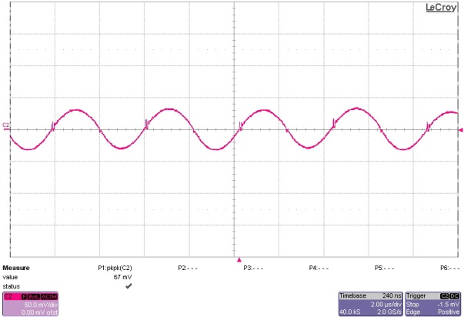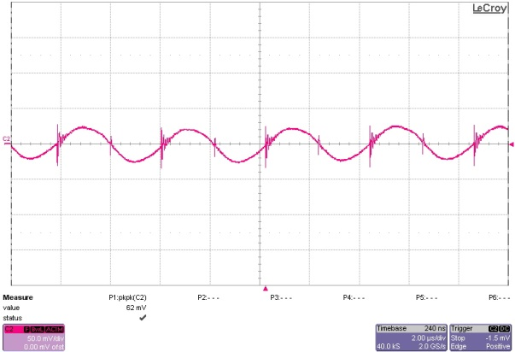

Dynamic Loading

Load Step, 0A to 360mA Load Step, 80mA to 360mA
500mV/div, 200mA/div 500mV/div, 200mA/div
5msec/div, 36mA/usec 5msec/div, 36mA/usec
Measured 1.52Vpp: Measured 719mVpp: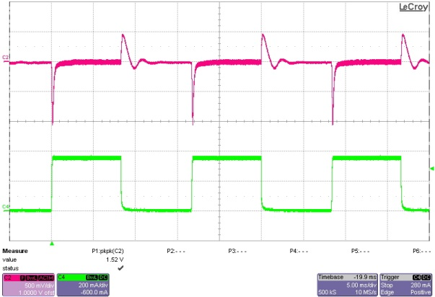 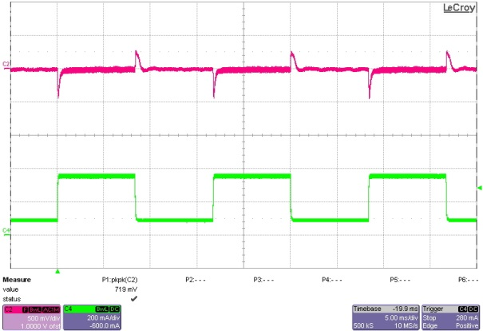

Load Step, 180mA to 360mA
500mV/div, 200mA/div
5msec/div, 36mA/usec
Measured 430mVpp:
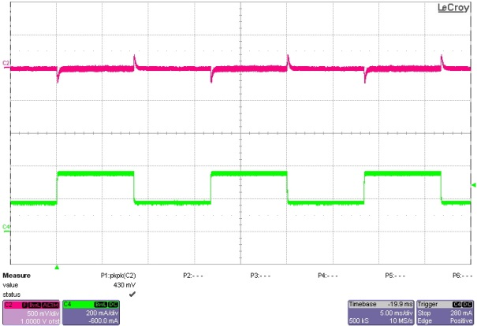
Turn On Response

360mA Load 0A Load
1msec/div, 10V/div: 1msec/div, 10V/div:
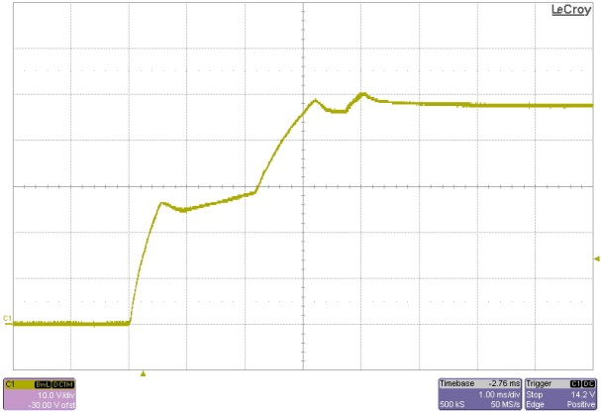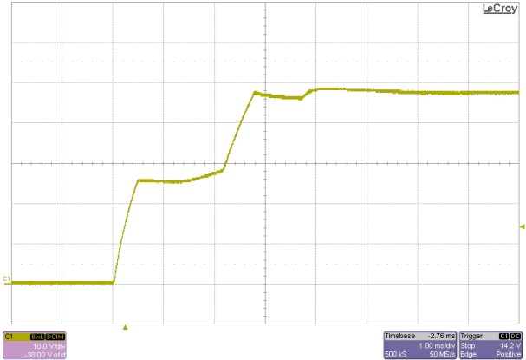

Stability

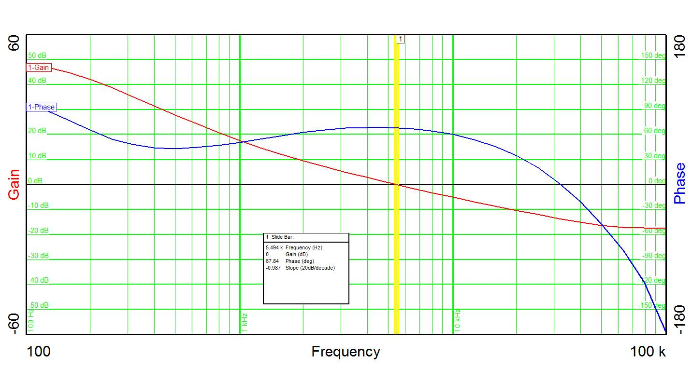
BW=5.5Khz PM=67 degrees GM=13dB

Thermal:

Top:
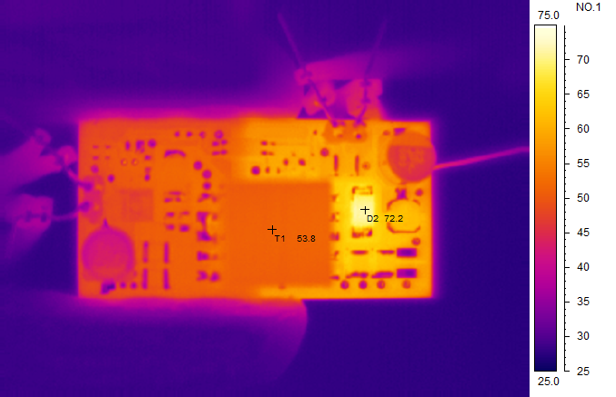

Bottom:
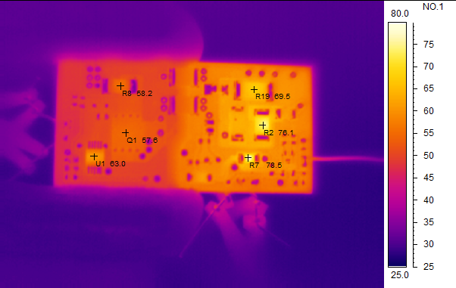

Photo:

Top:
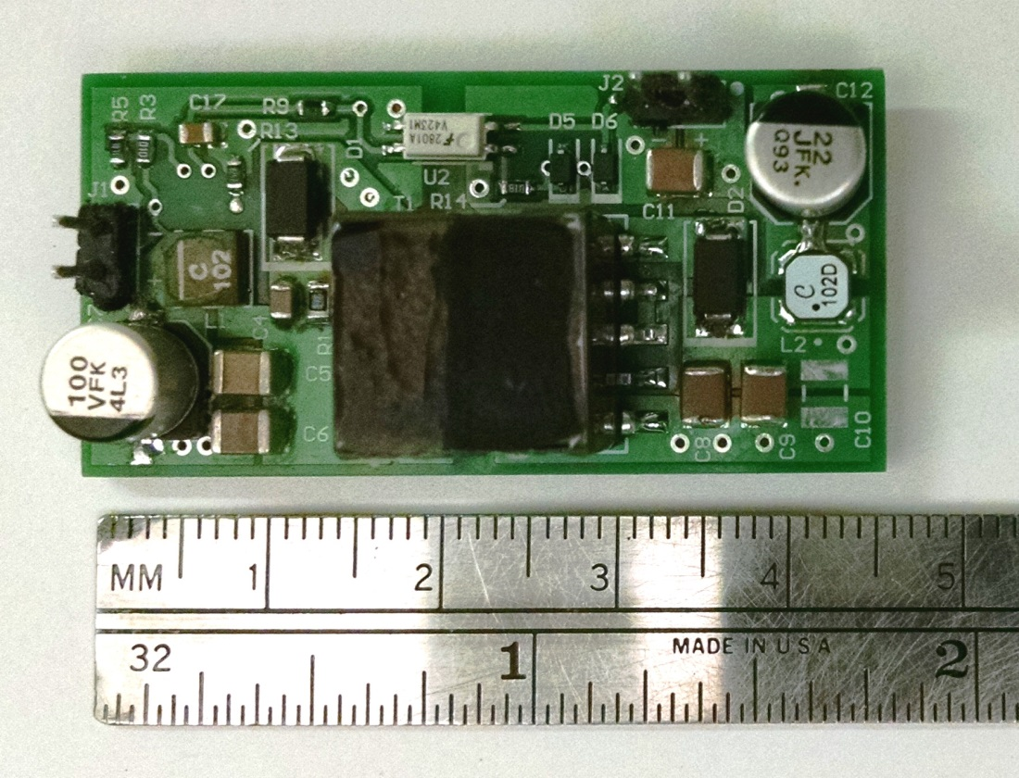

Bottom:
