Step-1: Initiate installation
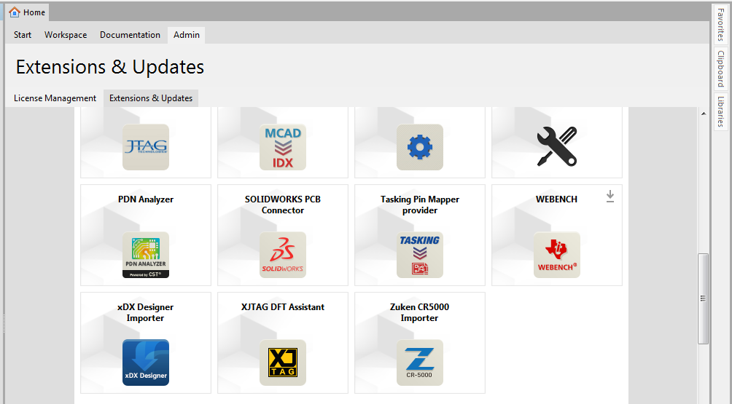
Step2: Installation running
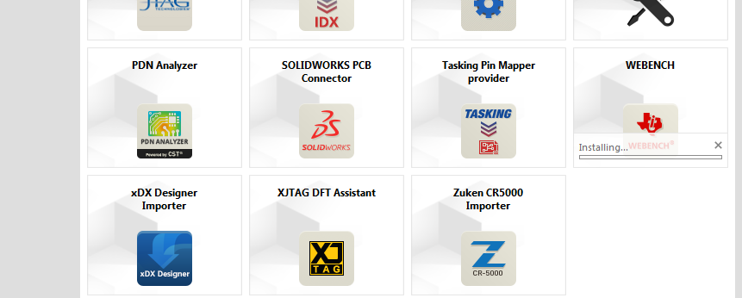
Step3: Restarted the Altium as per requirement
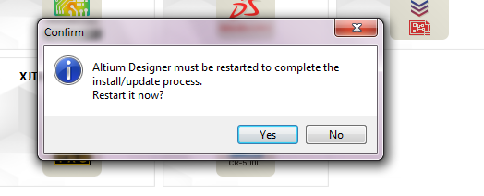
Step4: Webench come at toolbar
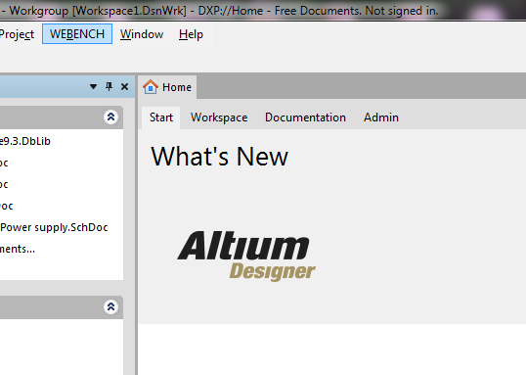
Step5: Select the option for activation
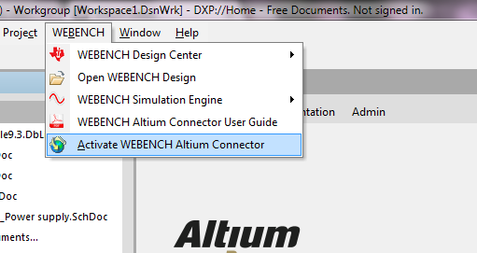
Step6: Message come about already activated
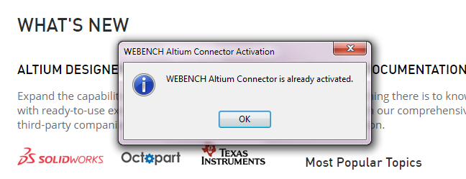
Step7: At Preferences select auto detect of WBSE installation location (Here activation code is not present)
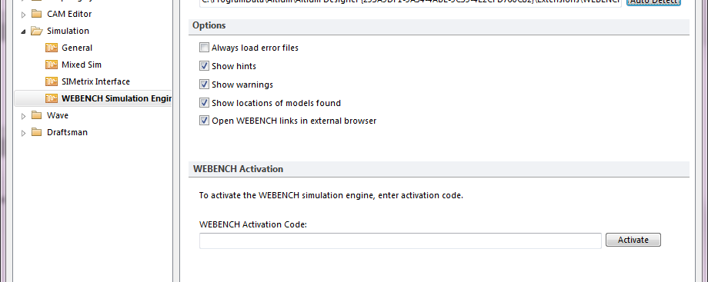
Step8: Opened the file which was exported from TI-WEBENCH site.
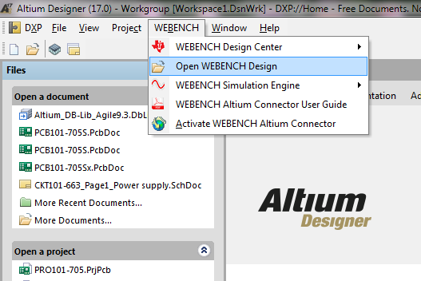
Step9: File selected with .wbx extension
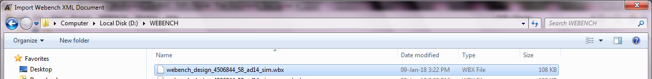
Step10: Below is the image of opened schematic in Altium
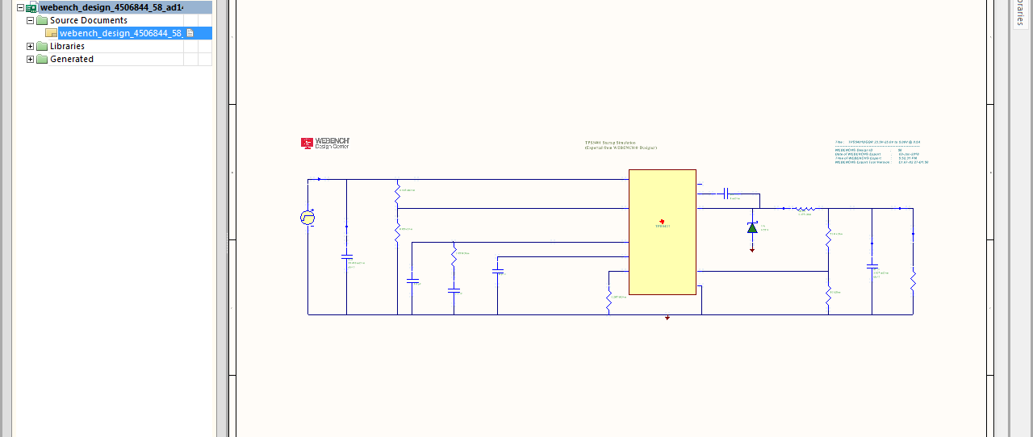
Step11: Select the option to run the simulation from WEBENCH
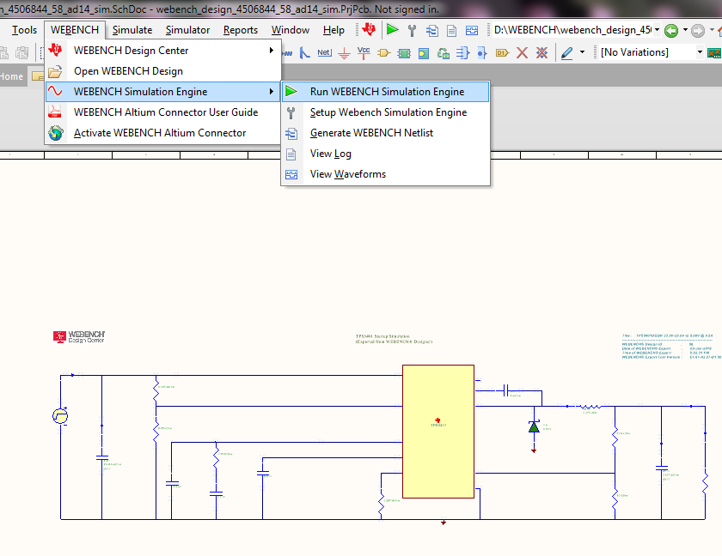
Step12:Below error message come and no result is coming.
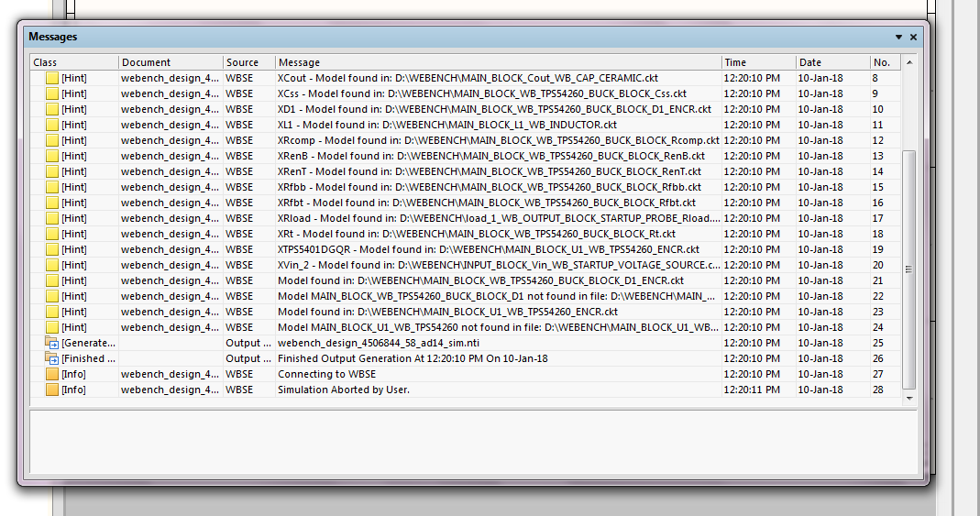

This process repeated with different files exported from TI site, and same message come.

