I reviewed the schematic and I noticed the use of FB5 and C56. Could you short FB5 and remove C56 and see if there is effect? I worry the use of FB5 would hurt the cross regulation on the iso output rail. By the way, do you know what is Isat of the transformer?
Could you also clarify the following?
- Did you capture a SW waveform, along with the voltage cross the secondary side diode? If yes, please share the scope pictures. If not, please take the measurement, then share.
供电电压 | FB5去掉前 |  | FB5去掉后
 | SW | along with the voltage cross the secondary side diode | SW |  | along with the voltage cross the secondary side diode
9 |  | 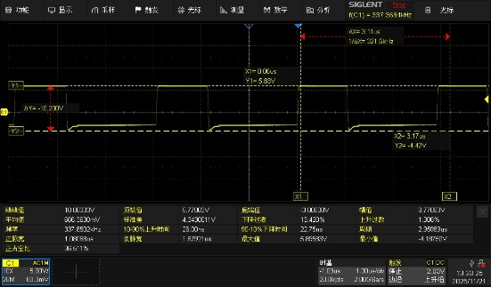 | 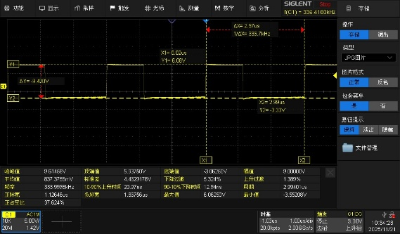 |  | 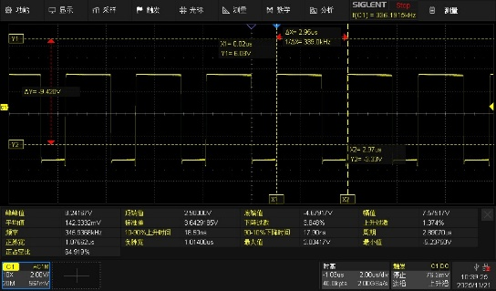
24 |  | 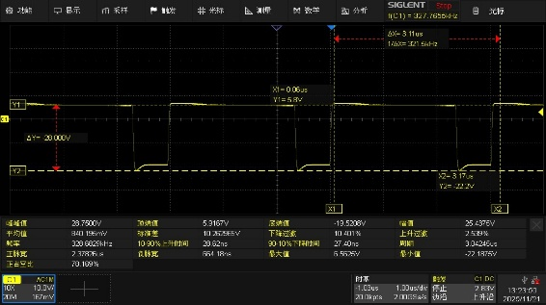 | 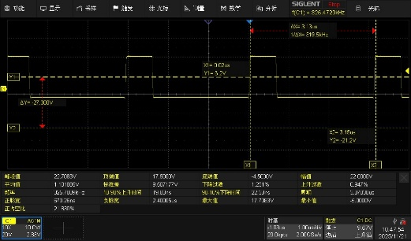 | 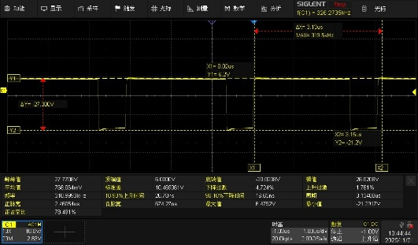
41 | 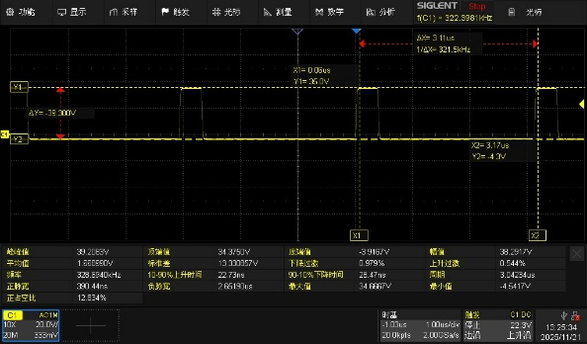 | 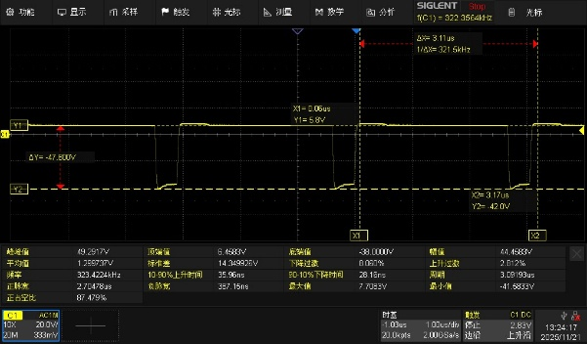 |  | 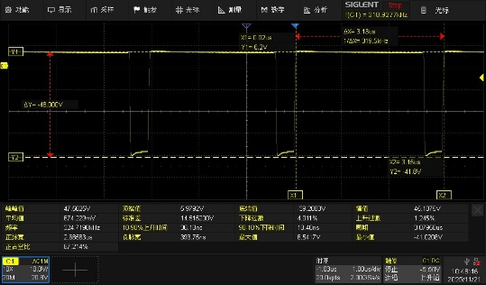

- What are the load currents on both output rails, namely the non-iso and iso output rails, when you observe the problem?
供电电压 | non-iso | iso output
9V | 258mA | 12.74mA
24V | 257.8mA | 12.9mA
41V | 259mA | 13.37mA

- What is the Iso output voltage when you change Vin to 9V, 12V and 49V?
供电电压 | iso output
9V | 5.4V
24V | 5.8V
41V | 6.2V

- Your info regarding R136 and C140 implies possible Vout ripple issues. Could you measure the output ripples under these conditions?
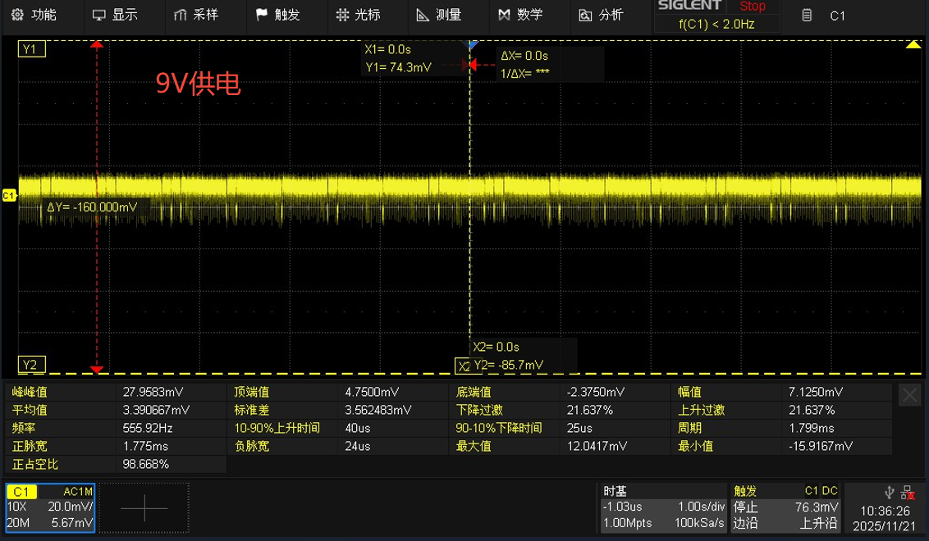
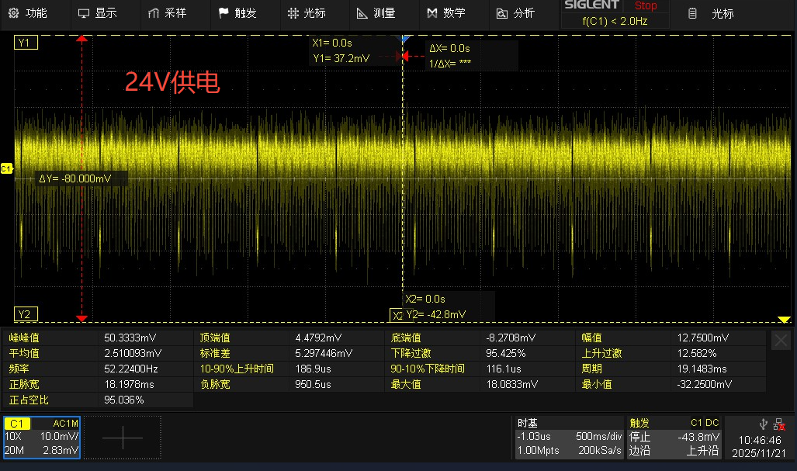
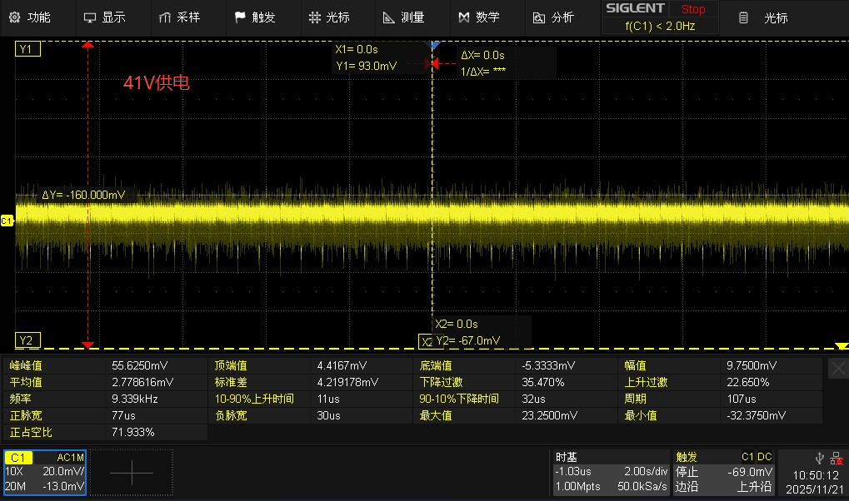
- When you say the problem went away after you disconnected R131, could you recheck the circuit by doing the following?
  - keep R131 installed,
  - remove FB2
  - and draw similar load from C18//C19//C20,
  - supply the LDO with a separate dc source as you did before
  - In this way, the LM5161 is operating with similar load, but it just does not supply the LDO.
  - Then please run with different Vin and see if the problem comes back or not.
未进行

