**Observation Schematic Vs Layout changes.**

* **Design Source:** Reference Design **DI board_tidc249b** Download from TI Website.

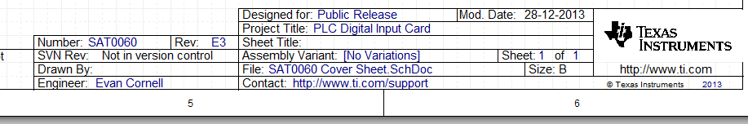

**Observation 1)**

In the Reference design Schematic sheet 1: T1 (Path no : 750342178) Pin no 2 and 9th pins are connected each other as shown in the below image.

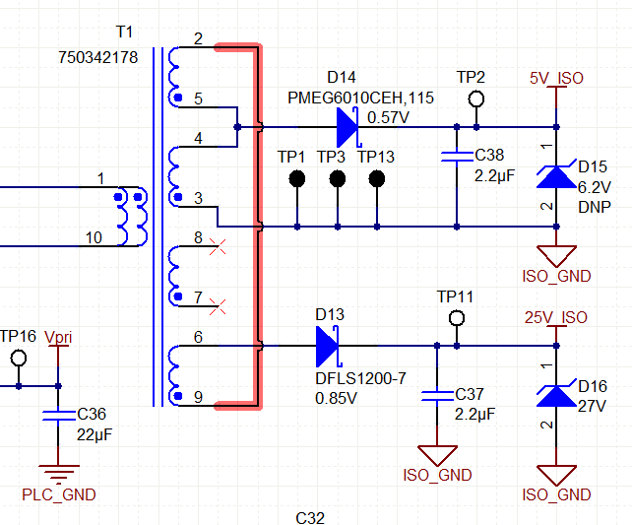

* This Connection is not implement in the PCB please refer the below image

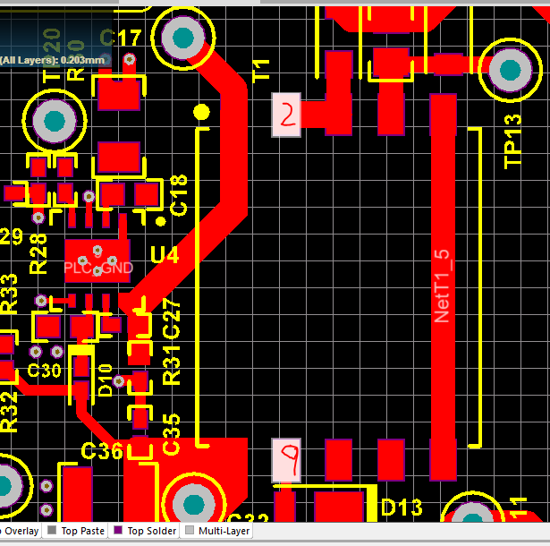

**Observation 2)**

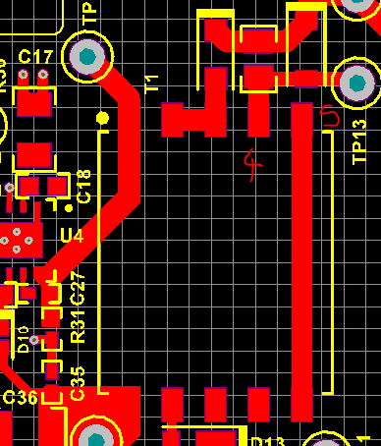T1 Pin 5 and 4 are short and its connected to D14 and this not implemented in the PCB.

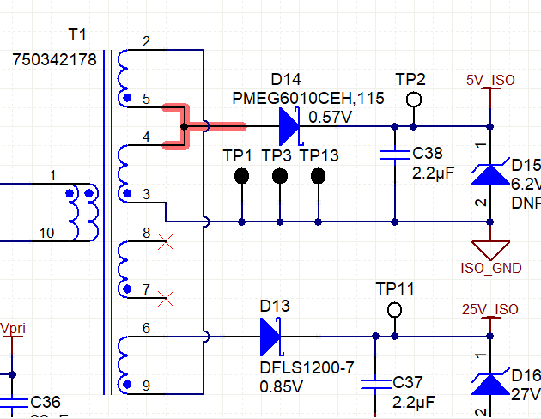

**Observation 3)**

In the Schematic T1 part Pin no 3 is connected to the ISO GND but in the PCB its not connected.

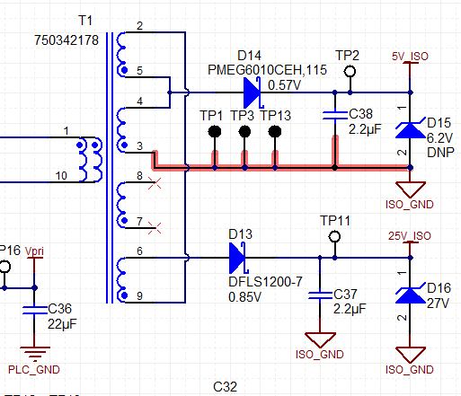

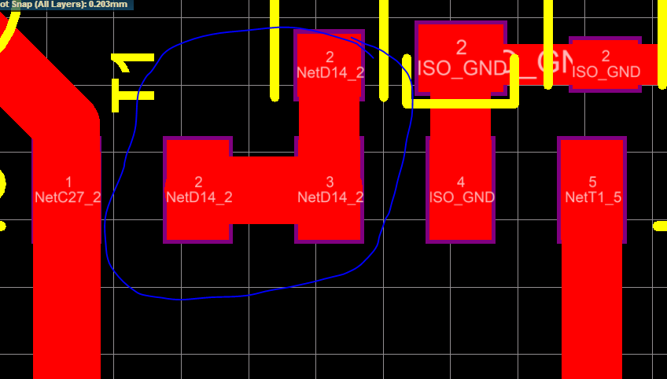

**Observation 4)**

In the Schematic T1 part Pin no 6 is connected to the Diode D13 but in the PCB its not connected.

