Problem description (Min Spacing) 1:

We required Min TT-TP-PP-TWof : 0.150mm for 1oz base copper weight.
We found min TT-TP-PP-TW : 0.041 to 0.140mm.

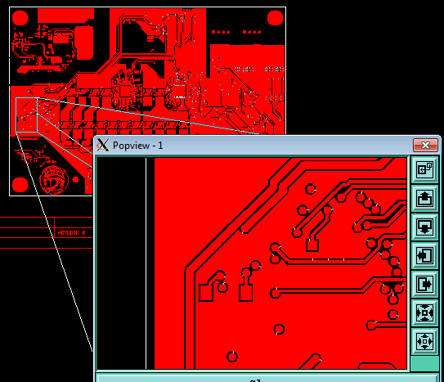

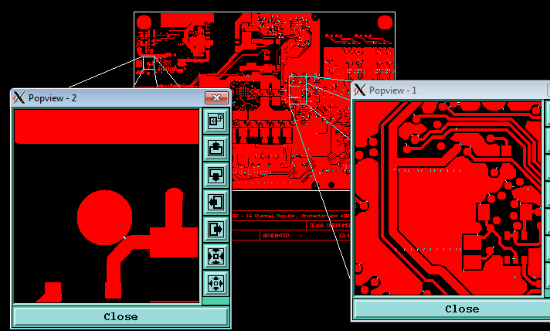
Suggested solution :
Provide us corrected data.

Problem description 2:
As per fab dwg, 4 layer board but supplied zip has 2 layer data. Missing inner layers.

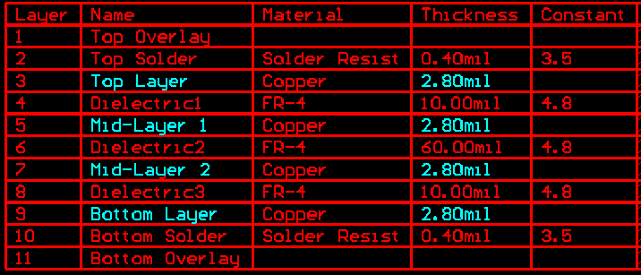

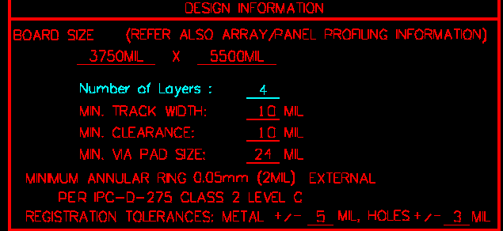

Suggested solution :
Provide us missing layers for further process.

Problem description 3:

As per below note, 2.8mil (2oz) copper weight required for outer layer.



Suggested solution :
As per our standard we will provide 35um start and 60um finish copper weight. Please confirm it.

Problem description 4:
As per fab dwg, arrar/panel with score but no panel information given.

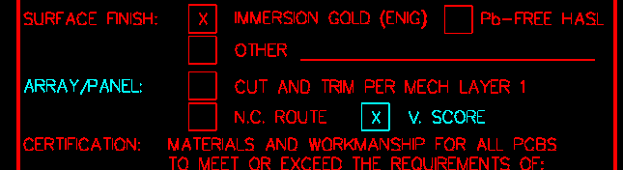

Suggested solution :
We have ignored it and considered single board. Please confirm it.

