TIDA-01407 HARDWARE BOARD REPORT
(Functionally Check Parameter)

POINTS:
- Input Operating Conditions (Set-up Picture)- (36-60)V
For controller and Gate IC's- (10)V
- Transformer design - As per. Spec of Input Voltage
- Switching Frequency - Delay Observed
- SS and CS Pin Voltage - Voltage Not Constant
- Tmin and Comp Pin Signal.
- Primary side PWM Signal.
- Primary Gate Driver Signal.

IC’s, Mosfet & T/F Used:

Controller IC | Gate Driver IC  Input Side Output Side |  | Transformer | Mosfet
 |  |  |  | Input Side | Output Side
UCC28951-Q1 | UCC27212A-Q1 | UCC27511A-Q1 | EE-55(6+6) | BSC072N08NS5 | BSC057N08NS3

- Input Operating Condition:
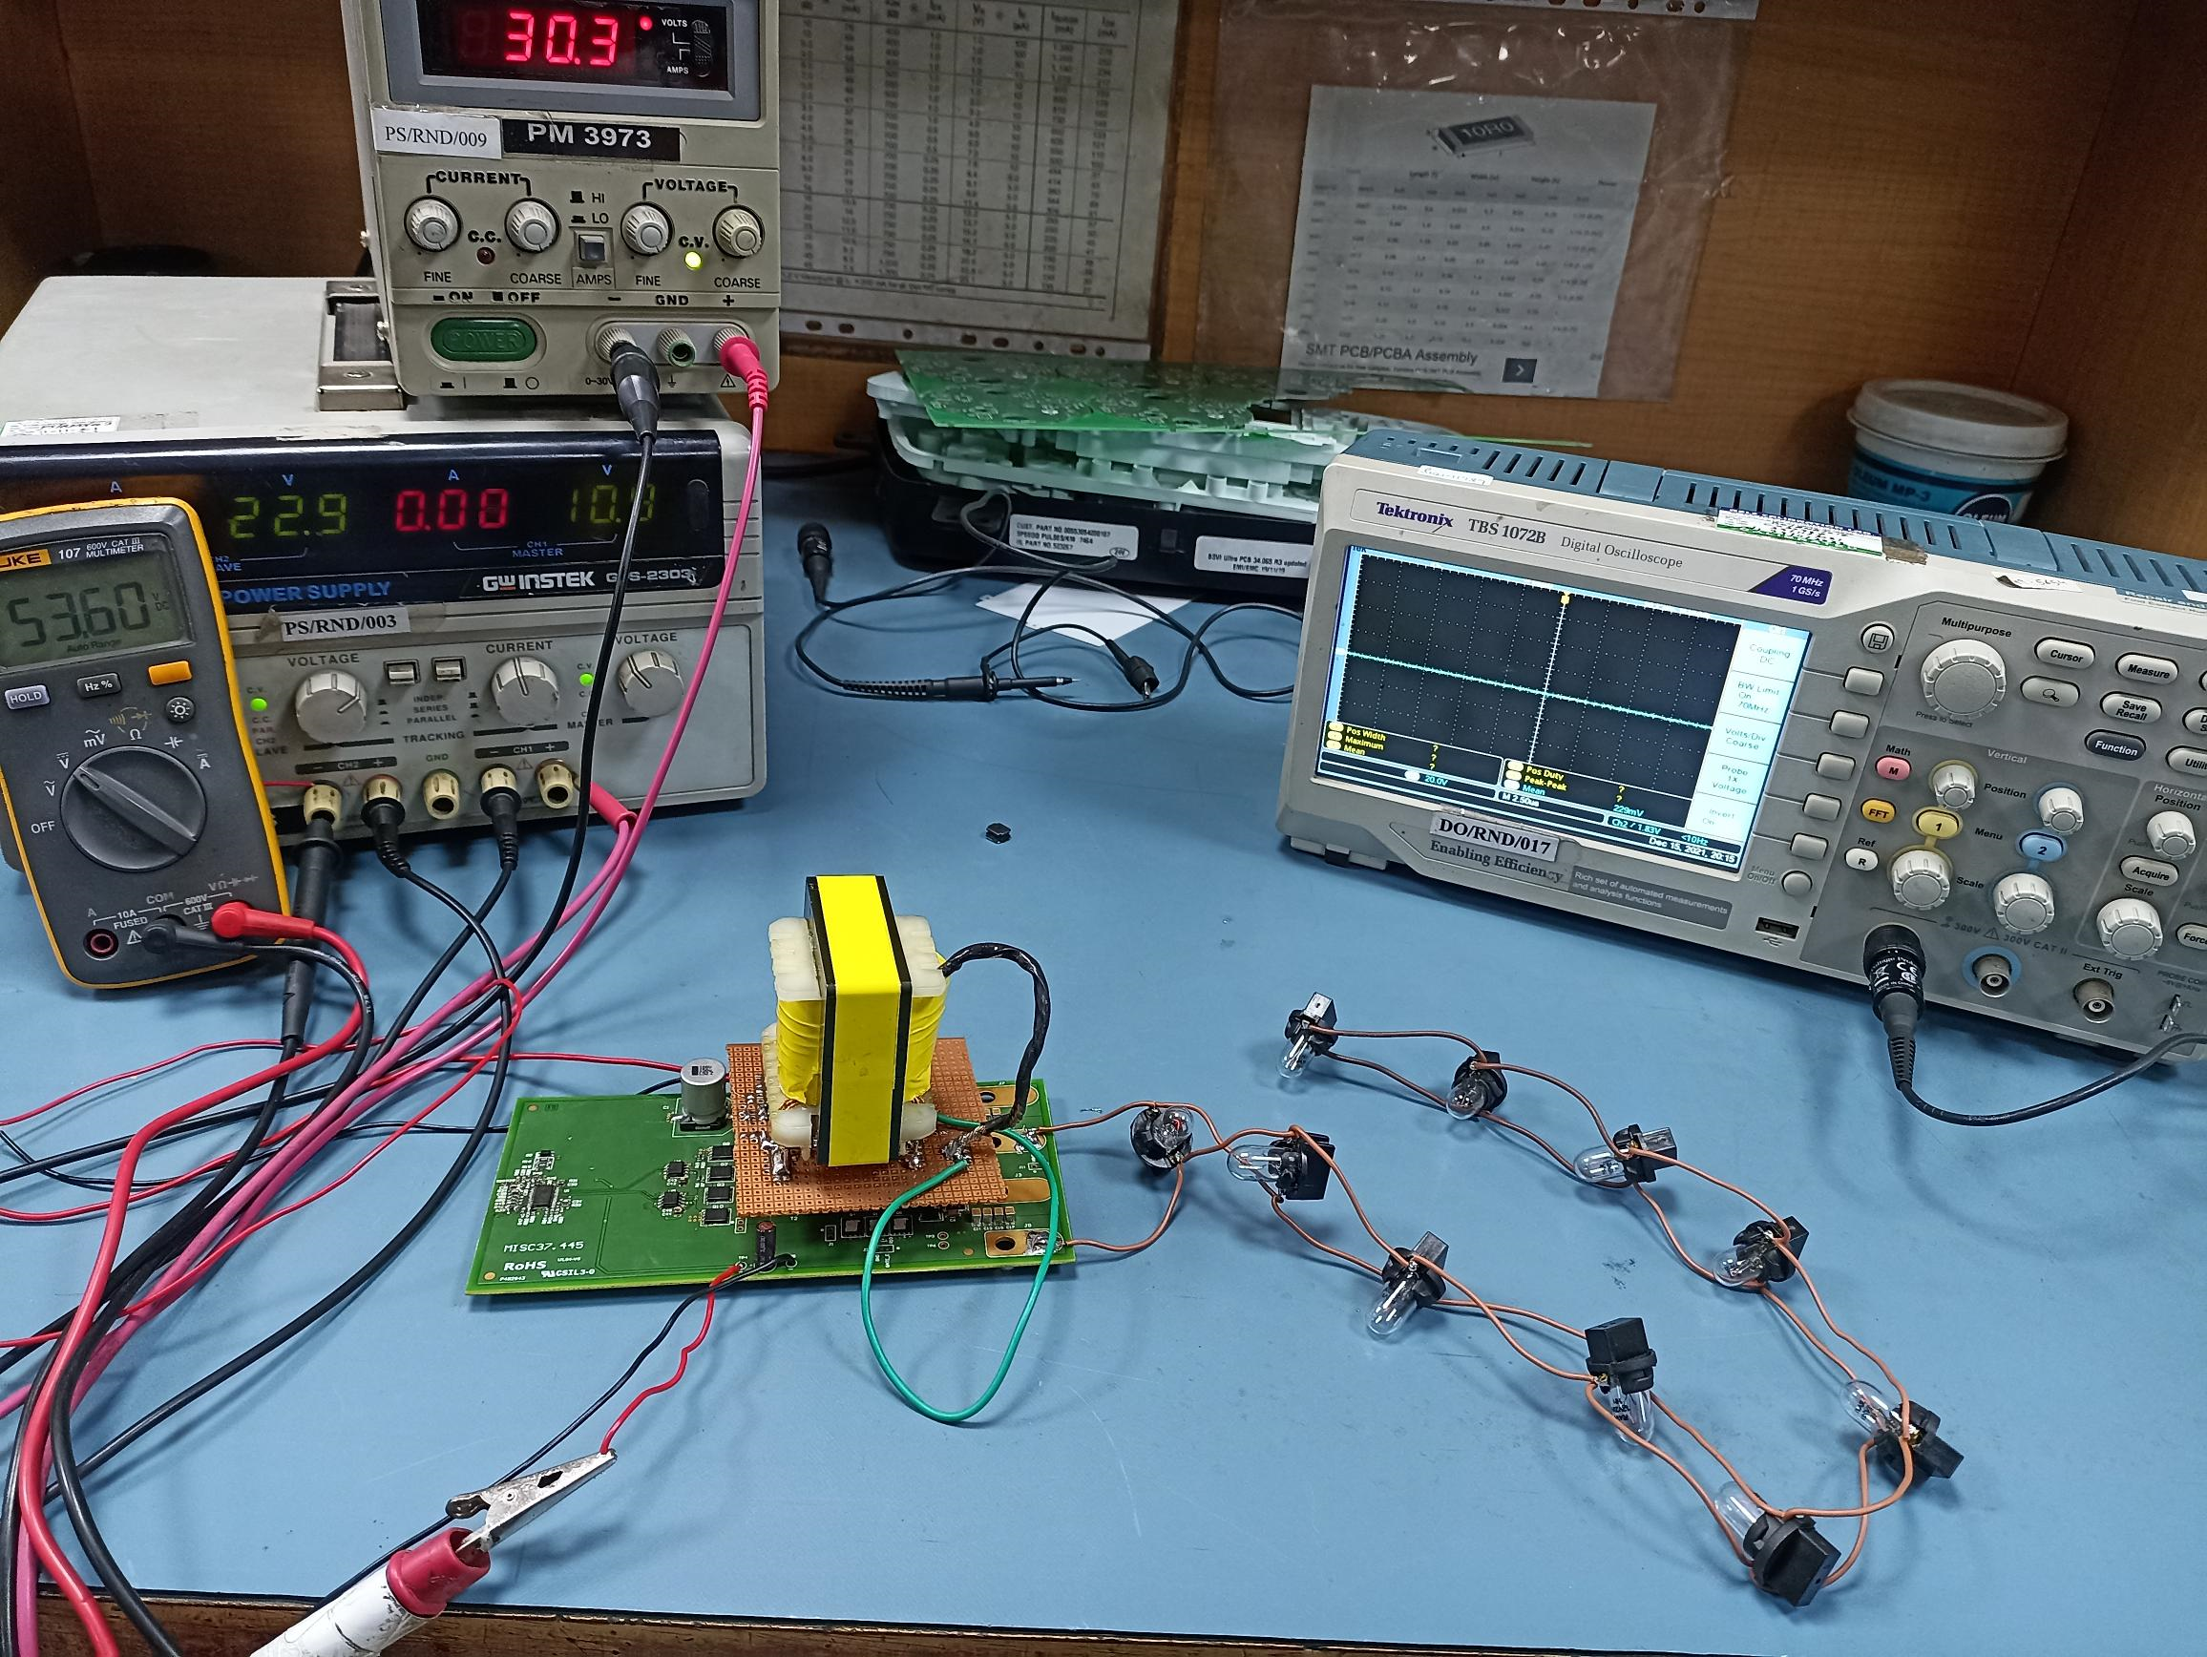
SET-UP PICTURE
- Vin- 36-60V
- Load Connect: 1A/12V
- Controller Voltage:
- Vdd- 10V
- Vref- 10V
- Vss – 5V(Voltage Instant Drop)
- Comp- 5V (Voltage Instant Drop)
- TOTAL PULSE WIDTH TIME
- 3.314us
T=1/F
T=3.314
F=1/3.314
= 300KHZ (SWITCHING FREQ-300KHZ)

2. Transformer Design: We have design center Tap Transformer as per the Input voltage spec. And with the fix turn ratio. Used EE-55(6+6) with primary side 80uH inductance and R is about .03 to to .026.
For Reference Purpose image showing in set-up Picture.

3. SS and CS Pin Voltage- We have seen rapid drop in voltage at the SS and CS Pin voltage.

4. Tmin and Comp Pin Signal - As below image showing the signal of Tmin and Comp pin.
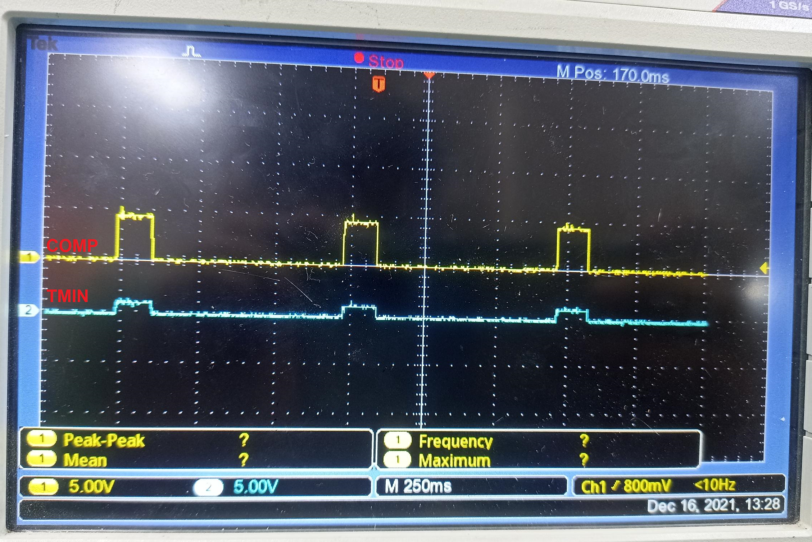
As shown in image Tmin is Lower the Comp Pin. So as per design will behave as per but the PWM Signal are not observed in (E & F) the gate of the mosfet.
5. Primary side PWM Signal-
Primary side PWM signal amplitude is 10V.
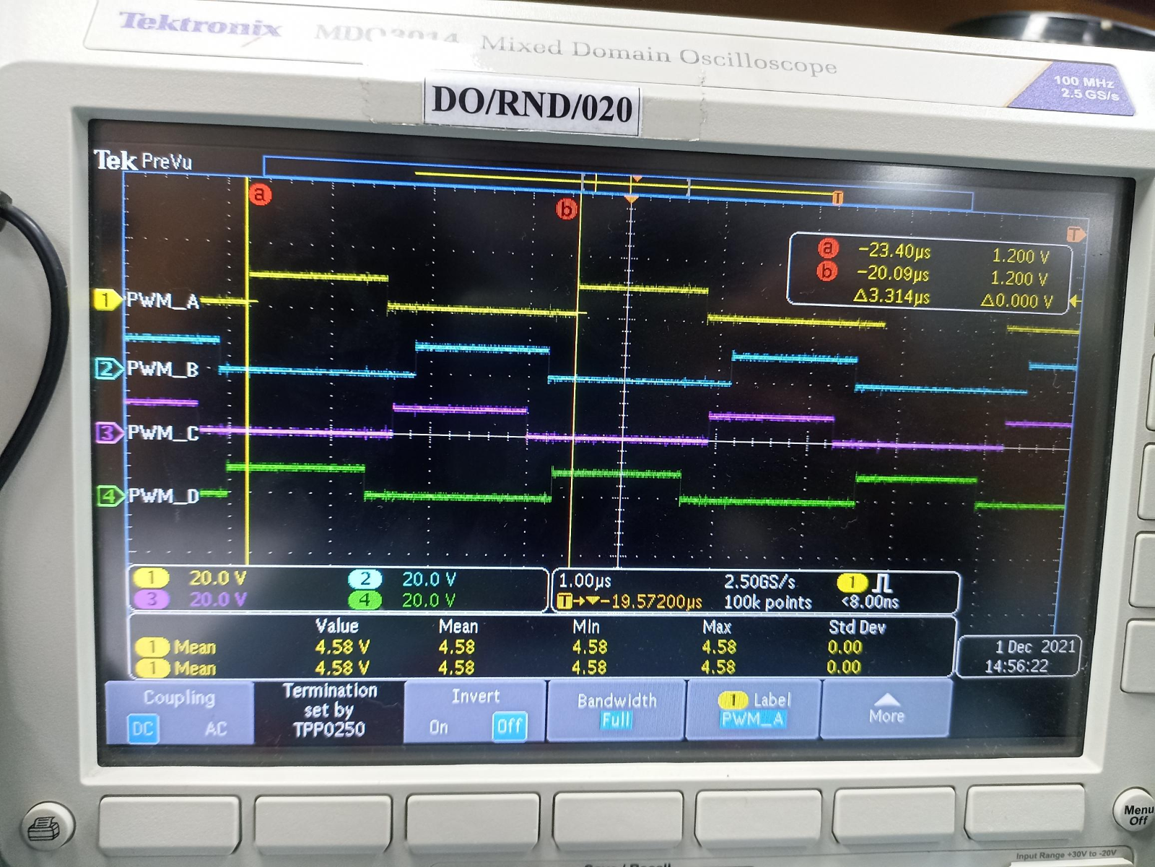

6. Primary Gate Driver Signal:
a.) Gate Driver Output signal to the Input of Mosfet gate.
b.) But we observed the Gate to source voltage amplitude is about higher the input voltage. (40V)
c.) Gate driver output HO as Gate(Q2) and LO as Gate(Q10).
d) We have given 30V input and observed 40V on the Mosfet gate of (Q2).
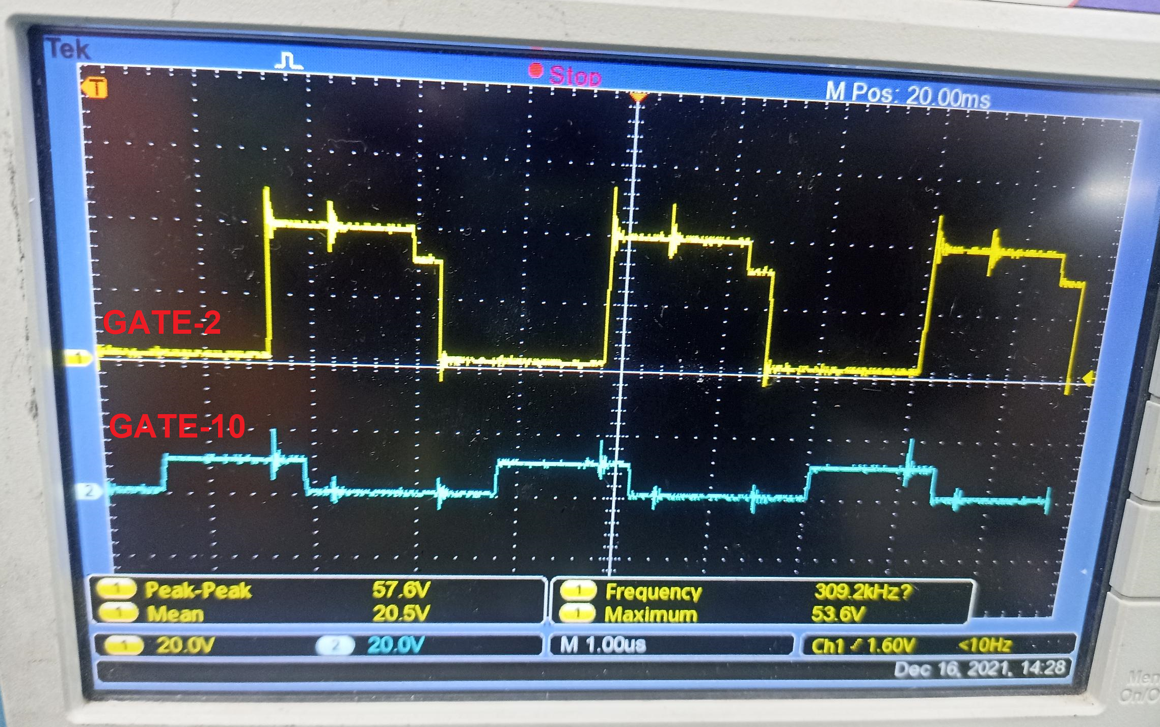

Note:
Kindly Provide your valuable feedback regarding this issue.

