Starting with provided Simulation and adding the following:
- Added practical inductance values of 0.7nH in place of 1fH inductors.
- Added practical ESL and ESR to the power supply of 10mOhms and 0.7nH.
Results in Oscillation.
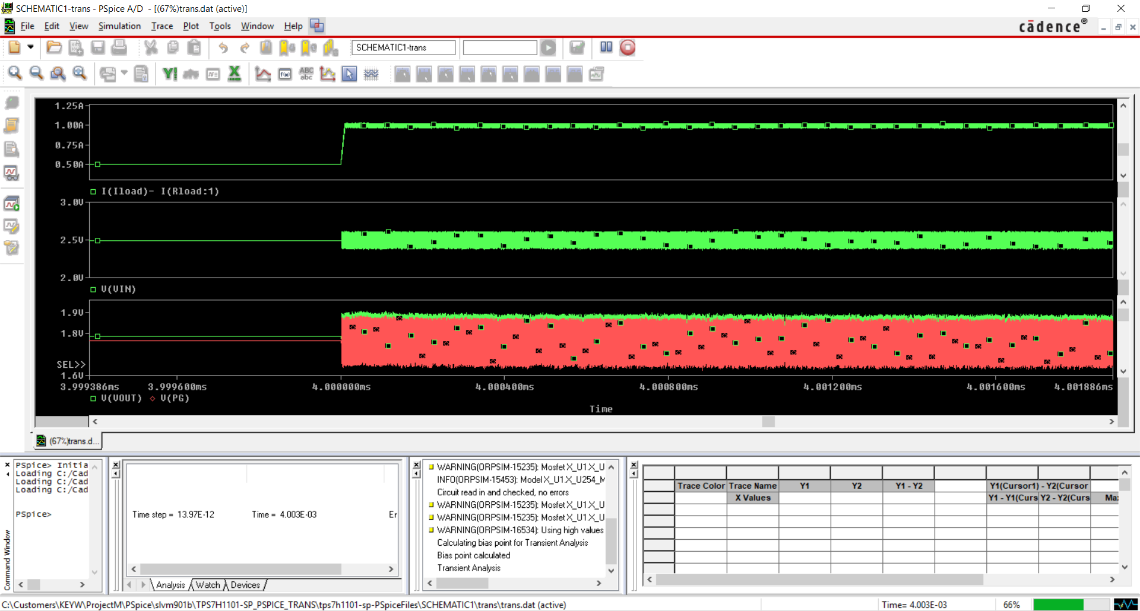
Close up of oscillation: 1/106.768e-12 = 9.3661e+09
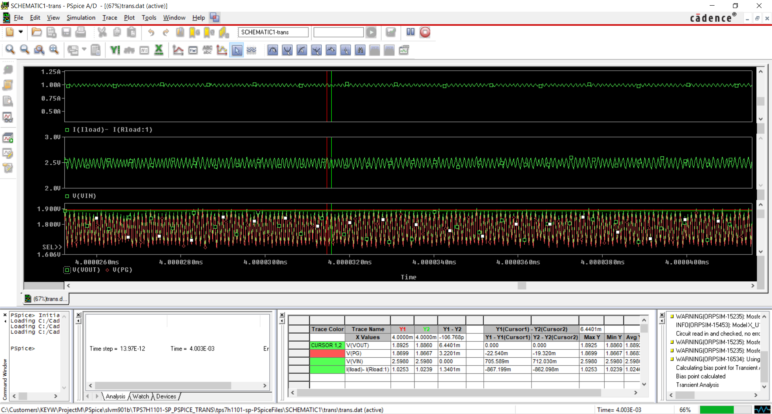
Foscillation=10

