UCCx813-1 Boost converter testing

PSPICE Protected model simulation

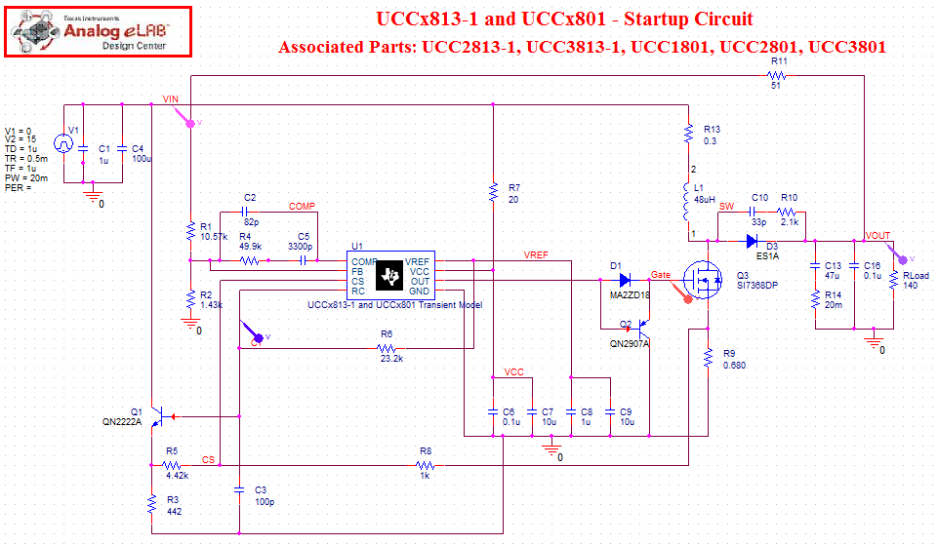

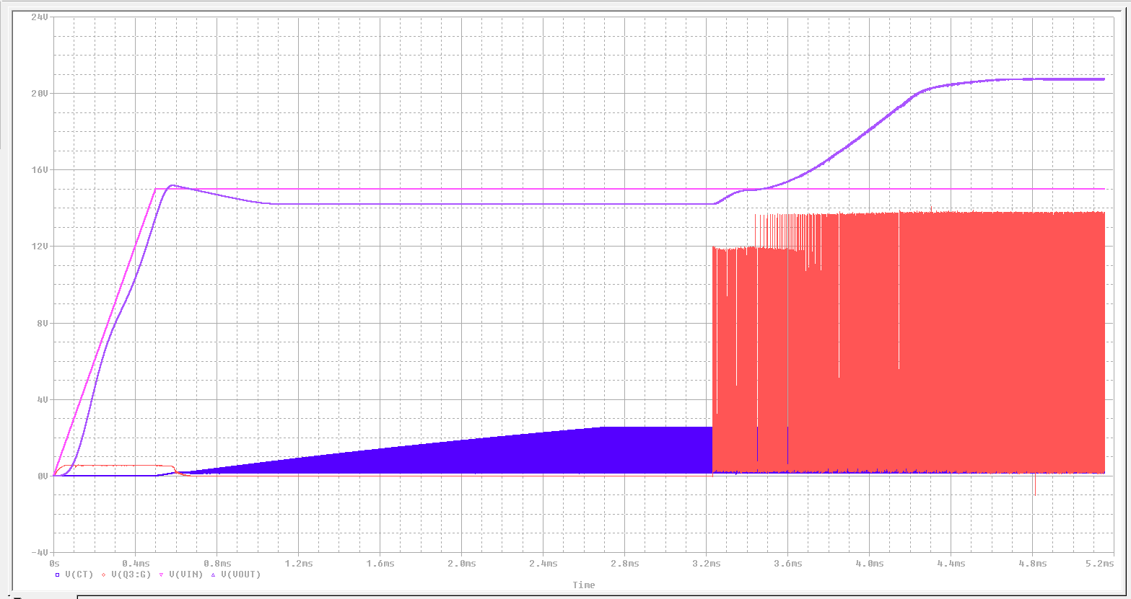

PSPICE UnProtected model simulation

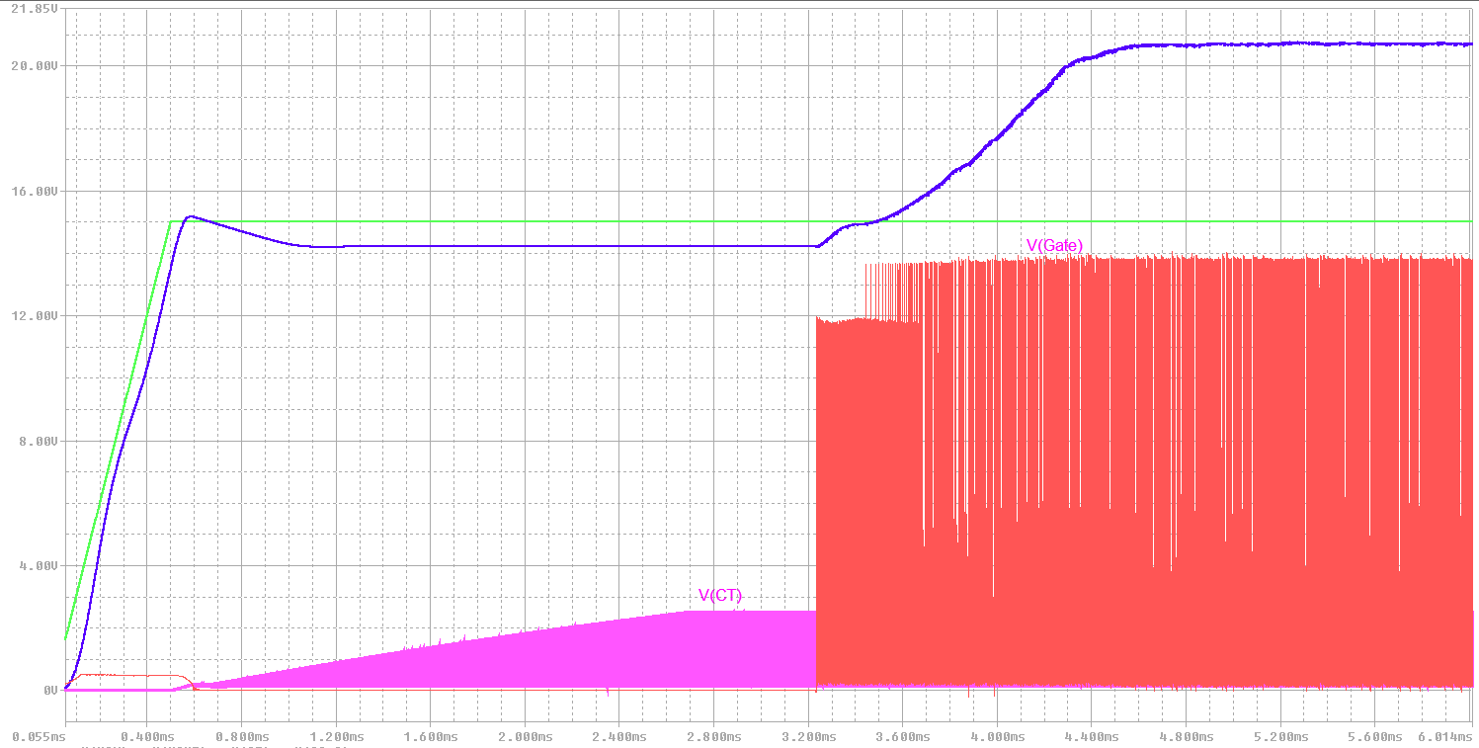

LTSPICE unprotected model simulation – there is a break at the V(Gate) startup waveform.

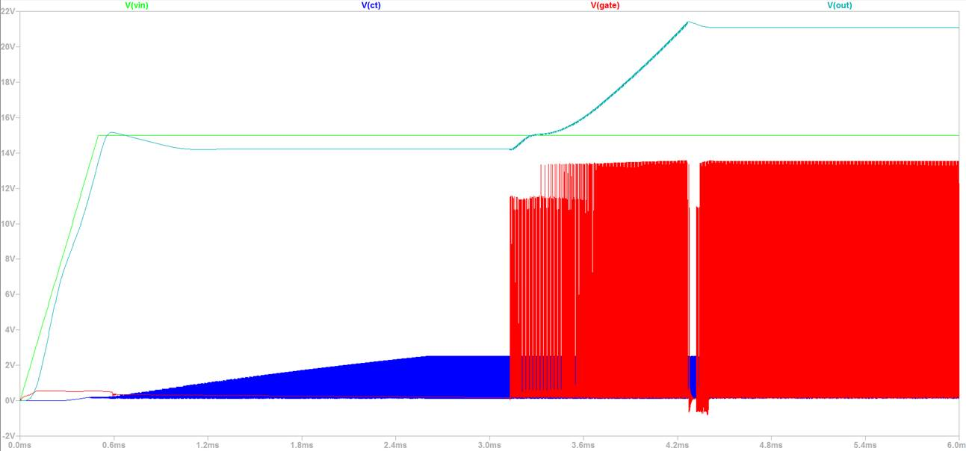

LTSPICE unprotected model simulation – Set max time step to 4ns

