Hi Nikhil,

I have created a PSPICE and a LTSPICE simulations on S_ST (PSPICE) and SW (LTSPICE).  It seems that there are differences between the two.

Please note that the second trip point for PSPICE is 9V versus that for LTSPICE is 10V.

So what is the equation for VT and VH for PSPICE?

The one for LTSPICE is VT= {((VON-VOFF)/2) + VOFF} VH = {(VON-VOFF)/2}

PSPICE

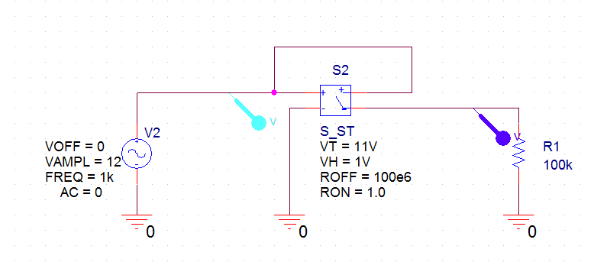

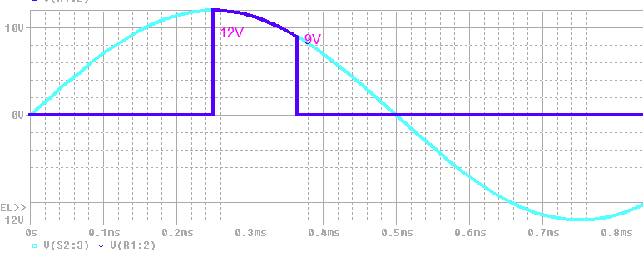

LTSPICE

