**Additional Notes: S-parameter measurements using Pspice for TI**

For Mita Kikuo

The Cadence notes on computing s-parameters are also attached (*Obtaining S-Parameter Data from Probe Window in Pspice*). And this note is to verify the Cadence setup.

* For the passive test circuit shown in the above document, Pspice for TI had an error. The problem seems to be in a device library. I have reported the problem.
* But, I verified the methodology of the Cadence notes by running the test case in the Spectre analog simulator. Below are the setup and results. I’ve added some notes.

First, there are some termination circuits that setup the circuit and collect the data for the s-parameter analysis. The analysis itself is done using AC analysis in the simulator. Fig 1 shows the circuit that computes s11. The source (V3) launches the sinusoidal voltage wave. The source resistance is R11=50 Ohms.

1. Additional circuitry in Fig 1 will compute the reflected wave. The source (E2) is a controlled source with gain=2. The voltage signal (CKT_REFLECTS) on the input of E2 will add to the V4 source, and the difference signal will be the s11 reflected waveform.
2. Please note that V3 and V4 have the same amplitudes and frequencies. Thus, the SRE_REFLECTS node will yield the s11 value. And since the AC analysis will be done by sweeping frequency, the output data will be s11(f).

Figure 1: The circuit to compute s11.

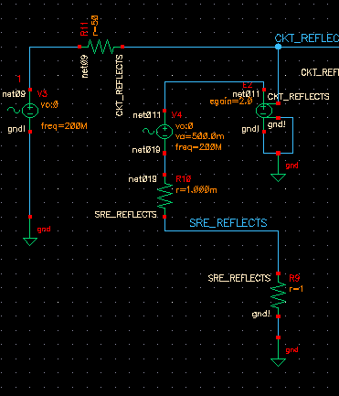

Figure 2: The circuit to compute s21

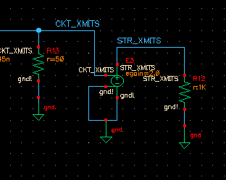

Unlike Fig 1, there is no driving source. In Fig 2, the R13=50 Ohm termination matches the input source impedance. The high-impedance of the E3 controlled source measures the transmitted signal from the network. And, similar to the reflected signal on the input, the STR_SMITS waveform represents the portion of the signal power that got transmitted. This is s21.

As shown in the Cadence document, the s12 and s22 parameters are similarly calculated.

The full circuit looks like this, Fig 3.

Figure 3: The Butterworth circuit with input and output circuits needed for s-parameter calculation.

