1. PFC needs to check the UCC28180 design calculation sheet to design the inductor value, BUS capacitor, compensation value based on your spec
2. The TL103W could supply internal 2.5V VREF, I don’t think LM258 has the same function, it is better to change to TL103W if you copy this circuit; and your output voltage and current are different from the reference design, you need to calculate the voltage/current reference based on your design (R55 to R59), (R75 to R76)

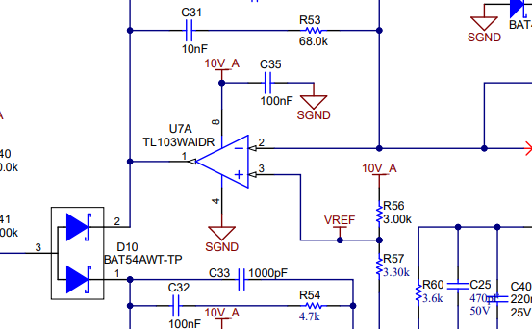

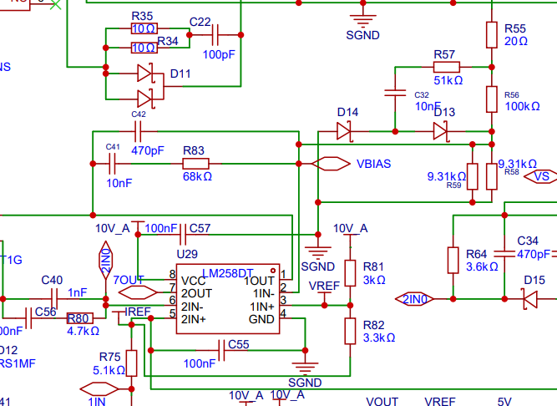

1. Besides, do you need both voltage and current loop? This reference design is used for e-biker, so it has the voltage and current loop. If you only need voltage loop, you do not need add this circuit

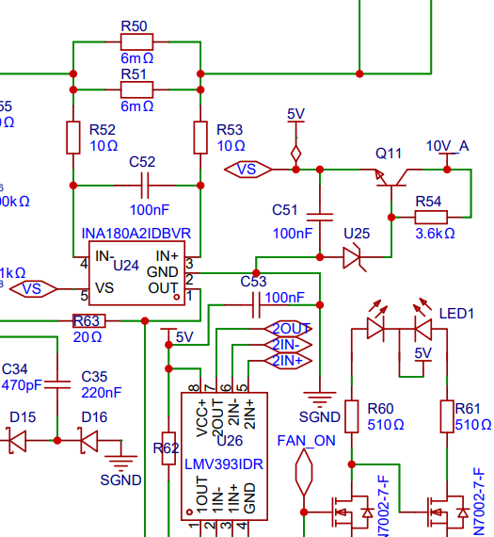

1. If you need the current loop, the output current is 20A, so the shunt resistor should be decrease and it is better to make the output of INA180A2 below 2V

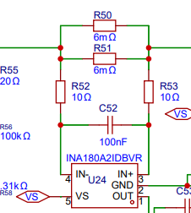

1. About the loop compensation of LLC, the parameters may need to adjust when you power up
2. I adjust the calculation sheet, it seems no red highlight part now. Pls modify the parameters of UCC25660 based on the calculation sheet.