Hello,
I would like to run Demo TIDEP-0101.
Hardware: AM4037 IDM
Software:
CCS8 .1.0.00011
PRU-ICSS-Industrial_Drives-01.00.02.03
ti-processor-sdk-rtos-am437x-evm-05.01.00.11
OS: Windows 10 Pro Version 21H1.
I tried running the sample project but the problem occurs as follows:
In the fist run:
the program starts running from “syscalls.c” and nothing happen on A437x IDK (picture below)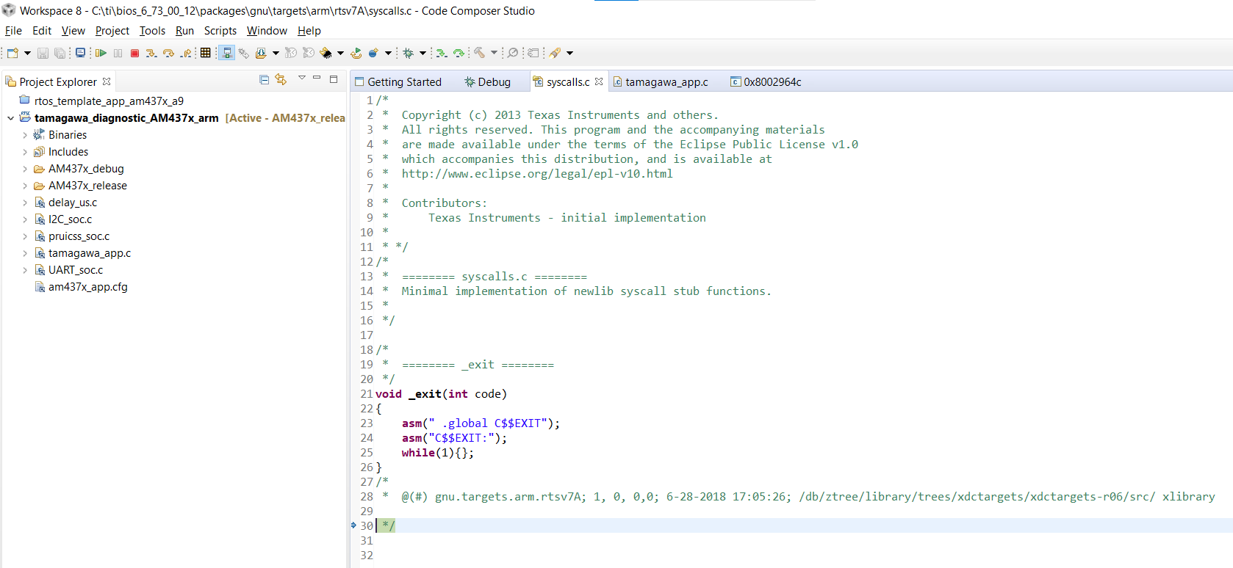

Run => Load => Reload Program
The program starts running from “tamagawa_app.c”, and the console tab display: “CortexA9: SemiHosting : File IO Error : fopen() : C:\ti\Workspace 8\tamagawa_diagnostic_AM437x_arm\AM437x_release\:semihosting-features : Invalid argument”
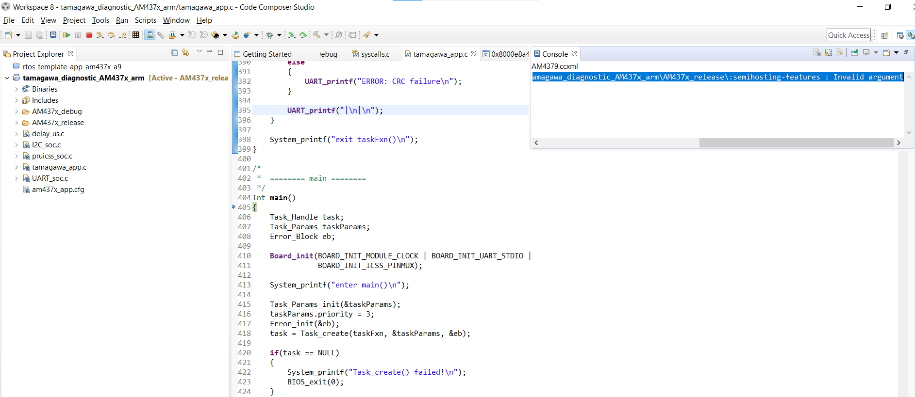
Click “Resume” => The AM437x IDK sends data to RS232 port as picture belows:
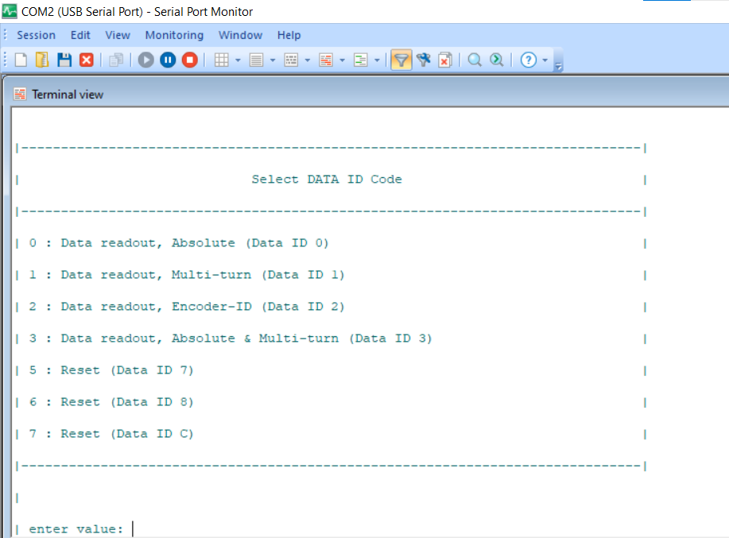
But the am437x IDK is not sending any data through ports J16-28, J16-30 and J16-32.
can you help me to solve the problem?
Thanks.
P/s: sorry my English is not good.

