isolate the 6VX-ISO at the back end to the isolated ground waveform
Vin=9V, 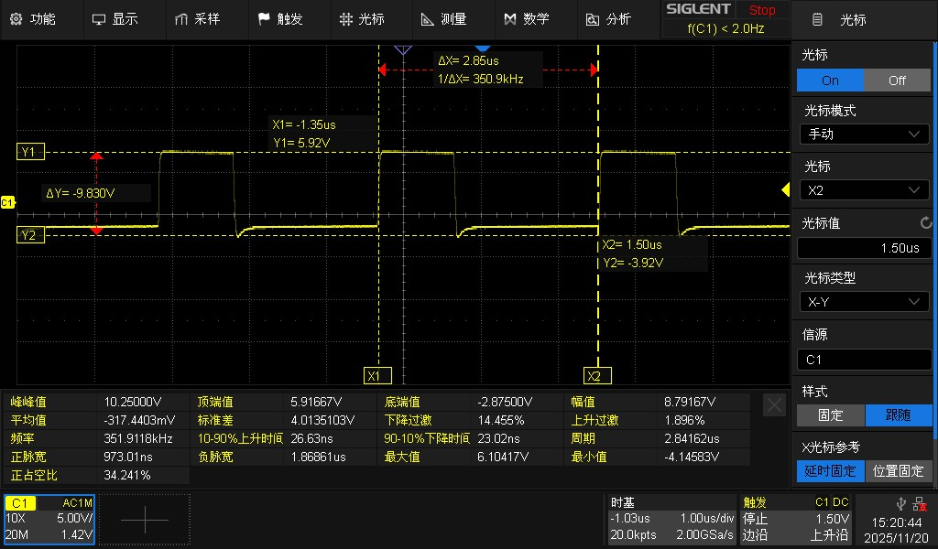
Vin=24V，
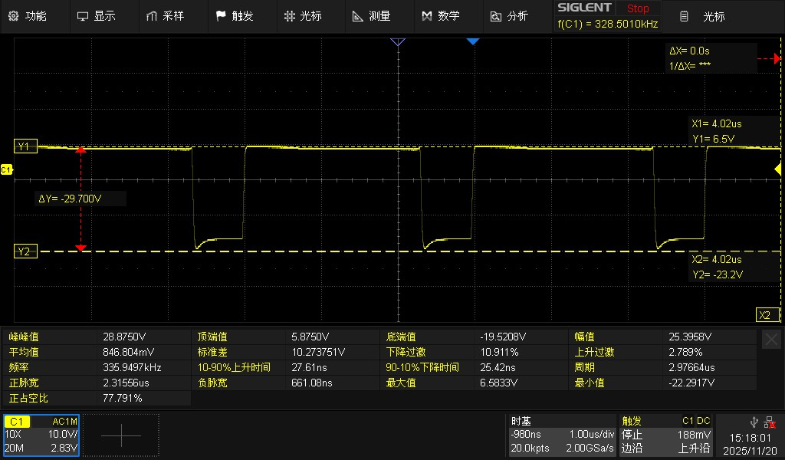
Vin=41V
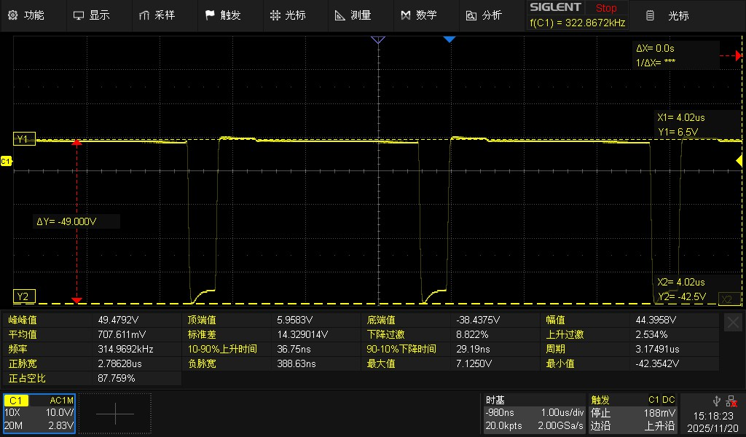
Isolate the ripple pattern on the C21 at the back end
Vin=24V
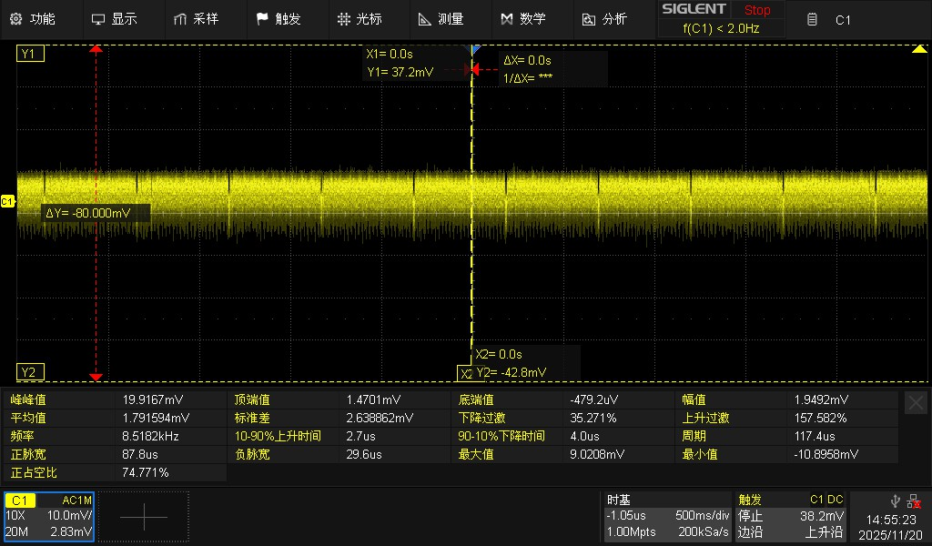
供电电源
