1.Open loop buck DC DC

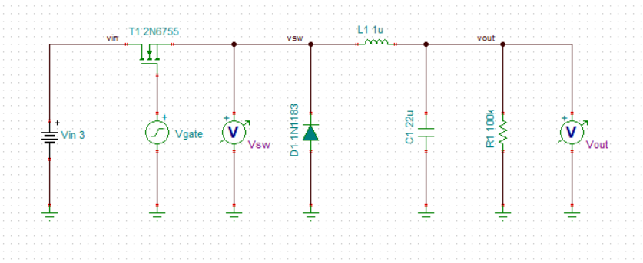

In theory，the output voltage should be Vout=3\*40%=1.2V. But in fact the output is 3.28. Could you tell me why?

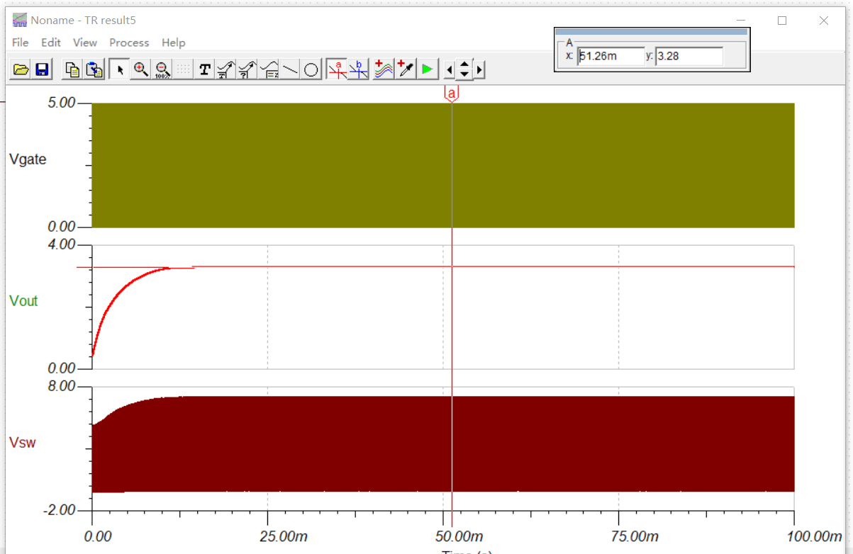

You can see the zoomed circuit as below. It seems that the waveform of the Vsw is abnormal.

