Design of the power supply for M2100 with universal input AC + DC

Ratings

85-265 VAC

18-36 VDC / better 9-36 VDC

Typ Total Power 20VA or 15W

Max Total Power 26VA or 20W

Isolation Primary / Secondary 3kV or 4kV

Output Voltages 2x24V isolation 500V or 1500V

Considered topology

1. LV boost + HV flyback

Advantages

No voltage drop when low voltage Input

Disadvantages

High voltage between 1st and 2nd stage

DC/DC booster switch and diode have to be HV rated (>400V)

HV Flyback has worse efficiency ? personal experience – consider quasi resonant or valley switching driver

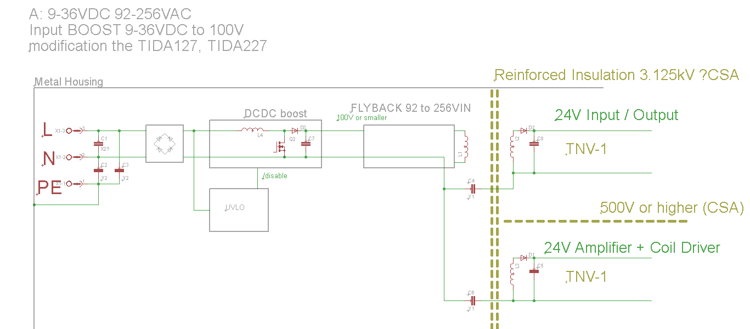

1. HV buck / PFC + LV flyback

Advantages

Low voltage between 1st and 2nd stage

Disadvantages

HV BUCK switch and diode are HV rated (>400V), higher RDS ON causes voltage drop when Low Voltage Input.

