No. | Questions & Answers
 | Please provide photos of the “suspect” TI part(s) top and bottom marking for our traceability!
 | 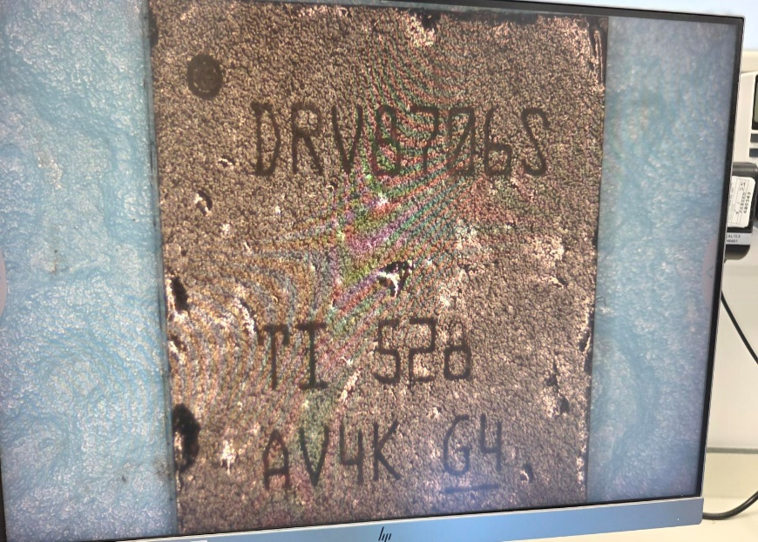
 | Please provide photos of the TI labels posted on the shipping carton/boxes/bags or reels the “suspect” TI part(s) for our traceability!
 | No photo’s of reel, packaging available
 | Did you purchase the units indeed directly from TI? Pls provide the order number or proof of delivery.
 | Handled by Sensata’s Procurement Team, I would need to chase this up with other departments if required
 | Please provide your verification / analysis report describing the efforts done to isolate the problem! It should include waveform / oscilloscope plots or measurements of the observed failure mode on TI part level?
When the Driver IC is exposed to temperatures of 60degC or above, there is a leakage voltage present on the pin 14 line.
As shown in the scope lots below, the signal on this pin increases rather than remain stable which the Control shows.
The Driver IC pin was separated from any interfacing sub circuits and tested again. When in this state, the signal continued to rise in this manner, so we have ruled out sub circuit impacts.

Occurs on 1 out of 4 Driver IC on one board only.
All surrounding components of the Driver IC were replaced: No effect
All pins on Driver IC were reflow soldered: No effect.
Pin Diode test on all pins: Pin 14 fails test only
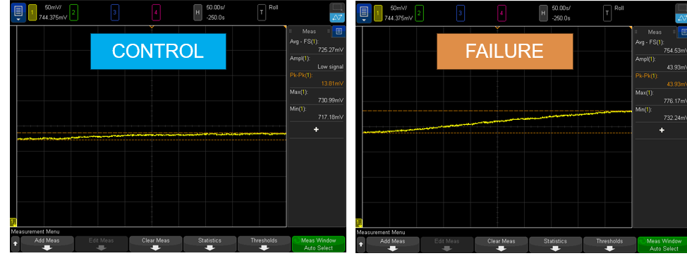

The left hand (Control) image is a voltage measurement of Pin 14 on a control Driver IC, during the Contactor Switches being in an Open State, from the same PCB (peak rise of 13.8mV). The Voltage is level and stable.
The right hand (Failure) image is the voltage measurement on Pin14 on the suspected Driver IC, during the Contactor switches being in an Open State. The voltage measurement pin 14 can be seen increasing over time (Peak rise of 43mV). In same conditions, there is no reason for this voltage on pin 14 to increase

 | How was the problem detected? You reported it failed a RELIABILITY / QUALIFICATION test, what are the conditions of this test (temp / pressure / voltage / cycle…)?
Post Thermal Shock Functional Test.
Ambient Function Test : Passed Ok
Tmax (85degC): Issue first observed
During functional test the contactors closed, then opened successfully.
When attempted to close again, they could not and PCB reported error about high voltage on the pin 14 signal line.
When measured via scope, the voltage on Pin 14 had risen above our internal thresholds for fault
 | You stated the impedance measurement failed. What values have been measured for pin 14?
 | Scope plots attached showing the voltage characteristics of Pin 14. When board is at 60degC or above the voltage on pin 14 can be seen to rise.
 | How often does the failure mode happen with respect to the units tested? (failure rate)
Below 60degC: No Failure
At 60degC: intermittent failure
60degC to 85degC: Repetitive failure
 | You wrote that this is a new application, so was the schematic / layout reviewed with TI before?
 | Unsure as I was not in design project at this time. The schematic has been reviewed against TI datasheets, it is also the same design used on several other platforms with same design for same conditions
 | Please explain why the issue is not visible on the suspect TI part outside of the application?
 | What is the application type the “suspect” TI part(s) were assembled into?
 | ECU Controller PCB design to operate the state of High Voltage Contactor Switches. There are 4 Driver IC’s per board
 | What kind of standard production tests have been applied to the application before it failed?
 | EOL electrical Test, AOI component inspection, Function test of measurements and operations. Contactors would have been opened and closed during EOL functional tests.
 | Please provide the (partial) schematic of the application incl. voltage & current conditions!
 | 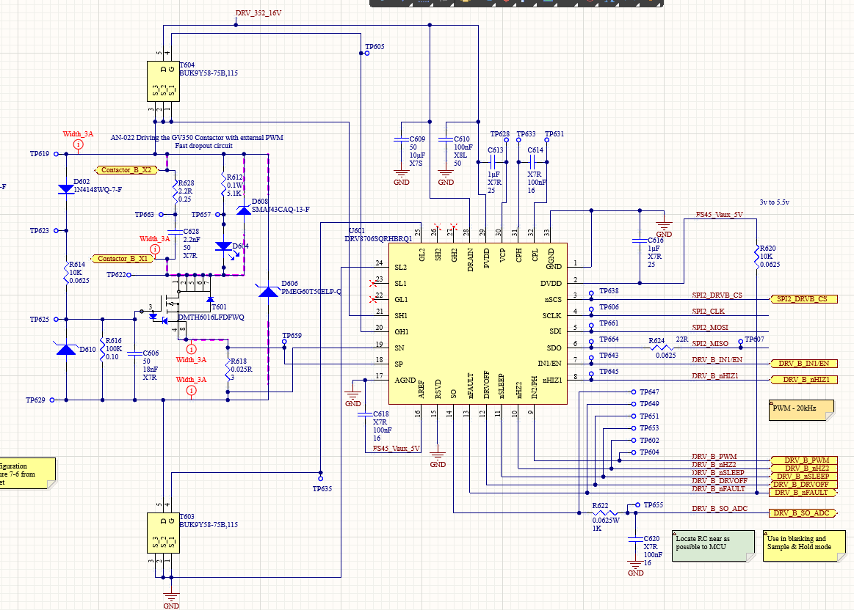
Was the issue indeed confirmed via A-B-A swap on TI part level (not system level) and not just by replacing the “suspect” TI part with a good new TI part?
(Demystify Video: https://training.ti.com/troubleshooting-tips-return-guidelines-b-swap)
The Driver IC was replaced with another Driver IC of same PN, the PCB was operated in same conditions and passed ambient, 60degC and 85degC Contactor closing. Pin 14 measurements were also taken and shown as side by side comparison in the previously attached PPT.
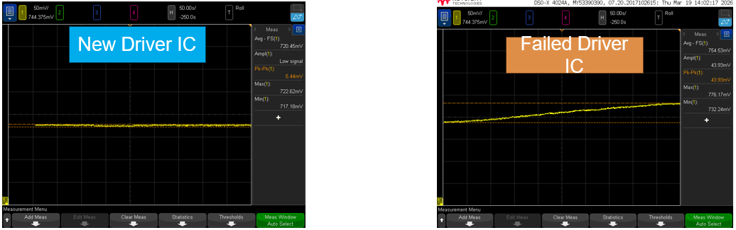

In this test, the suspected Driver IC was swapped with a new Driver IC from reel.
The comparison shows the voltage on the Pin14 circuit is not stable, like the control part example.
At the Tmax condition(85degC), the operation is now passing. No warnings are being raised

Can Texas Instruments perform any analysis on this Driver IC? Can use confirm through test if the IC was exposed to an ESD event, or if any isolation barriers have been damaged?
We see not physical damage to the IC, maybe there is some internal that can be examined?

Please answer the questions before you upload it again via the upload files section (Select file to upload) in CPR. In addition, please also update your problem description and attach additional documents, plots, photos as well.

IMPORTANT NOTE: Please read the Guidelines for Returns – http://www.ti.com/lit/pdf/sprac01 and take it consideration.
Our Demystify Videos are training series - www.ti.com/troubleshooting – that may help customers troubleshoot and debug integrated circuits.

