Hi Rick,

First of all, thanks for your support. I’m a customer encountering the problem described in current issue.

This issue occurs easier in closing gate which has been closed before. As expected, “Fault” pin should feedback to indicate end of close. But no feedback on “Fault” pin with lower voltage and 5.6ohm Rsense.

As you required, some scope images are provided here.

1. VCC:6.0v (Vbat), Rsense: 1ohm, IN1: High, IN2: Low, Out1: Yellow, Out2: Green, Load: Gate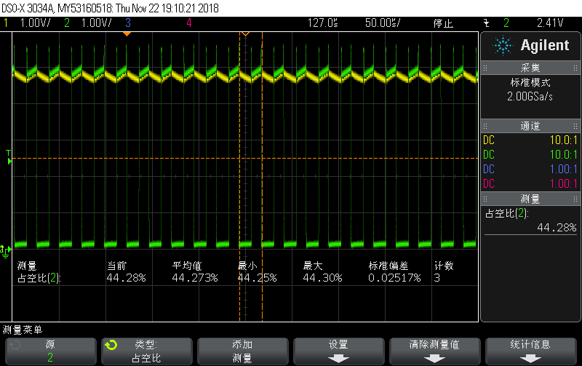

Voltage of output: 5*(100-44.273)/100 = 2.78V (Close to 2.5V )

1. VCC:6.0v (Vbat), Rsense: 1ohm, IN1: High, IN2: Low, Out1: Yellow, Out2: Green, Load: NULL

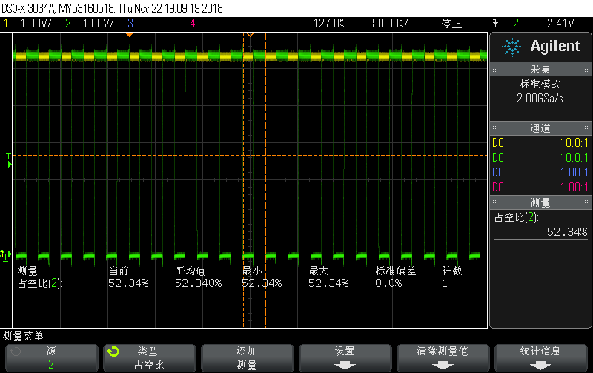

Voltage of output: 5.4*(100-52.340)/100 = 2.57V (Close to 2.5V )

1. VCC:6.0v (Vbat), Rsense: 5.6ohm, IN1: High, IN2: Low, Out1: Yellow, Out2: Green, Load: Gate

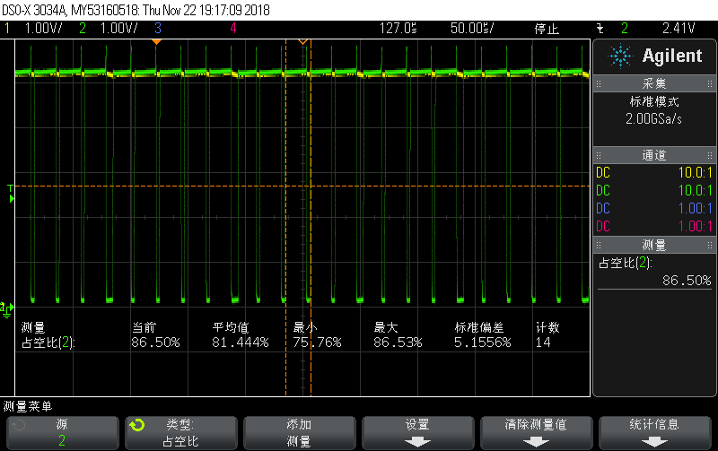

Voltage of output: 5.2*(100-81.44)/100 = 0.96V (deviate from 2.5V, **unexpected**)

1. VCC:6.0v (Vbat), Rsense: 5.6ohm, IN1: High, IN2: Low, Out1: Yellow, Out2: Green, Load: NULL

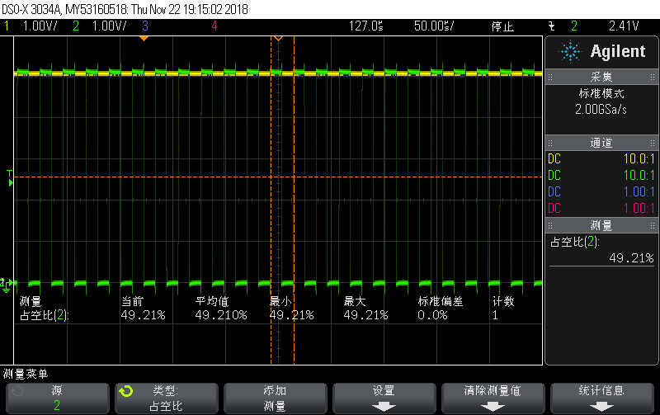

Voltage of output: 5.1*(100-49.21)/100 = 2.59V (Close to 2.5V)

1. VCC:4.5v (Vbat), Rsense: 1ohm, IN1: High, IN2: Low, Out1: Yellow, Out2: Green, Load: Gate

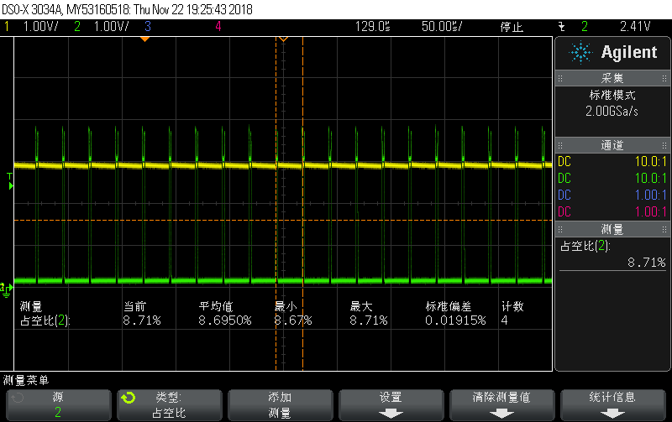

Voltage of output: 3*(100-8.69)/100 = 2.73V (Close to 2.5V)

1. VCC:4.5v (Vbat), Rsense: 1ohm, IN1: High, IN2: Low, Out1: Yellow, Out2: Green, Load: NULL

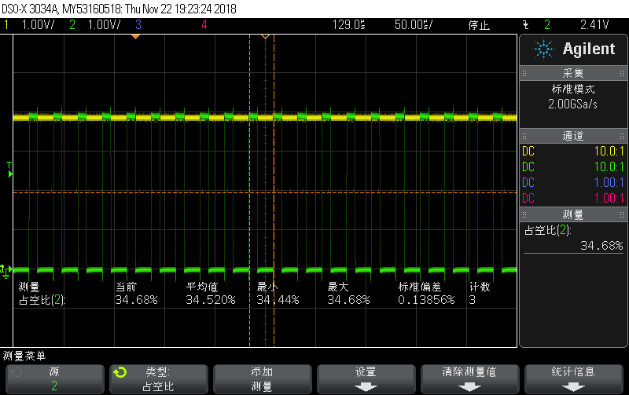

Voltage of output: 4*(100-34.52)/100 = 2.61V (Close to 2.5V)

1. VCC:4.5v (Vbat), Rsense: 5.6ohm, IN1: High, IN2: Low, Out1: Yellow, Out2: Green, Load: Gate

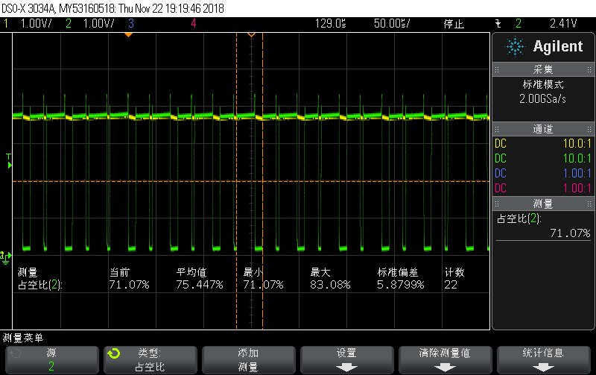

Voltage of output: 3.8*(100-75.44)/100 = 0.93V (deviate from 2.5V, **unexpected**)

1. VCC:4.5v (Vbat), Rsense: 5.6ohm, IN1: High, IN2: Low, Out1: Yellow, Out2: Green, Load: NULL

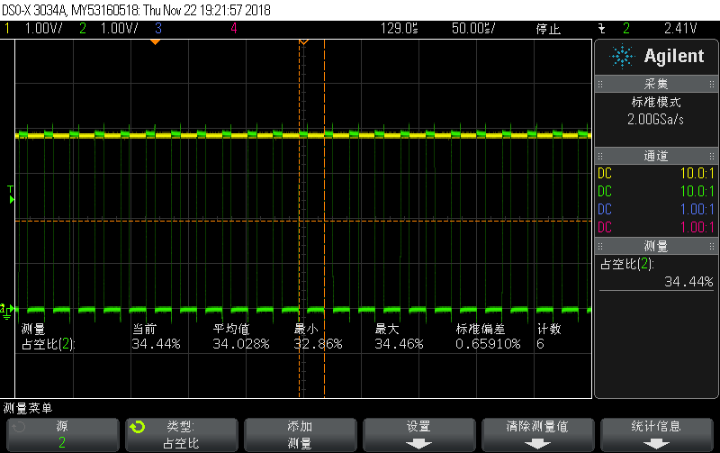

Voltage of output: 3.9*(100-34.02)/100 = 2.57V (Close to 2.5V)

Summary: Voltage of output is unexpected as design with Rsense 5.6ohm and load of gate, regardless of Vcc.

The following images show the process of closing gate, the fist image show that output wave(Vcc: 6.0v, Out1: Yellow, Out2: Green). The second image show the voltage of Rsense(Green) and feedback of “Fault” pin (Yellow).

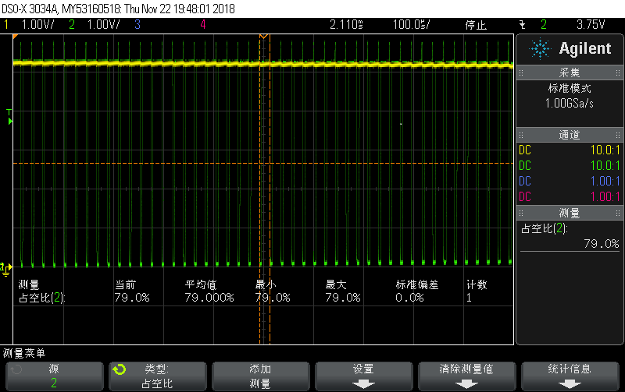

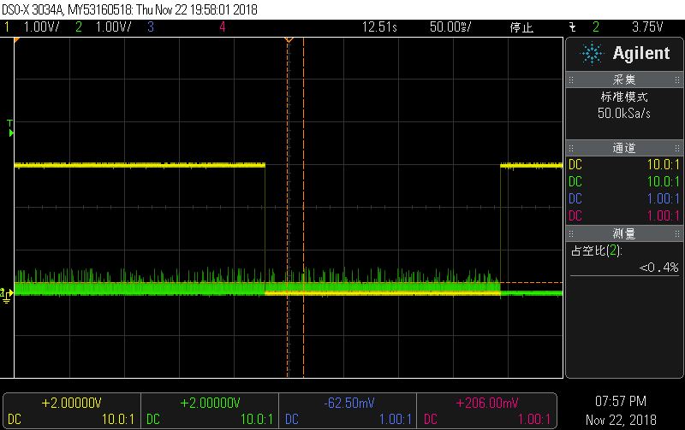

Because of limit, for now, we provide those scope images here. Look forward to your supports. Thanks.

Best regards,

Qingfeng,Yuan