## “EEPROM not Ready “issue with DRV10987

--20241121

一、”EEPROM not ready” issue with DRV10987EVM.

1、Use DRV10987EVM GUI to control DRV10987EVM，a fan is connected with DRV10987EVM.Configure the GUI with below parameter，Click“eewrite”button，The “EEPROM not read” will be occasionally appeared。Sometimes this window pops up continuously and cannot be program. To solve this issue, sometimes have to replace the DRV10987 IC on DRV10987EVM

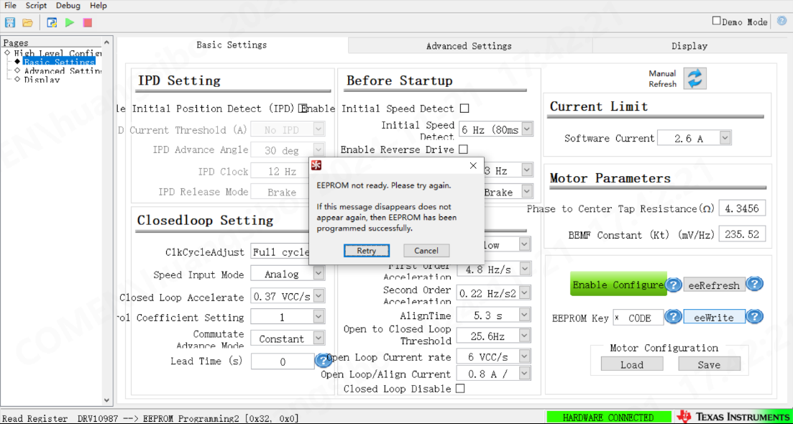

二、The issue with customer’s board.

1. In customer system, system MCU will access EEPROM after power up every time and program the EEPROM. After customer's board worked for a period of time (a few days later), it was discovered that DRV10987 could not feedback “eeReadyStatus = 1” (pls note that the EEPROM access is followed the procedure listed in 8.3.6 of DRV10987 datasheet. Replace DRV10987IC, the issue will be disappeared, but after work for some days, the issue will be occasionally happened again.
2. Customer did an experiment with a same customer board to check three DRV10987 ICs, all meet the same problems in #1. Then measure the pins resistance of these chips, there are no significant different with that of a good DRV10987. After the issue happened with those 3 pcs of DRV10987, customer system removed the procedure to access the EEPROM at power-up, The three DRV10987s have PWM output to drive fan but will re-start periodically.
3. With a new DRV10987, only on first power-up, access EEPROM to do some program. The EEPROM is not accessed when power is added later. this DRV10987 can work well even after 5 days.

三、I2C waveforms

With ACK

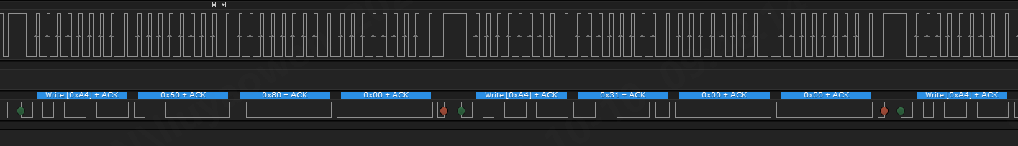

No ACK.

